A. Analysis

AN OUTLINE OF THE PROBLEM

I am planning to create a simulation that will simulate population growth between a predator and prey. I will do this based on the logistical model as it will create a far more realistic simulation than the exponential model as it recognises the factors that will limit a population. These factors will be to some extent chosen by the user potentially on some form of menu page and will include, the starting population, the availability of food, water, and temperature.

Furthermore, there will also be a start and stop button that will give the user control over the simulation and the populations of the predator and prey will be outputted to the screen. After a fixed amount of time or when populations each a fixed value then the simulation will stop and print key information the screen

For this to work, the simulation will require: two boxes to show the populations of the predators and prey; a menu screen in which the user can alter factors; a button to start and stop the simulation; a button to exit from the simulation back to the menu page and an end page that displays after a certain amount of time or when populations are too large.

STAKEHOLDERS

The target audience will be students in key stage three and four meaning they will be between the ages of 8-16 and their teachers. This simulation in terms of graphics will not include graphic or violent graphics despite the fact that they are demonstrating the death of a population. It will be clear and easy to understand meaning it will be appropriate for the younger range of the audience. On the other hand, the ability to adjust a number of factors means that it will still be valuable to people on the older range of the target audience. Furthermore, the fact that this will be a useful educational tool as it will be an accurate representation of population growth means that it will also be desirable to the teachers of key stage three and four.

I have selected a user to personify my target audience, Natalie Faughy. She is a teacher of Key Stage 4 Science and will therefore know the needs and learning behaviours of students in the target audience of this simulation so she will be able to evaluate if this is a useful and successful simulation. I will also be able to be in regular contact with Natalie Faughy as will are a part of the same household.

HOW THE PROBLEM CAN BE SOLVED BY COMPUTATIONAL METHODS

This problem is well suited for a computer because of the fact It can be solved through computational methods. This is because a simulation is an abstraction from reality to convey an idea, it can have multiple conditions that can be set to influence the outcome of the simulation and the simulation will use simple algorithms for these different scenarios. This section will detail the ways in which computational methods can be used to solve this problem through a series of examples.

Thinking Abstractly

Simulations are abstractions from reality making them perfect for this as it needs to be decided what elements of reality will be included in the simulation and which will be left out.

Abstraction for population growth simulation:

·        To include multiple variables including the starting populations, temperature, availability of food and water to then influence the algorithms that will calculate the populations throughout the simulation and then ignoring any other factors that could effect population group.

·        Remove the third dimension and have the simulation in two dimensions.

·        Remove all sounds to have the simulation silent whereas of course in reality there would be sound.

·        Simple backgrounds to not distract from the simulation, abstracting away any scenery.

·        Some animations to clearly see the size of the population but ignoring the how the animals would move in reality.

·        Include a menu to allow the different variables to be adjusted including only information important to the simulation such as a simulation key or the simulation controls.

·        To output the numerical values of the populations only including the final populations, and initial conditions for the populations with no other statistics that could be included.

Thinking ahead

Looking ahead and considering future stages of this project to decide what you want allowing you to plan somewhat giving the problem some structure.

·        I am planning to use the Defold game engine as this is an effective software to write simulations in and then will be using lua for coding the scripts.

·        Inputs will probably be obtained through the mouse in the use of different keys to activate different simulation states and the inputting of numerical values.

·        The outputs of the simulation consist of animations and numerical values.

·        Numerical information which will affect the simulation will be stored through a number of variables: amountPopulation1, amountPopulation2, temperatureLevel, amountWater, amountFood, amountSpace.

Thinking Procedurally

Thinking procedurally gives the problem structure. This involves decomposition as the problem is split into a number of smaller problems which makes the whole process more efficient as the problem can be solved in parts.

This problem had been broken into three main problems that need to be solved for the simulation to have even a basic level of functionality.

Control:

It will be through these controls that the user interacts with the simulation. The mouse and key presses will be used to enter numerical information that will then be used to influence the simulation. The player should also be used to allow the simulation state to change between the actual simulation, paused state, the menu state and the simulation over screen.

Simulation states:

This will give the simulation a measure of structure making it easier to utilise and understandable for the user. The menu state will first allow the user to change different values for the factors that they can control as mentioned under statistics and then the program will move into the running state. Then if a certain time has passed which will be signified using a timer or if either population reaches zero then the end state will display and then the user will return to the menu state. If the user is in the running state they will be able to use a key press to move to the paused state and then the same key press to return to the running state

Statistics:

The simulation will process a number of values which will give the user further control over the simulation increasing the applicability of the simulation making it far more useful to the user. The values of these variables will be dictated by the user in the menu state however if the user neglects to enter a value then there will be a series of default values when the simulation starts.

Procedurally breaking down of the problem:

Thinking logically

This helps to consider how the logical aspects of the problem will be solved.

A key presses and the mouse will allow the user to enter information into the menu state. Key presses will allow the user to move from the menu state to the running state; the running state to the paused state; the paused state to the running state and from the end state or the running state to the menu state. There will be a number of conditions that will be analysed such as the simulation not beginning until there is a population, and the factors have values. There will also need to be a timer that will after a certain amount of time cause the simulation to end with there being a constant iteration to check if this certain amount of time has passed and then the end state will display.

Thinking concurrently

This is useful for considering the efficiency of the solution when it is running to ensure processor time is well used without overwhelming the system.

Data showing the size of the populations will be displayed live whilst the simulation is running and this will happen whilst data is processed, calculations are being made and the animations are playing according to these calculations.

Conclusion

This demonstrates that features of this problem can be solved using computational methods making it suited to a computer program. It is therefore through these methods that the problem can be given structure and can be solved more easily as it has allowed me to consider the problem in greater depth.

If successful solved this program will allow stakeholders to simulate population growth where they can control a number of factors and then will be able to watch these populations being stimulated under these conditions through animations for a certain amount of time until the simulation ends and this will therefore be a useful educational tool for the stakeholders

RESEARCH

Interview to get an idea of initial requirements.

The aim of this interview is to find the basic requirements of the user and this will therefore give direction to what type of simulation will be created. This will be achieved through investigating what the user thinks makes a good simulation, what user controls are required and what type of visuals are wanted for the simulation. Under each question there will be a series of small more specific questions to make the requirements as specific as possible to get the best idea of what the project will be at this early stage

Question layout:

What is your idea?

What is your target audience?

What makes a simulation good?

·        Do sound effects affect your simulation experience?

·        Do you think visuals affect your simulation experience?

·        Should numerical information be included in the simulation?

·        How realistic should the simulation be, taking the target audience into consideration?

·        How many moving objects should there be per simulation?

·        How would you want to interact with the simulation?

What controls will you give users over your simulation?

·        Would user controls improve or detract from your simulation experience?

·        What are your thoughts on the purpose and effectiveness of simulations?

·        What controls would you give users?

What sort of visuals would you want for the simulation?

·        If any realistic features should be included for your simulations, what should they be if so?

·        What type of simulation style would you like?

·        What sort of themes would you want for the background of the simulation?

·        Would you want backgrounds to change?

·        Would you want any animations for the moving objects?

Interview script 29/04/2020

What is your idea?

To make a simulation to show trends in population growth between predators and prey based on the logistic model considering a number of factors such as starting populations, the availability of food, space, water and temperature.

What is your target audience?

Students in key stage 3 or 4 and therefore their teachers to use this as an education tool.

What makes a simulation good?

Do sound effects affect your simulation experience?

I feel for a simulation although they would not subtract from the experience I personally feel as the target audience is that much older being in KS3 and 4 I don’t feel that for my simulation sound effects are overly necessary and I feel if overused they could take away from the validity of the simulation.

Do you think visuals affect simulation experience?

I think that visual effects are vital to a simulation as it is their purpose to create a visual representation of something that may be difficult to understand or visualise therefore visual effects will be a key component of my simulation as this is intended to be an educational tool and therefore not only needs to be a visual representation of an idea in this case population growth it also needs to be engaging.

Should numerical information be included in the simulation?

Numerical information is going to have a key role in this simulation as it will be this that is driving the formulas behind the simulation which is conveying the idea of population growth to the user.

How realistic should the simulation be, taking the target audience into consideration?

Although it is important that it is clear what different visual effects and image are representing in the simulation, I don’t feel that it being realistic in the sense of visual effects is particularly important as long as it is clear I especially don’t feel that factors such as gravity need to be considered however it is important that they represent population growth as realistically as possible and it is a true to how these animals would behave in nature as it can be.

How many moving objects do you think there should be per simulation?

Of course, that depends on the users input and then the formulas that will be used to determine then how many objects are outputted to the screen however there would need to be limits to this for example 500 sprites on the screen but that can be later determined.

How would you want to interact with the simulation?

To be able to alter factors to investigate a number of factors and have clear representations to demonstrate the growth of populations.

What controls will you give users over your simulation?

Would user controls improve or detract from your simulation experience?

I feel that this would improve the simulation experience as it would add value because more can be learnt about different factors which expands the scope of the simulation therefore making it more valuable.

What are your thoughts on the purpose and effectiveness of simulations?

I think that simulations are an important and valuable learning resource that can help people learn and visualise potentially difficult concepts.

What controls would you give users?

I will allow them to choose numerical values for some factors such as the number of predators and pray and then allow the user to choose levels for other factors.

What sort of visuals would you want for the simulation?

If any realistic features should be included for your simulation what should they be?

Visually I don’t feel that it needs to be particularly realistic in terms of the actual images nor does physics need to act on the images in the sense that I don’t feel that gravity needs to consider.

What type of simulation style would you like?

I would like it to have a simple style, so the attention is on how the populations are changing and I don’t feel that it needs to be very stylistic as this is an educational tool not something for leisure time or entertainment.

What sort of themes would you want for the background of the simulation?

I would like the background to be a simple block colour perhaps with outlines to separate where the different information is such as the objects representing the animals and the number of animals on the screen, but I feel it needs to remain simple, so the attention is drawn the changing amounts of animals.

Would you want the back grounds to change?

I would like the background to stay the same throughout as I don’t feel that anything would be added by changing the background however potentially having a pop-up screen to change factors.

Would you want any animations for the moving targets/objects?

I think having the animals move may be nice and having animations for selecting buttons or changing levels of the different factors would make the simulation clearer and give a smoother feel to it.

A REVIEW OF THE INTERVIEW: 29/04/2020 ANSWERS

The purpose of this interview was to discover what sort of things the stakeholders would want from this simulation to therefore improve upon its effectiveness and desirability.

It was concluded that a simulation with a coherent design meaning that it is clear to the user how to utilise the simulation and that the simulation should be accurate and give information that is based on scientific or mathematical reasoning is preferable. It was further decided that sound effects and realistic visual effects would not be necessary in this simulation.

Furthermore, the stakeholder communicated that they would like the user to be allowed to choose numerical values for some factors such as the number of predators and pray and this would improve the simulation experience.

The Stakeholder also dictated that they would like to keep the visuals very simple as we feel if there were lots of flashy visual effects it would detract from the purpose of the simulation which is to convey the concept of population growth and although it needs to be somewhat engaging, we don’t feel it needs to be entertaining. Therefore, we concluded that although functional elements such as buttons would be beneficial to the simulation further stylistic additions would not be necessary.

Research - abpi schools’ population growth simulator

Abpi schools’ population growth simulator allows the user to choose a number of parameters and then once the user presses start animations representing foxes and rabbits will appear conveying how their populations would change over time.

This simulation has three states. The first encountered by the user does not show any populations and instead acts as an opportunity for the user to change a number of variables to affect the simulations and these include the temperature, moisture, food and the starting population of foxes.

When the user presses the start button the simulation will begin with the parameters dictated by the user and a starting population of 100 rabbits and they are no longer able to alter the parameters. Throughout the simulation the population of rabbits and foxes is outputted to the screen and the user can at any point pause the simulation or can reset the simulation and return to the menu state

After a finite amount of time has passed representing seven months the simulation enters its final state in which the simulation remains still with the animations outputted at the end of the simulation. The user is able to begin the simulation again at which point the simulation would return to its menu state

Main features of the simulation include:

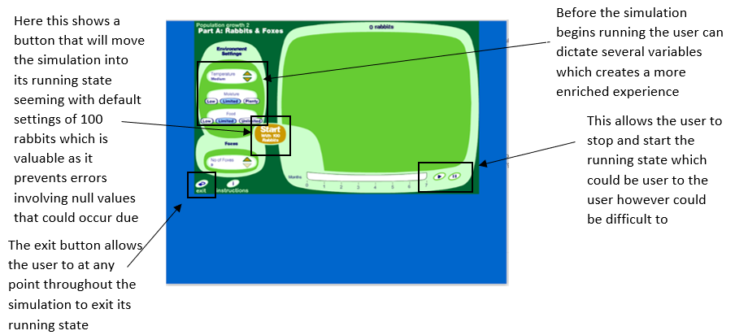

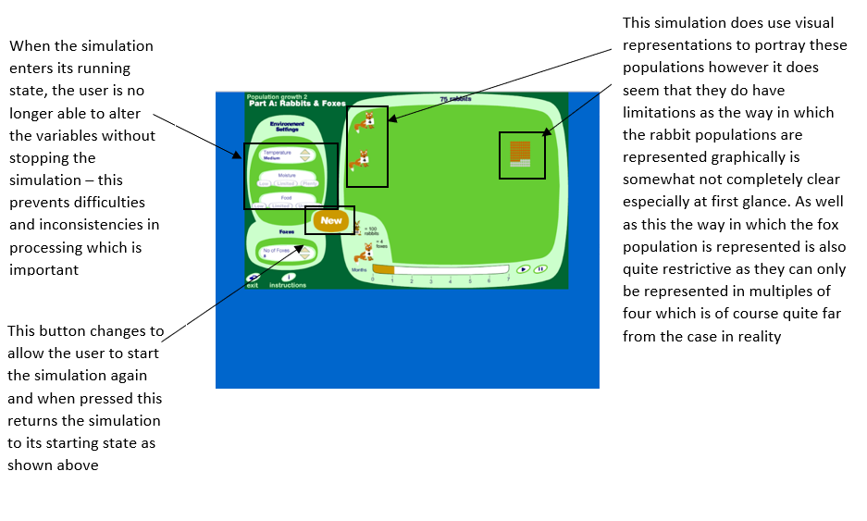

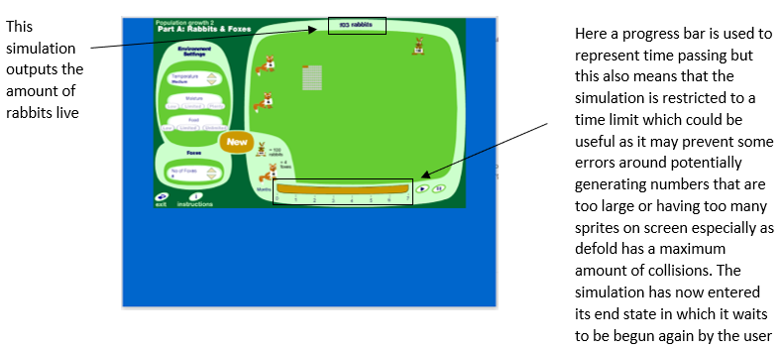

Shodor’s population growth simulator

Shodor’s population growth simulator allows the user to run a simulation representing the populations of rabbits, wolves, and the vegetation.

This simulation has a number of states, the first being the starting screen in which the user can choose to start the simulation or alter parameters. The user can modify a great deal of factors coming under four main categories: the rabbit parameters, wolf parameters, start-up parameters and the amount of space. The user can also throughout the simulation access a key describing what the animations are representing.

The simulation then enters its running state when the start button is pressed. The user is then able to either pause, reset or step the simulation. The simulation also allows for the user to modify parameters during the running state and these will take effect from the user saving their changes. There are also options to view the statistics of the simulation such as a population graph and the cumulative states and again these can be accessed while the simulation is running, and the simulation continues to run whilst these are in view.

This simulation will run indefinitely until the user chooses to stop it.

Main features of the simulation include:

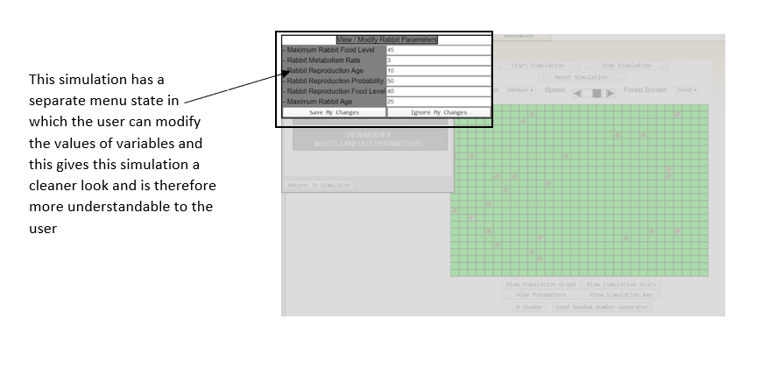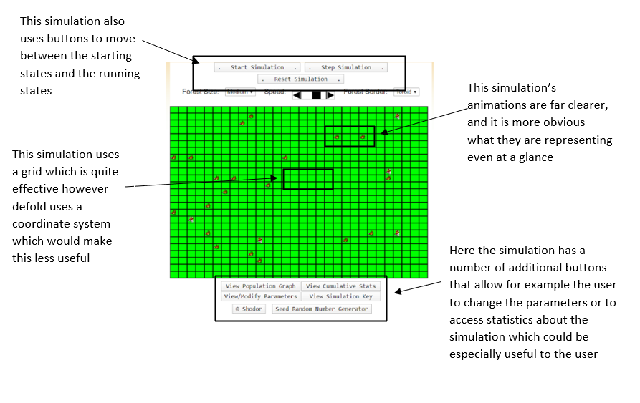

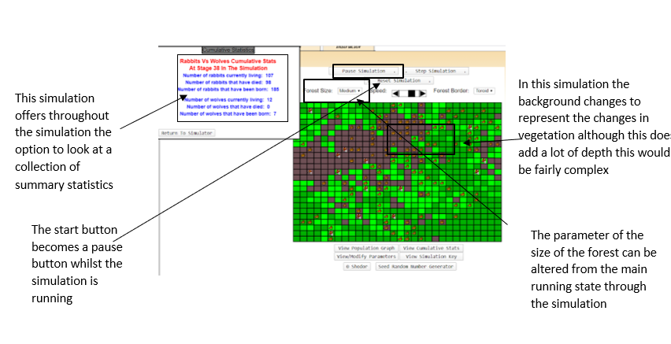

How do the different features affect the population growth simulation?

Visuals/animations

These simulations have quite different visuals with the abpi school’s using images to represent a certain number of each population (100 rabbits or 4 foxes) this is somewhat confusing whilst the other Shodor’s simulation has more sprites on the screen each representing one of that population and this is much clearer.

Abpi school’s simulation has a constant background whilst the Shodor’s simulation has a changing background that represents vegetation and although this adds some more depth to the simulation this would be fairly complex especially as defold does not use a grid system instead coordinates and it takes away somewhat from the visual clarity of the simulation.

Pause/play

Both simulations allow the user to pause and then play the simulation. This would be very useful as it would allow the user to discuss points of the simulation making it a much more useful educational tool.

Presentation of statistics

Abpi offers a total of the rabbit population that updates live with the simulation and is always present on the screen which is useful for the user as they can always chart the progress of the simulation.

Shodor’s simulation offers far more statistics about the simulation offering both graphs and cumulative statistics throughout the simulation although this gives the user far more information it could be a little overwhelming and is not always present on the screen suggesting this might not be necessary in its entirety.

Control of parameters

Both simulations allow the user to control a number of parameters. In abpi’s simulation the user can alter the parameters before the simulation begins and then cannot in the duration of the simulation’s running state and the user is able to modify four parameters.

On the other hand, Shodor’s simulation allows parameters to be changed throughout the simulation’s running state with the changes applying from when the user saves their changes to them. Furthermore, they also offer far more parameters to be changed totaling nineteen. Although this really does enrich the simulation it also creates a great deal of complexity.

Progress bar/time limits

Abpi’s simulation has a progress bar and after this finite amount of time when the progress bar has reached the end the simulation stops and enters into an end state, unlike shordor’s simulation that will continue until both the rabbits and wolves die out or until the user stops it. This could be quite effective in avoiding errors around the maximum number of collisions in defold and having very large populations if the simulation was to be left for too long.

Simulation key

Both simulations have simulation keys to show what the sprites are representing, and this adds clarity despite not being essential.

Interview: 09/06/2020 Plan

This will give more specific requirements regarding the simulation’s visuals, statistics and controls, the simulation states. It will then be with this information that I will be able to therefore create my first set of requirements which will allow me to then start considering how this problem will be solved.

Question layout:

Visuals:

* What animations would you like for the two populations?
  + Would you like these to be the same or the two animals to move differently?
  + Would you like these objects to actually move on the screen or just be spawned and deleted?
* What data would you like to be outputted to the screen?
  + Would you like this to be updated and outputted live or just have cumulative statistics?
  + If you would like data to be outputted live what information would this include?
  + What would you want to be included in the cumulative statistics if this is wanted?
* Do you want the cursor to have a sprite?
  + If so, what would this be?
* Would you like the simulation to have a simulation key?
  + If so, what would this include?
* What would you like the background to look like for example would you like it to be still or moving to represent vegetation for example?
  + If you would like it to be still what kind of background would you like - for example would you like this to be a simple colour of an image?
* Would you like the simulation to include any sound, if so, what would this be and when would it occur?
* Would you like there to be a progress bar to represent time in the simulation running state?

Simulation states

* How would you like the user to begin the simulations running state, would these be through a graphic on the screen or a key press for example?
* Would you like the user to be able to pause the running state?
  + If so, would you like there to be a separate menu or would they still see the running state but stationary?
  + If so, how would you like these to be done with a key press or a graphic on the screen.
* Would you like the user to be able to exit the running state?
  + If so, would they be able to return to the state as it was left, would the appropriate amount of time passed, or would it have been reset?
  + Would the user be able to alter parameters whilst the simulation is running?
  + Would you like the user to be able to reset the simulation whilst it is running?
* What would you like to cause the running state of the simulation to end?
  + If time what do you feel is an appropriate amount of time for this to pass in?
  + Could any other factors cause the simulation to end such as a population becoming extinct?
* What would you like the end state to comprise of?

Statistics and controls

* How would you like the user to enter information for different parameters for example would you want this to be as levels almost as in abpi’s simulation or as numerical values such as in Shodor’s simulation or a combination of the two?

Numerical values and this will allow more flexibility.

* + If in ‘levels’ what would these be?
  + If in numerical values what would the limits of these be?
* Would the user be able to alter parameters whilst the simulation is running and have these changes in effect for the rest of the simulation?
* In the menu state what controls would the user have for example what other states could they access?
* In the running state would controls would the user have over what state they are in?
  + Would they be able to access different states? How would they do so and which states?

Interview script – Questions and answers:

Visuals:

* What populations would you like to be depicted?

Preferably the user would be able to explore a number of different species to investigate how factors such as size and metabolism effect population dynamics however as a minimum I would expect two species that will be recognisable to my students such as rabbits and foxes.

* What animations would you like for the two populations?
  + Would you like these to be the same or the two animals to move differently?

Same otherwise the students will be potentially distracted by how they move differently, and this may make the simulation less effective. I would like them to both move smoothly with each population having a simple animation as they are moving.

* + Would you like these objects to actually move on the screen or just be spawned and deleted?

Spawn and then move on a path at a very moderate speed to not be distracting.

* What data would you like to be outputted to the screen?

Number changing whilst the simulation is running.

* + Would you like this to be updated and outputted live or just have cumulative statistics?

Both would be beneficial to the simulation.

* + If you would like data to be outputted live what information would this include?

The population sizes - if too much information is outputted at this point it could be confusing.

* + What would you want to be included in the cumulative statistics if this is wanted?

The final population

Percentage change

The initial conditions of the simulation

* Do you want the cursor to have a sprite?

Yes, otherwise I would not know where I was pointing.

* + If so, what would this be?

The caret as usual

* Would you like the simulation to have a simulation key?

Yes, otherwise it would be unclear what the simulation is representing.

* + If so, what would this include?

What sprite represents each population and the amount of that population each sprite represents?

* What would you like the background to look like for example would you like it to be still or moving to represent vegetation for example?

Still, otherwise too many things moving and would be too confusing.

* + If you would like it to be still what kind of background would you like - for example would you like this to be a simple colour of an image?

Simple colour to not detract from the simulation.

* Would you like the simulation to include any sound, if so, what would this be and when would it occur?

No as this is an educational tool and should be treated as such and the teacher will most likely be adding their own narration.

* Would you like there to be a progress bar to represent time in the simulation’s running state?

Yes, and this will further portray the idea of time passing and will allow the teacher to know how far through the simulation the class is.

Simulation states

* How would you like the user to begin the simulations running state, would these be through a graphic on the screen or a key press for example?

A key press as often teachers brush active boards and would therefore change its state.

* Would you like the user to be able to pause the running state?

Yes, in case you would like to discuss something in depth as this would allow for teaching moments.

* + If so, would you like there to be a separate menu or would they still see the running state but stationary?

I would like it to return to the start menu/see running state but stationary with a symbol to signify it is paused.

* + If so, how would you like these to be done with a key press or a graphic on the screen.

I would like this to be done with the ‘esc’ key.

* Would you like the user to be able to exit the running state?

Yes, in order to return to the menu state.

* + If so, would they be able to return to the state as it was left, would the appropriate amount of time passed, or would it have been reset?

Reset

* + Would the user be able to alter parameters whilst the simulation is running - if so, would these be in effect for the rest of the simulation?

No, this would be unnecessary as you could run it from the beginning with new parameters.

* + Would you like the user to be able to reset the simulation whilst it is running?

Yes, in case a mistake has been made or all has been from that simulation.

* What would you like to cause the running state of the simulation to end?

Time

* + If time what do you feel is an appropriate amount of time for this to pass in?

2 minutes - students may lose interest.

* + Could any other factors cause the simulation to end such as a population becoming extinct?

Yes, this would also prevent students from losing interest.

* What would you like the end state to comprise of?

The cumulative states and a prompt to return to the menu state.

Statistics and controls

* How would you like the user to enter information for different parameters for example would you want this to be as levels almost as in abpi’s simulation or as numerical values such as in Shodor’s simulation or a combination of the two?

Numerical values and this will allow more flexibility.

* + If in ‘levels’ what would these be?

N/A

* + If in numerical values what would the limits of these be?

Initial populations 0-100

Temperature 0-40

Availability of food (prey) 0-10

Availability of water 0-10

Amount of Space 0-10000

* In the menu state what controls would the user have for example what other states could they access?

Running state and here they will be able to use the mouse to enter the parameters.

* In the running state what controls would the user have over what state they are in?

Return to the menu state.

* + Would they be able to access different states? How would they do so and which states?

Through the ‘esc’ key

* If you would like to be able to pause the simulation how would this be done?

With a key press such as ‘p’

* + Would the user be able to return to the running state in the same way?

The same key press ‘p’ could be used to return to the running state from the paused state

* Would you like any data to be read to a file?

Yes

* + If so, what data would this be?

The cumulative states as they are presented on the end screen as then this can be used to compare simulations.

* + How would this data be included in the simulation?

Information about other simulations could be displayed in the end state along with the most recent simulation

Review of the interview: 09/06/2020

From this interview the main features of the simulation can be established

Menu state:

* The user will be able the alter parameters using a mouse and key presses.
* These parameters will have limits.
  + Initial populations: 0-100
  + Temperature: 0-40
  + Availability of food (prey): 0-10
  + Availability of water: 0-10
  + Amount of Space: 0-10000
* This will first be displayed to the user when the simulation is started and can be accessed from both the running state and the end state through a key press (‘esc’)
* A key press will take the user to the running state (‘s’)

Running state:

* Two sprites for the different populations that will be animated to simply move around the screen.
* Once a sprite is spawned it will stay on the screen until the population decreases at which point it will be deleted
* The size of the populations will be outputted to the screen whilst the simulation is running.
* A simulation key for what the graphics represent.
* A still, simple background of one colour
* No sounds
* Progress bar to represent time passing.
* This state will begin with a key press from the stating state.
* A key press will allow this state to be paused (‘p’).
* A different key press will allow the user to leave this state and return to the menu state and therefore reset the simulation.

End state:

* This will be displayed to the user when a set time of 2 minutes is reached or when a population has become extinct.
* Cumulative statistics will be displayed here including the final populations, the percentage change and the initial parameters.
* There will be a prompt for the user to return to the menu state through the ‘esc’ key.

Paused state:

* Symbol to signify the simulation is paused.
* Key press ‘p’ will return the simulation to the running state.

Save to file:

* Information about the simulation will be saved to a file automatically by the simulation.
* Information about previous simulations will be loaded and displayed by the simulation

Features of the proposed solution.

|  |  |
| --- | --- |
| Population size boxes | This will output the current sizes of the prey and predator populations as the simulation is running to give the user a concept of what is happening in the simulation and could be useful to a teacher discussing the simulation |
| Data entry | The user will be able to enter values that will be used as parameters in the model with the temperature, availability of water and availability of food affecting the carrying capacity which will be calculated from the amount of space which will also be entered by the user. The availability of food will be obtained through user input for the prey but for the predator this will be calculated from the amount of prey. The initial populations will also be dictated by the user. This will therefore make the simulation more useful as it can be used as a learning tool in a wider variety of situations. Also, for the prey the number of predators will affect the carrying population |
| Validation of the user’s data entries | This will be based on these limits.  Initial populations 0-100  Temperature 0-40  Availability of food (prey) 0-10  Availability of water 0-10  Amount of Space 0-10000 |
| Save to file | When the simulation reaches its end, state save the cumulative statistics and the values in the parameters to a file as this would allow the user to compare multiple simulations and would allow students to process this data through for example making graphs allowing the simulation to reinforce more skills |
| Initial controls | Be able to use the mouse and keyboard to alter the parameters.  Use the key press ‘s’ to start the simulation.  Therefore, there will be simple and easy to use controls and data entry objects for my user group |
| Controls whilst the simulation is running | Use ‘esc’ key to return to the menu state and therefore reset the simulation.  Use ‘p’ key to pause the simulation |
| Controls in the simulations end state | Use the ‘esc’ key return to the menu state |
| Prey/Predators spawning and dying | This will happen in accordance with the model |
| Progress bar | This will represent time passing so when it has reached the end the simulation will end if it has not already. This prevents the simulation from becoming too long and gives the user a sense of how far through the simulation they are |
| Background | This will be still and a plain block colour |
| Prey and Predator animation | These will have different sprites however they will move the same way on a path turning at the edges of the screen |
| End state displays | Will display cumulative stats of the most recent simulation and some previous simulations and a prompt for user to press ‘esc’ to return to the menu screen |
| Simulation that lasts for 120 seconds or until a population becomes extinct | This means that the values of the populations will not become too large, there will not be too many collisions and the simulation remain engaging |

There is a time restraint on this simulation as I have around 8 months to complete it however, I study three other subjects and I have to balance the theory portion of the Computer Science A-Level. As well as this there are further time restraints due to the global Covid-19 pandemic of 2020 and 2021.

Hardware and Software Requirements

Hardware requirements

|  |  |
| --- | --- |
| **Hardware** | **Justification** |
| Monitor (14 inches with a resolution of at least 1280x1024 if they are using an interactive whiteboard otherwise for a 14 inch monitor a resolution of around 1360x800 would be sufficient) | To display the visuals of the simulation back to the user. The vast majority of monitors are larger than 14 inches therefore to allow as many people as possible to use the simulation this will be required. The average interactive smart board now have a resolution of around 1280x1024 pixels therefore if the user wants to project the simulation onto a board the device needs to have a resolution approaching this to be clear however if not the average resolution for a computer screen which depends on the device would be sufficient for a 14-inch monitor this is around 1360x800 |
| Mouse | This is an input device that allows the user to navigate through and interact with the simulation |
| Keyboard | Required for the user to input data. |
| 10Mb of secondary storage | This simulation will not need particularly high storage requirements. |
| 4Gb of RAM (minimum) | The DEFOLD editor uses 75% of the systems available memory therefore the Defold Foundation recommends a device with at least 4Gb RAM for a smaller project. |
| 2GHZ+ processor | Around this will be needed to perform the graphics and animations along with the processing behind the simulation. This is a relatively low specification compared to most hardware on the market meaning that this should allow the vast majority of people to use this simulation |

Software Requirements

|  |  |
| --- | --- |
| Software | Justification |
| Operating System: WINDOWS 10 | There are multiple platforms for which Defold will work with meaning that it can be downloaded and supported by these operating systems for example Android, LINUX or Apple OS X as it is cross-platform game engine meaning it can be run on a variety of devices including desktops and laptops but also mobile phones and tablets  although I will be unable to test the simulation for each operating system meaning that I will develop this simulation with Windows as its target platform and although it will in theory run on other platforms it cannot be ensured that there will not be errors |
| Defold | This is the game engine that I will use and therefore this will provide the software framework that will assist in animations, rendering graphics, detecting collisions and memory management which will greatly assist in this project |
| LUA 5.1 | LUA is the code used in the scripts in this environment as Lua is designed to be simple meaning it can be executed fast and can be learnt fairly quickly. Despite this simplicity it allows for object orientated programming which will result in the solution being more efficient as Lua has pseudo inheritance which will make the process of spawning objects simpler. Lua also had a number of useful libraries including libraries that assist with table manipulation, mathematical operations and file input and output making Lua's powerful library set a clear advantage. Furthermore, Lua can be easily embedded into the defold programming language meaning that the Lua script interacts well with the features of defold for example there is code in place for animations and detecting collisions which will help in the development of this simulation. As well as this Lua is run by a bytecode interpreter which allows defold to be a cross-platform game engine. |
| Defold libraries | I will use defold libraries if this is necessary or will be significantly beneficial to the solution and if this is the case it will be referenced however, I will try to use my own code |

Success criteria

|  |  |  |  |  |
| --- | --- | --- | --- | --- |
| No. | Requirements | Justification | ☑️ | Reference |
| 1 | Start menu | In order to explain what the simulation they are about to watch is, show a simulation key and prompt the user to enter data | ☐ | Interview 09/10/20 |
| 2 | Use the mouse the navigate the start screen | This is the easiest way for the user to decide what data they want to enter on the start page | ☐ | Interview 09/10/20 |
| 3 | Label that can be edited by the user to allow data entry for the availability of food for the prey, initial populations, temperature, availability of water, space | This will make the simulation more useful as different factors and their effect on the simulation can be investigated | ☐ | Interview 09/10/20 |
| 4 | Press the ‘s’ key to enter the running state from the menu state | Allow the user to access the running state when they choose | ☐ | Interview 09/10/20 |
| 5 | Use a logistical model to accurately represent the predator/prey dynamics and therefore have them spawn or delete accordingly | This is essential to the simulation being a useful education tool | ☐ | Interview 09/10/20 |
| 6 | Have the predator/prey animated in the same way on a path | This will create a visual representation of the populations | ☐ | Interview 09/10/20 |
| 7 | Have a simple background of one colour | To not distract from the simulation | ☐ | Interview 09/10/20 |
| 8 | Have population size boxes for the size of the predator and prey populations outputted live as the simulation goes on at the top left of the screen | To give the user a clear and concise idea of what is happening in the simulation | ☐ | Interview 09/10/20 |
| 9 | Press the ‘p’ key to enter the paused simulation state from the running state | This will be convenient to the user as they can for example stop the simulation and discuss what is happening in that moment | ☐ | Interview 09/10/20 |
| 10 | Press the ‘p’ key to re-enter the running state | This will allow the user to resume the running state | ☐ | Interview 09/10/20 |
| 11 | Use the ‘esc’ key to return to the menu state from the running state or the end state | This will allow the user to end the simulation at any point they wish | ☐ | Interview 09/10/20 |
| 12 | The prey will have the sprite of a rabbit | This will be clearly the prey as they are a very recognisable animal | ☐ | Abpi simulation |
| 13 | The prey will have the sprite of a fox | This will be clearly the predator as they are a very recognisable animal | ☐ | Abpi simulation |
| 14 | All sprites and backgrounds will be simple and clear | This will mean that it is clear what they are representing but will not distract from the educational value of the simulation | ☐ | Interview 09/10/20 |
| 15 | The parameters the temperature and availability of water will affect the carrying capacity of the populations in the same way | This will allow the user to investigate the effect of different parameters. | ☐ | Interview 09/10/20 |
| 16 | The carrying capacity will be initially calculated from the amount of space and then it will be altered appropriately by the appropriate parameters | This will allow the user to investigate the effect of different parameters | ☐ | Interview 09/10/20 |
| 17 | The carrying capacity of the prey will be affected by the size of the population of predator and the amount of food | This will allow for the two different population sizes to affect each other therefore allowing population dynamics to be portrayed | ☐ | Interview 09/10/20 |
| 18 | The availability of food for the predator will be dictated by the population size of prey. Meaning the population size of the prey will affect the population size of the predator. | This will allow for the two different population sizes to affect each other therefore allowing population dynamics to be portrayed | ☐ | Interview 09/10/20 |
| 19 | The data entry from the user will be validated to endure it is within the given limits.  Initial populations 0-100  Temperature 0-40  Availability of food (prey) 0-10  Availability of water 0-10  Amount of Space 0-10000 | This will ensure that the data values that are processed by the model are not too large and therefore the outcomes are not too large as otherwise that would be confusing to look out and too demanding on the user | ☐ | Interview 09/10/20 |
| 20 | Have a progress bar to represent the passing of time | This will give the user a concept of how far through the simulation the user is | ☐ | Interview 09/10/20 |
| 21 | Have the simulation end and enter the ending state after a certain amount of time (2 minutes) | This will prevent the simulation from going on for too long | ☐ | Interview 09/10/20 |
| 22 | Have the simulation end if a population becomes extinct | This will prevent the simulation from not being engaging as one of the populations has died. | ☐ | Interview 09/10/20 |
| 23 | Have the end state display the cumulative stats including the final size of both populations both of their percentage changes, the initial values used for the three previous simulations. As well as a prompt for the user to press ‘esc’ to return to the menu state | This will allow the user to have a good idea of what had taken place in the simulation | ☐ | Interview 09/10/20 |
| 24 | Have the simulation write to file the initial and final populations, the parameters and the percentage change | This will allow the user to compare multiple results and could process data from multiple simulations in different ways more easily | ☐ | Interview 09/10/20 |
| 25 | Have a symbol to represent that the simulation is in the pause state | To ensure the user knows what state of the simulation they are in | ☐ | Interview 09/10/20 |

What I am not going to solve

|  |  |  |
| --- | --- | --- |
| Requirement | Justification | Why will this not be solved? |
| Considering other parameters for example the weather or amount of sunlight | This would create a more realistic simulation which would more accurately represent real life | This would create far too much complexity as it would require a graphical representation of this and a number of further algorithms which I do not have time to complete because of my other three subjects and the effect of the COVD-19 pandemic |
| Include a third species to create a more complex ecosystem and have these three species interact | This would increase the scope of the program, making it more complex and further demonstrating the ideas of population dynamics | This again would involve further coding which I will not be able to achieve because of the time restraints of my other A-Levels and the time everyone has had away from college due to COVID 19 |
| To have the sprites move differently and more closely to the animals they are depicting | This would help the user differentiate between the two sprites | This again would involve further coding which I will not be able to achieve because of the time restraints of my other A-Levels and the time everyone has had away from college due to COVID 19 |
| To include different environments | This would allow students to appreciate the range the effect of different terrains | This again would involve further coding which I will not be able to achieve because of the time restraints of my other A-Levels and the time everyone has had away from college due to COVID 19 |
| To allow the user to change the conditions of the simulation whilst the simulation is running | This will allow the students to see the effect of changing certain parameters more easily | This again would involve further coding which I will not be able to achieve because of the time restraints of my other A-Levels and the time everyone has had away from college due to COVID 19 |
| Allow the user to run multiple simulations at once to quickly compare different species or initial conditions | This will allow the students to see the effect of changing certain parameters or species more easily | This again would involve further coding which I will not be able to achieve because of the time restraints of my other A-Levels and the time everyone has had away from college due to COVID 19 |
| Impressive visuals | This would make the simulation clearer and therefore it would be easier for the user to visualise the population dynamics | This is a software limitation as I do not have access to applications such as ‘photoshop’ that would assist in this nor do I have the time because of the time restraints of my other A-Levels and the time everyone has had away from college due to COVID 19 |

Limitations of the solution

|  |  |  |
| --- | --- | --- |
| Limitation | Justification | Why this is a limitation |
| I will not be able to test the solution on IOS, Android, Apple OSX and Chrome devices | This means that if the user attempts to use the simulation on a device that uses IOS 10 or Android 4.1 although defold would be supported by this operating system it may not function entirely as the user would expect | I do not have access to the hardware to test this across the devices it could be used on and will instead use the time I have allocated to testing to ensure test my simulation thoroughly for the windows environment |
| The solution requires hardware that can manage such a project for example the device realistically needs more than 4Gb of RAM and 2GHz processing speed | Projects like this are the combination of hardware and coding using software meaning that when this project is being completed the BigO complexity of the solution needs to be considered to ensure that the software is not going to overwhelm the hardware | This means that hardware that does not meet the requirements of the solution will not be able to run the simulation meaning some potential users may not have access to the solution |
| If code complexity were to increase if for example any additional features were to be added in the future including if the simulation were scaled up to include larger numbers of prey and predator or if there was more than one simulation running at a given point this may introduce another loop which would then potentially lead to polynomial complexity and therefore be greater than the current linear (O(n)) complexity. This would mean the device running the simulation would need to have a larger RAM of most likely around 8 GB | Defold when running requires 75% of a devices available RAM therefore if a program is larger it will therefore require more RAM | This would make the code less accessible to the majority of people as this is a relatively high specification |

B. Design

Systems diagram

Why am I using this approach to help design my problem?

This has allowed me to decompose my problem into smaller parts meaning I am able to look at each part more specifically and also gives me a far clearer idea of what the solution will entail. This will put me in a strong position to practice “thinking ahead” to determine the inputs and outputs; this will also enable “thinking logically” which is another computational thinking skill, I will be able to determine where decisions are required and how this will affect other parts of the solution. This will give my solution some structure which will allow me to work towards a solution in a more systematic and efficient way especially as this will better allow me to see where functions or modules can be reused.

Explanation of each module

Control

Visual

Processing of data

**Save to file.**

Records the parameters, starting populations and final populations.

To have a data structure to store the parameters, starting populations and final populations in a file.

Display previous simulations.

To display this information alongside the cumulative statistics in the end state

**Paused**

To pause the running state when the ‘p’ button is pressed and to show the running state as still.

Unpaused

When the ‘p’ button is pressed in the paused state it will return to the running state

**Menu**

Visuals

Simulation Key

Display information to explain what the sprites in the simulation represent.

Display the controls.

What controls the user will have throughout the simulation and what they will do.

Background

To display a simple plain green background

Live statistics

Each time the simulation updates it will output the population of the rabbits and foxes to the screen.

**User controls**

Go to running state.

Use key ‘s’ to change the menu state to the running state.

Enter parameters and validation for the simulation.

Allow the user to use the mouse to dictate what parameter they are going to enter and then they will the use the keyboard to enter information.

This data will then be validated to ensure that they have been entered as integers and that they are within these ranges:

Initial populations 0-100

Temperature 0-40

Availability of food (prey) 0-10

Availability of water 0-10

Amount of Space 0-10000

Mouse

Required for the entirety of the menu to allow the user to dictate what parameter they are inputting.

Keyboard

Required for the entirety of the simulation to allow the user control of simulation (dictate what state they are in) also to input data for the parameters in the menu state.

**End simulation state**

Simulation end visuals

Cumulative statistics of last simulation

Output to the user the starting populations, the final populations, the parameters and the percentage change

Cumulative statistics of previous simulations

Load from file the starting populations, final populations, the parameters and percentage change of three previous simulations and display them here.

Display user controls.

Prompt for the user to return to the menu state by pressing the ‘esc’ key.

User controls

Returning to the start screen

When the user presses the ‘esc’ key return to the menu state

**Running state**

Processing of predator population

Logistical model using an initial carrying capacity.

This simulation will use the logistical model where the initial carrying capacity will be calculated from the amount of space which will be entered by the user and then the other parameters will further be affecting the carrying capacity. The initial population will also be user entered.

Temperature and availability of water

These parameters will affect the carrying capacity equally. The water will both be given as an integer between 0-10 which will be divided by 10 and then this will be multiplied by the carrying capacity to reduce it accordingly. The temperature will be a value between 0-40 where a value of 25 will be seen as the optimum temperature and will multiply the carryingCapacity by 1, when the value is below 25 it is divided by 25 and this is multiplied by the carryingCapacity and when the value is above 25 has 25 subtracted away is divided by 15 and 1 take away this is multiplied by the carrying capacity.

Availability of food calculated from prey population.

This will also affect the carry capacity of the predator. The predator carrying capacity will be multiplied by (2*preyPopulation)/(3*predatorPopulation) when the prey population is smaller than the predator population and divided by this when the prey population is larger.

Conditions for the simulation to end.

If a fixed amount of time passes (2 minutes) or if either population goes extinct meaning that there will need to be checks for if the predator population has reached 0 each time the population is re-calculated

Processing of prey population

Logistical model using an initial carrying capacity.

This simulation will use the logistical model where the initial carrying capacity will be calculated from the amount of space available parameter which will be entered by the user and then the other parameters will further affect the carrying capacity. The initial population will also be user entered.

Temperature, availability of water and availability of food

The availability of water and food parameters will affect the carrying capacity equally. They will be given as an integer between 0-10 which will be divided by 10 and then this will be multiplied by the carrying capacity to reduce it accordingly. The temperature will be a value between 0-40 where a value of 25 will be seen as the optimum temperature and will multiply the carryingCapacity by 1, when the value is below 25 it is divided by 25 and this is multiplied by the carryingCapacity and when the value is above 25 has 25 subtracted away is divided by 15 and 1 take away this is multiplied by the carrying capacity.

Size of the predator population

This will also affect the carry capacity of the prey. The prey carrying capacity will be multiplied by (2*preyPopulation)/(3*predatorPopulation)

Conditions for the simulation to end.

If a fixed amount of time passes (2 minutes) or if either population goes extinct meaning that there will need to be checks for if the prey population has reached 0 each time the population is re-calculated

Visuals

AI Predator and prey movement

Coordinates to move to

Co-ordinates that the predator or prey move towards will be randomly generated and then when this position is reached new coordinates will be generated.

Progress bar

At the bottom of the screen there will be the progress bar which will indicate to the user how much time is left in the simulation

Live statistics

In the top left of the screen the current predator and prey populations are to be displayed to the screen to allow the user to clearly see what is happening in the simulation

User controls

Returning to the menu

The user will be able to press ‘esc’ to return to the menu.

Pause

The user will be able to press ‘p’ to pause the running state of the simulation.

Usability features

Menu

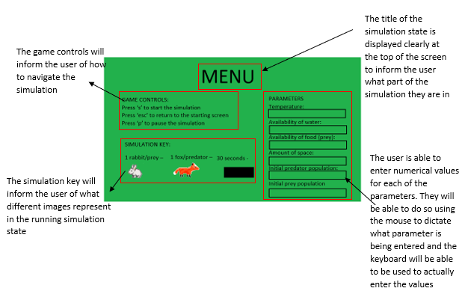

Running state

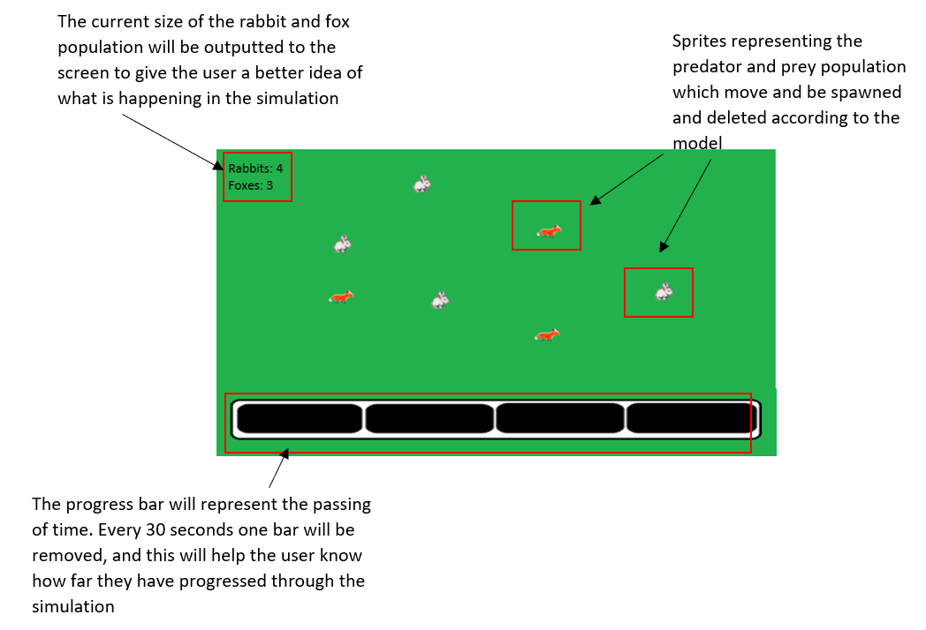

Paused

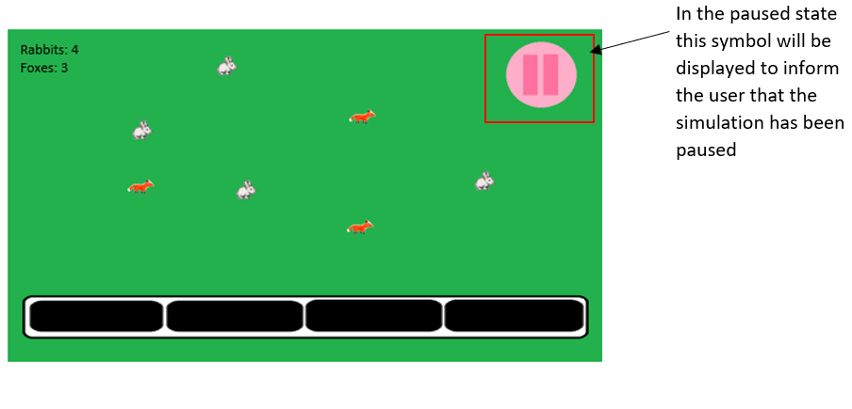

End state

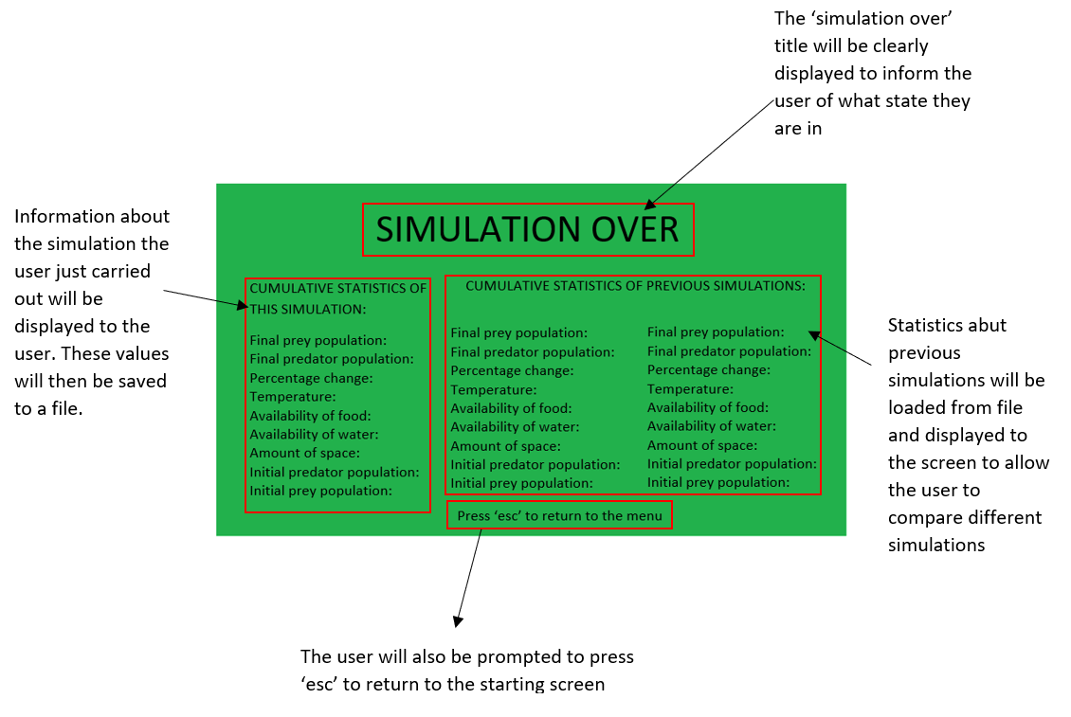

Class diagram

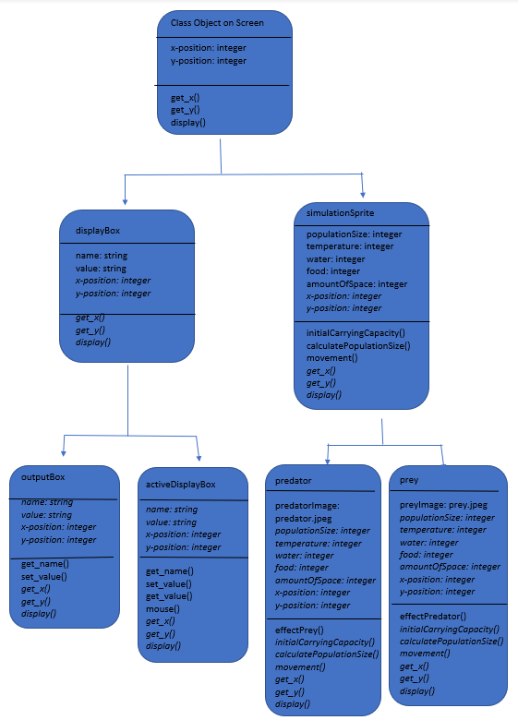

Algorithms

Save to file - Records the parameters, starting populations and final populations.

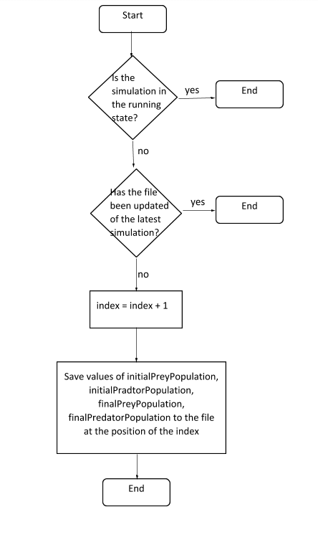

Display previous simulations.

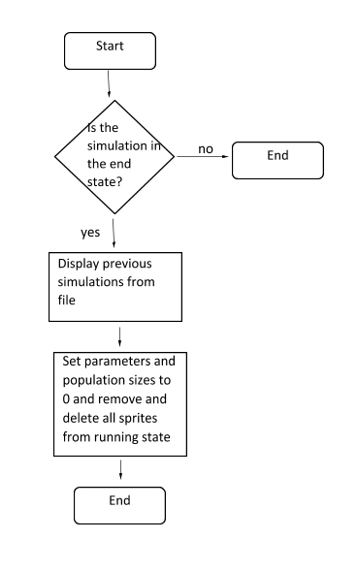

Paused

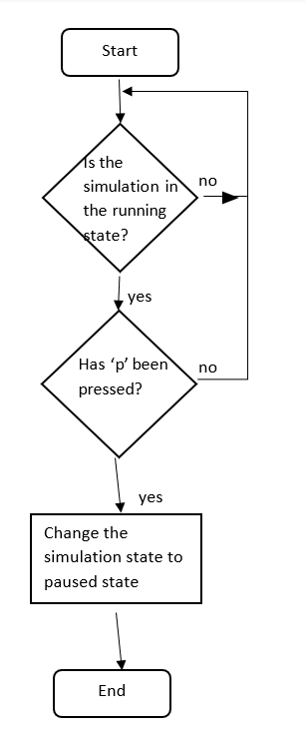

Unpause

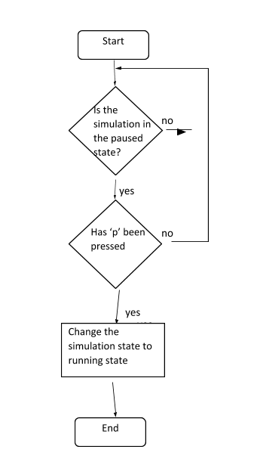

Menu - user controls

Go to running state.

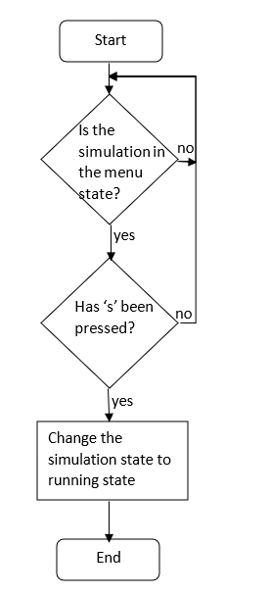

Enter parameters and validation.

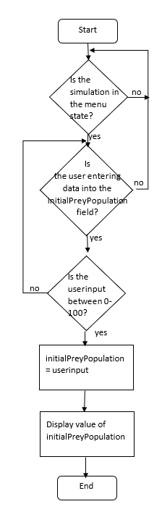 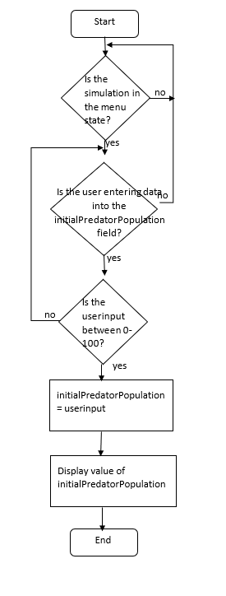

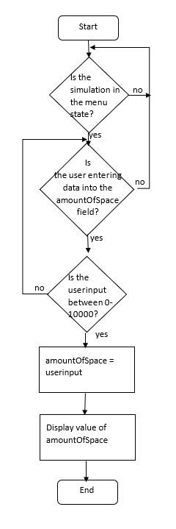 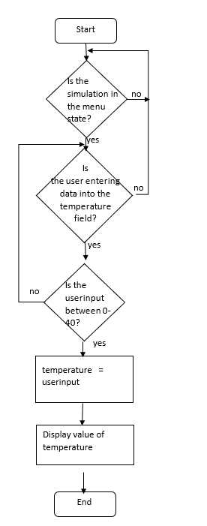

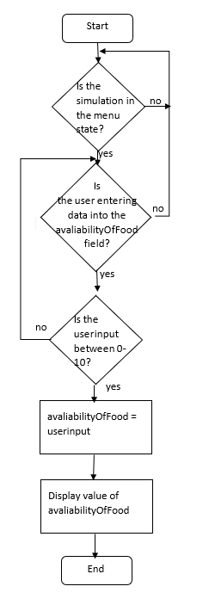 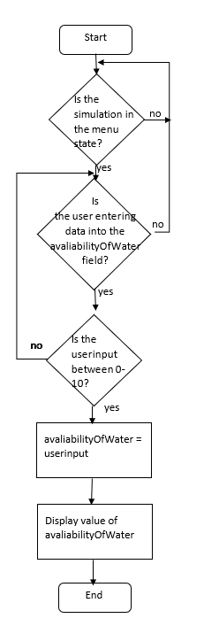

End simulation - visuals

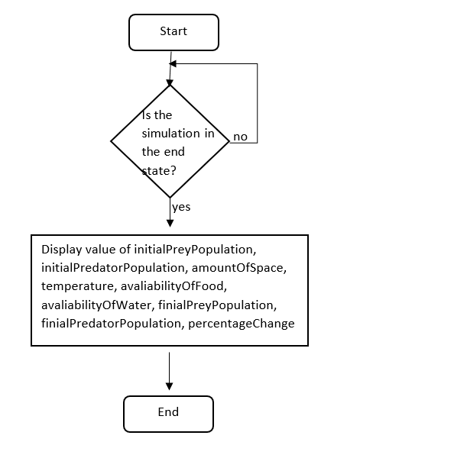

End state - Returning to the menu screen.

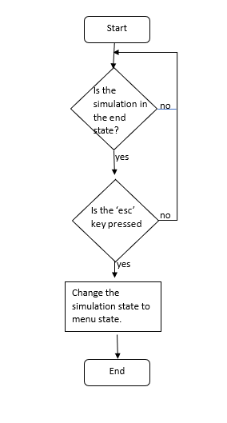

Running state - Effect of temperature, availability of water, availability of food, size of predator population

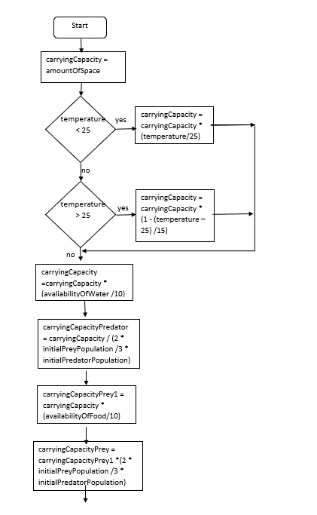

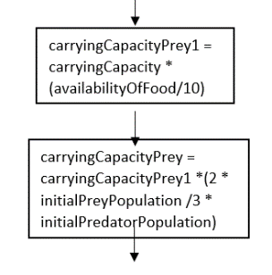

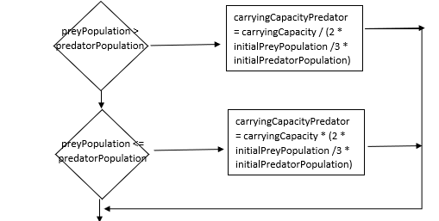

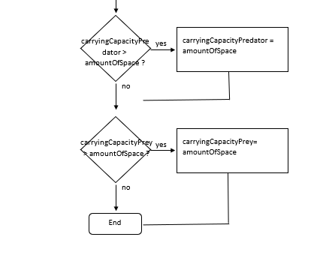

If the program were to have the following values:

Temperature: 27

availabilityOfWater: 7

amountOfSpace: 9800

avaliabilityOfFood: 9

initialPreyPopulation: 95

predatorPopulation: 89

|  |  |  |  |
| --- | --- | --- | --- |
| carryingCapacity | carryingCapcityPrey1 | carryingCapacityPrey | CarryingCapacityPredator |
| 9800 |  |  |  |
| 8493.3 |  |  |  |
| 5945.3 | 5350.8 | 3807.7 | 8354.7 |

Logistical model using an initial carrying capacity.

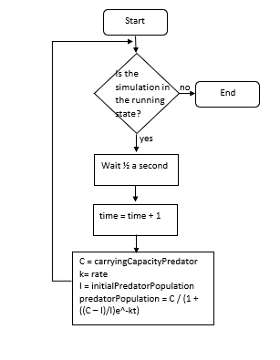

If the program were to have the following values:

time = 0

carryingCapacity = 1051.3

Rate = 0.5

Initial population = 89

|  |  |
| --- | --- |
| time | PredatorPopulation |
| 0 |  |
| 1 | 139 |
| 2 | 211 |
| ... |  |
| 10 | 980 |
| …. |  |
| 30 | 1051 |
| ... |  |
| 100 | 1051 |

Conditions for ending the running state.

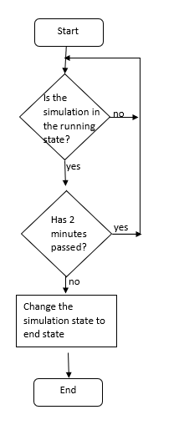

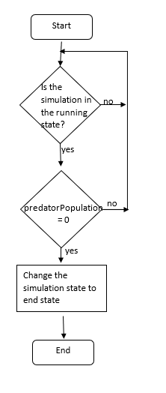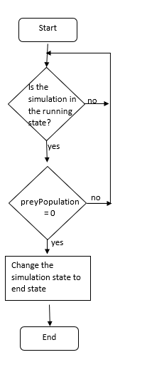

Running state – visuals

Progress bar

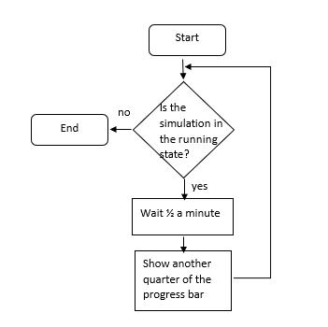

Display live statistics.

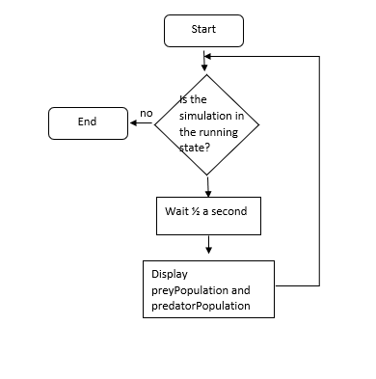

Running state - user controls

Returning to the menu

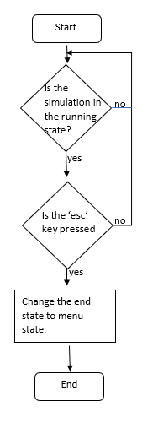

Linking the algorithm

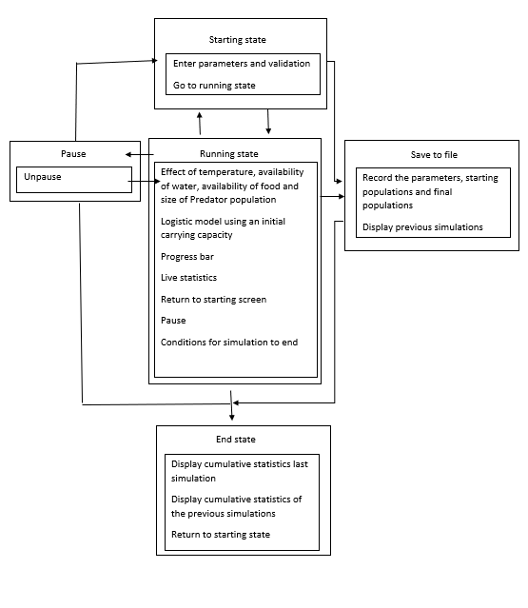

Key variables and data structures

|  |  |  |  |  |
| --- | --- | --- | --- | --- |
| Method | Name | Data Type | Explanation | Justification |
| Save to file |  |  |  |  |
| Simulation state | SaveToFile | N/A | This is where parameters and population sizes are saved to a file to then be loaded in the end state | This is where the code relating to saving data to a file will be stored |
| Procedure | saveFile | N/A | This will save parameters and population sizes to a file | This will allow the user to compare simulations easily |
| Array | parameters | N/A | Store the data to be saved to the file | This will allow the parameters and populations to be stored efficiently |
| Text file | parameters_file | .txt | This will store the parameters and populations of previous simulations | This will allow the parameters and populations to be stored |
| Paused |  |  |  |  |
| Simulation state | Paused | N/A | This is when the running state of the simulation is stored | This will be where the code related to pausing is |
| Procedure | Un-pause | N/A | This will change the simulation states from paused to running | This will allow the user to resume the running state |
| Field Sprite | pauseSign | .jpeg | This will show a pause sign | This will represent to the user that the simulation is paused |
| Menu |  |  |  |  |
| Simulation state | Menu | N/A | This is the part of the simulation where the user can enter parameters | This is where the code related to the menu is |
| Procedure | enterParameterAndValidation | N/A | This allows the user to enter parameters and validates them | This allows the user to change how the simulation will unfold and ensures they have entered valid values |
| Procedure | sPressed | N/A | Simulation state will change from the menu state to running state | This will allow the user to begin the simulation |
| Procedure | acceptParametersInput | N/A | This will allow the user to input parameters | This will allow the user to have more control over the simulation |
| Variable | preyPopulation | integer | A variable to hold the population of the prey which will first be dictated by the user | This will allow the user to have more control over the simulation |
| Variable | predatorPopulation | integer | A variable to hold the population of the predator which will first be dictated by the user | This will allow the user to have more control over the simulation |
| Variable | amountOfFood | integer | A variable to hold the amount of food for the prey which will be inputted by the user.  This will remain the same in the running state | This will allow the user to have more control over the simulation |
| Variable | temperature | integer | A variable to hold the temperature which will be inputted by the user.  This will remain the same in the running state | This will allow the user to have more control over the simulation |
| Variable | amountOfSpace | integer | A variable to hold the amount of space which will be inputted by the user.  This will remain the same in the running state | This will allow the user to have more control over the simulation |
| Variable | amountOfWater | integer | A variable to hold the amount of water which will be inputted by the user.  This will remain the same in the running state | This will allow the user to have more control over the simulation |
| Text label | simulationControls | Message Box | Text box that will display the user controls | This will help the user navigate the simulation |
| Text label | simulationKey | Message Box | Text box containing what different sprites represent | This will help the user understand the simulation |
| sprite | Rabbit | .jpeg | Image of still rabbit | This will make the simulation more interesting and will help to visually represent changing population sizes |
| sprite | timeBar | .jpeg | Box to represent a fixed unit of time that has passed in the simulation | This will help to give the user an idea of how far they have progressed through the simulation |
| sprite | Fox | .jpeg | Image of still fox | This will make the simulation more interesting and will help to visually represent changing population sizes |
| Text label | parameterName | Message Box | This will display what parameter the user can input below | This will help the user to input parameters |
| Text label | parameterEnter | Message Box | This will allow the user to input parameters | This will give the user greater control over the simulation |
| Text label | title | Message Box | Display the title of ‘menu so the user knows where they are in the simulation | This will help the user navigate the simulation |
| sprite | parameterBoxes | .jpeg | This will display where the user can enter parameters | This will help the user to input parameters |
| Text label | temperature | Message Box | This will accept the user input and output what they have inputted | This will allow the user to input parameters |
| Text label | amountOfSpace | Message Box | This will accept the user input and output what they have inputted | This will allow the user to input parameters |
| Text label | amountOfWater | Message Box | This will accept the user input and output what they have inputted | This will allow the user to input parameters |
| Text label | amountOfFood | Message Box | This will accept the user input and output what they have inputted | This will allow the user to input parameters |
| Text label | initialPrey | Message Box | This will accept the user input and output what they have inputted | This will allow the user to input parameters |
| Text label | initialPredator | Message Box | This will accept the user input and output what they have inputted | This will allow the user to input parameters |
| Running state |  |  |  |  |
| Simulation state | Running state | N/A | This is the state in which the simulation will take place | This is where code related to the running state will be |
| Procedure | Initialise | N/A | The simulation is initialized | This is where the variables are set |
| Procedure | Pause | N/A | The state is changed from the running state to the paused state | This is making the simulation more convenient as the simulation can be stopped and discussed for example |
| Procedure | Escape | N/A | This will change the running state to the end state | This will allow the user to stop the simulation when they like |
| Procedure | calculateCarryingCapacity | N/A | This will calculate the initial carrying capacity | This will make the simulation more accurate |
| Procedure | updateCarryingCapacity | N/A | This will update the carrying capacity as conditions end | This will mean that the changing population sizes will have an effect on each other making the simulation more accurate |
| Procedure | calculatePopulation | N/A | This will calculate the populations after each given unit of time | This will dictate how many sprites are outputted to the screen |
| Procedure | timeBar | N/A | This will output another bar of the progress bar after a given amount of time | This will allow the user to know the progress of the bar |
| Procedure | liveStatistics | N/A | This will each time the population is calculated output this new value to the screen | This will allow the user to easily see changes in population |
| Procedure | preySpawn | N/A | This will spawn the prey according to the model | This will allow the user to easily see changes in population |
| Procedure | predatorSpawn | N/A | This will spawn the predator according to the model | This will allow the user to easily see changes in population |
| Procedure | preyDelete | N/A | This will delete the prey according to the model | This will allow the user to easily see changes in population |
| Procedure | predatorDelete | N/A | This will delete the predator according to the model | This will allow the user to easily see changes in population |
| Procedure | preyMovement | N/A | This will move the prey on the screen | This will make the simulation more interesting to watch as it will be more life-like |
| Procedure | endSimulation | N/A | This will end the simulation if 2 minutes had passed or if one population is equal to 0 | This will mean that the simulation will not last too long nor will a population become too large and therefore hard to deal with |
| Procedure | predatorMovement | N/A | This will move the predator on the screen | This will make the simulation more interesting to watch as it will be more life-like |
| Procedure | SaveFile | N/A | At the end of the simulation this will append the final populations to the array containing information about the simulation and save this to file | This will allow the user to easily compare past simulations |
| variable | dt | real | This will be used in calculating the populations | This will therefore show the changes in populations over time |
| variable | carryingCapacity | real | This will be used in calculating the individual carrying capacities as some factors affecting it are the same | This will make the model more accurate |
| variable | carryingCapacityPrey | real | This will be used in calculating the populations | This will make the model more accurate |
| variable | carryingCapacityPredator | real | This will be used in calculating the populations | This will make the model more accurate |
| variable | preyPopulation | integer | This will be updated every fixed unit of time with the updated size of the prey population | This will store the result of the model |
| variable | predatorPopulation | integer | This will be updated every fixed unit of time with the updated size of predator population | This will store the result of the model |
| Flipbook animation | Rabbit | .jpeg | Animations group of a rabbit walking | This will make the simulation more interesting and will help to visually represent changing population sizes |
| Flipbook animation | Fox | .jpeg | Animation group of a fox walking | This will make the simulation more interesting and will help to visually represent changing population sizes |
| sprite | background | .jpeg | Green background | This will make the simulation more interesting without distracting from its educational value |
| sprite | progessBar | .jpeg | Box to represent the complete time of the simulation | This will help to give the user an idea of how far they have progressed through the simulation |
| sprite | timeBar | .jpeg | Box to represent a fixed unit of time that has passed in the simulation | This will help to give the user an idea of how far they have progressed through the simulation |
| Text label | Statistics | Message Box | This will display the current populations | This will allow the user to easily see the current population |
| End state |  |  |  |  |
| Simulation state | End state | N/A | This will be the screen displayed to the user when the simulation has ended that will display statistics from previous simulations and will allow the user to return to the menu screen | This will summarise the simulation from the user and allow them to start another simulation |
| Procedure | loadFromFile | N/A | This will load the last 2 simulations and display them to the screen | This will make comparing simulations easier |
| Procedure | displaySimulation | N/A | This will display statistics from the last simulation | This will give the user an overall look at the previous simulation |
| Procedure | Escape | N/A | Return the user to the menu when ‘esc’ is pressed | This will allow the user to begin again |
| Text label | userControls | N/A | Prompt the user to press ‘esc’ to return to the menu | This will help the user to navigate the simulation |
| Text label | title | N/A | This will tell the user that the simulation is in fact over and therefore what state they are in | This will help the user to navigate the simulation |

Test data

Save to file.

|  |  |
| --- | --- |
| Test data | Type |
| Array of integers (0, 8, 7, 4) | Valid |
| Array including non-integers (3.4, 6, “r”, “!”) | Invalid |

Menu

Enter parameters and validation.

Temperature

|  |  |
| --- | --- |
| Test data | Type |
| 0 | borderline |
| 40 | borderline |
| 25 | valid |
| “y” | Invalid |
| -7 | Invalid |

Initial Prey Population

|  |  |
| --- | --- |
| Test data | Type |
| 0 | borderline |
| 100 | borderline |
| 25 | valid |
| “y” | Invalid |
| -7 | Invalid |

Initial Predator Population

|  |  |
| --- | --- |
| Test data | Type |
| 0 | borderline |
| 100 | borderline |
| 25 | valid |
| “y” | Invalid |
| -7 | Invalid |

Availability of Food

|  |  |
| --- | --- |
| Test data | Type |
| 0 | borderline |
| 10 | borderline |
| 2 | valid |
| “y” | Invalid |
| -7 | Invalid |

Availability of Water

|  |  |
| --- | --- |
| Test data | Type |
| 0 | borderline |
| 10 | borderline |
| 2 | valid |
| “y” | Invalid |
| -7 | Invalid |

Availability of Space

|  |  |
| --- | --- |
| Test data | Type |
| 0 | borderline |
| 10000 | borderline |
| 2000 | valid |
| “y” | Invalid |
| -7 | Invalid |

Go to running state.

|  |  |
| --- | --- |
| Test data | Type |
| “s” | Valid |
| “!” | Invalid |
| “9” | Invalid |

Running state

Return to menu.

|  |  |
| --- | --- |
| Test data | Type |
| “esc” | Valid |
| “!” | Invalid |
| “9” | Invalid |

Pause

|  |  |
| --- | --- |
| Test data | Type |
| “p” | Valid |
| “!” | Invalid |
| “9” | Invalid |

Spawning of predator and prey

|  |  |
| --- | --- |
| Test Data | Type |
| Predator and prey spawned within parameters (1024,720) | Valid |
| Predator and prey spawned on perimeter (1024,720) | Borderline |
| Predator and prey spawned outside parameters (1024,720) | Invalid |
| Predator and prey can move within parameters (1024,720) | Valid |
| Predator and prey can move on perimeter (1024,720) | Borderline |
| Predator and prey can move outside parameters (1024,720) | Invalid |

Changes to prey and predator population

|  |  |
| --- | --- |
| Test data | Type |
| Population increased or decreased by an integer amount | Valid |
| Population increased or decreased by a non-integer amount | Invalid |
| Computation from model for prey population - amount of prey population being displayed = 0 | Valid |
| Computation from model for prey population - amount of prey population being displayed < 0 and no prey population are being removed | Invalid |
| Computation from model for prey population - amount of prey population being displayed > 0 and no prey population are being spawned | Invalid |
| Computation from model for predator population - amount of predator population being displayed = 0 | Valid |
| Computation from model for predator population - amount of predator population being displayed < 0 and no predator population are being removed | Invalid |
| Computation from model for predator population - amount of predator population being displayed > 0 and no predator population are being spawned | Invalid |

Paused

Un-paused

|  |  |
| --- | --- |
| Test data | Type |
| “p” | Valid |
| “!” | Invalid |
| “9” | Invalid |

End state

Return to the menu state.

|  |  |
| --- | --- |
| Test data | Type |
| “esc” | valid |
| “h” | Invalid |
| “!” | Invalid |

Acceptance testing

|  |  |  |  |
| --- | --- | --- | --- |
| No. | Requirements | Input | Expected outcome |
| 1 | Save the parameters to an array | N/A | Valid: an array containing the values of the parameters as integer in a predetermined order  Invalid: a data structure other than an array containing any value that is not an integer |
| 2 | Press the ‘p’ key to enter the paused simulation state from the running state | **Valid:** “p”  **Invalid:** “h”, “6”, “!”` | Valid: the running state is paused  Invalid: The running state will be continuing without any disruption or changes to another state |
| 3 | Press the ‘p’ key to unpause the simulation and re-enter the running state | **Valid:** “p”  **Invalid:** “h”, “6”, “!”` | Valid: the running state is returned to  Invalid: The simulation will continue to be paused or changes to another state |
| 4 | Menu displayed with a title, simulation key, user control instructions and text box to enter parameters | N/A | Valid: The user will have instructions about simulation controls and what images of the simulation represent and a text box to enter parameters  Invalid: The user will have something other than previously mentioned displayed to them or does not have something from the previously mentioned displayed to them |
| 5 | The user can enter the temperature parameter however it must be validated and be within 0-40 | **Valid**: 34  **Borderline (valid):** 0, 40  **Invalid:** “r”, 76, “!”, 3.4 | Valid: the user input will be stored as the value for the variable temperature  Invalid: the program will output that this is an invalid input, and the user will be able to input a new value |
| 6 | The user can enter the initial prey population parameter however it must be validated and be within 0-100 | **Valid:** 34  **Borderline (valid):** 0, 100  **Invalid:** “r”, 124, “!”, 3.4 | Valid: user input will be stored as the value for the variable initial prey population  Invalid: the program will output that this is an invalid input, and the user will be able to input a new value |
| 7 | The user can enter the initial predator population parameter however it must be validated and be within 0-100 | **Valid:** 34  **Borderline (valid):** 0, 100  **Invalid:** “r”, 124, “!”, 3.4 | Valid: the user input will be stored as the value for the variable initial predator population  Invalid: the program will output that this is an invalid input, and the user will be able to input a new value |
| 8 | The user can enter the availability of food parameter however it must be validated and be within 0-10 | **Valid:** 3  **Borderline (valid):** 0, 10  **Invalid:** “r”, 76, “!”, 3.4 | Valid: the user input will be stored as the value for the variable availability of food  Invalid: the program will output that this is an invalid input, and the user will be able to input a new value |
| 9 | The user can enter the availability of water parameter however it must be validated and be within 0-10 | **Valid:** 3  **Borderline (valid):** 0, 10  **Invalid:** “r”, 76, “!”, 3.4 | Valid: the user input will be stored as the value for the variable availability of water  Invalid: the program will output that this is an invalid input, and the user will be able to input a new value |
| 10 | The user can enter the amount of space parameter however it must be validated and be within 0-10000 | **Valid:** 34  **Borderline (valid):** 0, 10 000  **Invalid:** “r”, 76, “!”, 3.4 | Valid: the user input will be stored as the value for the variable amount of space  Invalid: the program will output that this is an invalid input, and the user will be able to input a new value |
| 11 | All sprites and backgrounds will be simple and clear | N/A | Valid: All sprites and backgrounds will be simple and clear without pixilation or objects being out of scale  Invalid: The sprites and backgrounds are not clear and there is pixilation or objects out of scale |
| 12 | Press the ‘s’ key to enter the running state from the menu state | **Valid:** “s”  **Invalid:** “h”, “6”, “!”` | Valid: becomes the running state from the menu state  Invalid: the simulation will remain in the menu or changes to another state |
| 13 | The carrying capacity will be initially calculated from the amount of space | N/A | Valid: carryingCapacity is initially equal to the amountOfSpace  Invalid: carryingCapacity is not initially equal to the amountOfSpace |
| 14 | The parameters the temperature and availability of water will affect the carrying capacity of the populations in the same way | N/A | Valid: the temperature and availability of water will affect the carrying capacity of the populations in the same way  Invalid: the temperature and availability of water do not affect the carrying capacity of the populations in the same way |
| 15 | The carrying capacity of the prey will be affected by the availabilityOfFood | N/A | Valid: The carrying capacity of the prey will be affected by the availabilityOfFood  Invalid: The carrying capacity of the prey will not be affected appropriately by the availabilityOfFood |
| 16 | The availability of food for the predator will be dictated by the population size of prey which will then in turn affect the carrying capacity of the predator | N/A | Valid: population size of the prey will affect the carrying capacity of the predator  Invalid: population size of the prey will not appropriately affect the carrying capacity of the predator |
| 17 | The predator population will affect the prey population, and this will be updated each time the population is calculated | N/A | Valid: population size of the predator will affect the carrying capacity of the prey  Invalid: population size of the predator will not appropriately affect the carrying capacity of the prey |
| 18 | Use a logistical model to accurately calculate the predator population | N/A | Valid: the logistical model is used to accurately calculate the predator population  Invalid: the logistical model is not used to accurately calculate the predator population |
| 19 | Use a logistical model to accurately calculate the predator population | N/A | Valid: the logistical model is used to accurately calculate the prey population  Invalid: the logistical model is not used to accurately calculate the prey population |
| 20 | Have sprites of the appropriate population spawned if the calculated population is greater than the number of displayed sprites and deleted if less | N/A | Valid: Have the same number of sprites as the size of the two populations  Invalid: to not have the same number of sprites as the size of the two populations |
| 21 | Have a progress bar to represent the passing of time | N/A | Valid: Have another time bar be displayed every 30 seconds  Invalid: Have another time bar be displayed at different time intervals or not displayed at all |
| 22 | Have population size boxes for the size of the predator and prey populations outputted live as the simulation goes on at the top left of the screen | N/A | Valid: Have the population sizes displayed  Invalid: no values are displayed for the populations or values other than the size of the populations are displayed or values are displayed that are not integers |
| 23 | Have the simulation end and enter the ending state after a certain amount of time (2 minutes) | N/A | Valid: If two minutes had passed the simulation should end  Invalid: The simulation ends at any other time unless other conditions are met |
| 24 | Have the simulation end if a population becomes extinct | N/A | Valid: the simulation ends  Invalid: the simulation doesn’t end |
| 25 | Save to file the array storing the parameter values and the final populations before the simulation moves to the end state | N/A | Valid: text file is appended to include the parameters and final populations of the simulation that has just run  Invalid: text file doesn’t include the parameters and final populations of the simulation that has or contains the incorrect values |
| 26 | Use the ‘esc’ key to return to the menu state from the running state | **Valid:** “esc”  **Invalid:** “h”, “6”, “!”` | Valid: the simulation moves to the menu state  Invalid: the simulation stays in the running state or changes to a different state |
| 27 | Have the end state display the cumulative stats including the final size of both populations and both of their percentage changes. As well as a prompt for the user to press ‘esc’ to return to the menu state | N/A | Valid: Have the end state display the cumulative stats including the final size of both populations and both of their percentage changes for the last three simulations. As well as a prompt for the user to press ‘esc’ to return to the menu state.  Invalid: having anything displayed not mentioned above or not displaying something of the above |
| 28 | Use the ‘esc’ key to return to the menu state from the end state | **Valid:** “esc”  **Invalid:** “h”, “6”, “!”` | Valid: the simulation moves to the menu state  Invalid: the simulation stays in the end state or changes to another state |
| 29 | Have the simulation load from file the statistics from the two previous simulations if two simulations have been run | N/A | Valid: The statistics from two previous simulations will be displayed  Invalid: the statistics from the last two simulations are not displayed |

**C. Developing the coded solution (“The development story”)**

18/11/20

The development of my simulation will follow an iterative process by which I will produce successive prototypes interviewing my stakeholder after each prototype to give comments and make improvements for the next iteration to ensure that it meets the requirements. I will develop modules based upon the systems diagram to ensure development is logical and easy to follow. This process will repeat until a completed solution that the stakeholders are content with is reached or I run out of time.

Code Decomposition

To begin code development, I have researched other code to learn some techniques that I will be able to implement into my own code. I have used David Chadwick’s tutorial for the Tower Defence Game and ‘Balloon Pop!’ game.

The video tutorial for the Tower Defence Game:

<https://www.youtube.com/channel/UCkHxiTiccq97knREKsi5UKA/videos>

‘Balloon Pop!’ game tutorial

<https://www.tactxstudios.com/_B_BalloonPop.html>

Tower Defence Game

Structure

Here David Chadwick has created a collection called tower_game which contains the pause GUI, a loader script and the gameProxy. Although I think that I am going to have the symbol for pause in the same script that controls the running state and have the time step to 0 in the controller script. I am going to use elements of the loader script in my controller script as well as proxies for each simulation state as Chadwick has.

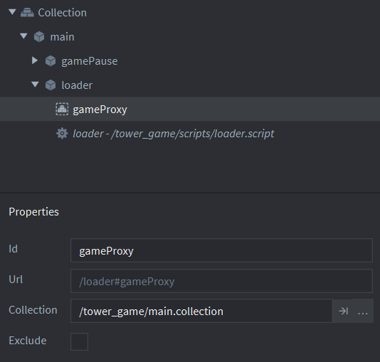

Here the collection the collection proxy will load is set and Chadwick has chosen to not tick the exclude option I will also do this as it downloads the contents of the collection with the code instead of when built which is not necessary as it requires the live update feature which will then add complication.

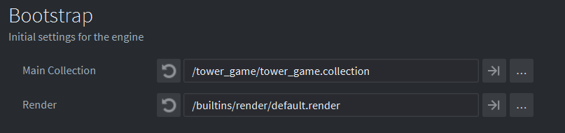

This dictates which collection is first run when the game is run. Here this is set so the collection including the loader script and proxies are first loaded. I will also set the bootstrap to be the collection including the controller script and collection proxies

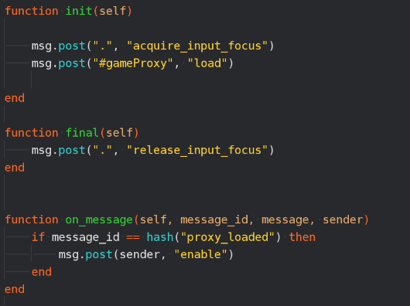

This is the loader script where a proxy is being used to load the game. I will use this same technique in my controller script to move between simulation states.

Pause

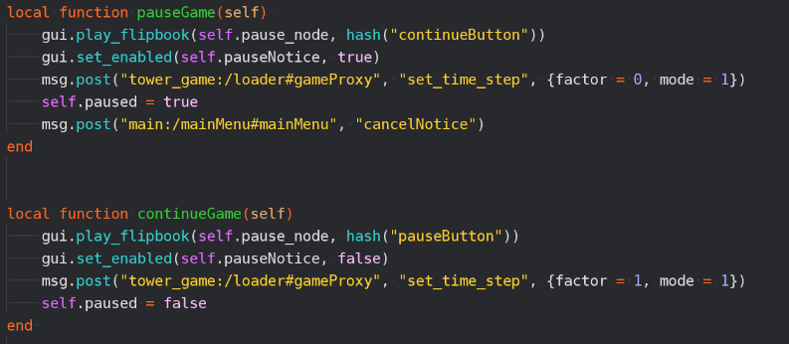

Although I do not think I am going to use a GUI for the pause I will use the same functions to set the time to 0 and then back to a factor of 1.

Menu

The game object cursor in this example includes a collision object to allow there to be a reaction to the user clicking on elements on the screen, a script to control and initiate this reaction and a label that output the coordinates of the cursor. I will include the collision object and script. Additionally this game object does not have a sprite as instead the machine mouse is used and the game object is updated to the position of the machine cursor, I will also rely on this approach.

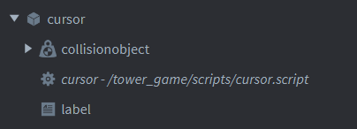

This is from the cursor script and similarly to Chadwick I will need to update the cursor position to that of the machine cursor and will do so in the same way.

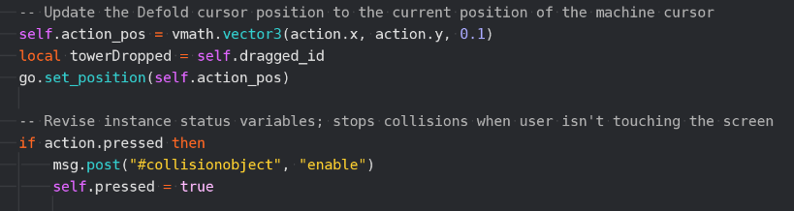

Similarly, when the mouse is pressed this will result in a message being sent to the script of the box that has been collided with and clicked on.

Balloon pop game:

Spawning

Balloon prototype

Here a prototype is used for the on-screen objects and this prototype has a sprite attached and a script to dictate the actions of the balloon. I will similarly use a prototype for the fox and rabbit objects, they will both have an appropriate sprite and a script to control its movement (both prototypes will have the same script for movement).

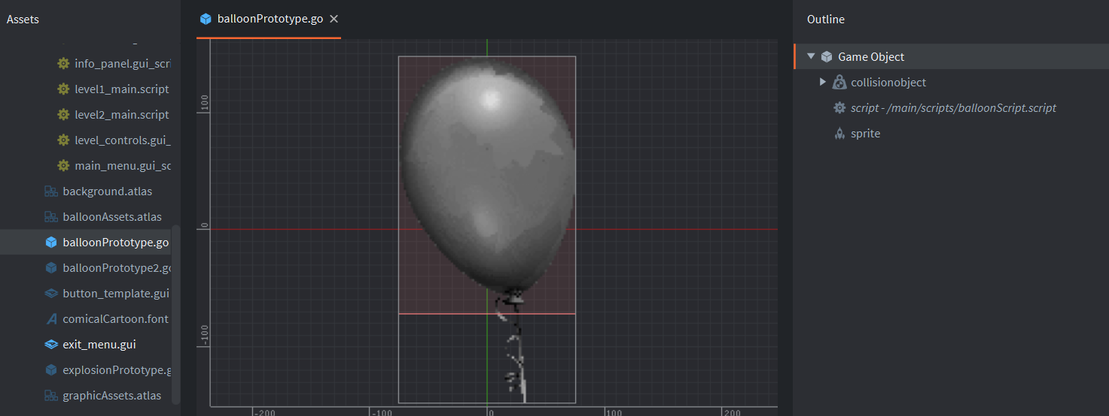

Level 1 Collection

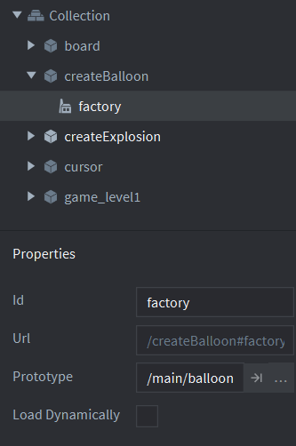

The prototype for the factory is set here. I will here set one factory to the rabbit prototype and another to the fox prototype.

A factory is then included into the collection which allows for the game object prototypes to be produced. I will have two factories for loading the rabbits and foxes.

Here the creators of this game have selected to not have the game loaded dynamically. I will also make this choice. This means the engine loads the prototype resources when the factory is loaded which is fine as the prototype will not require much memory.

level1_main script

Here the function factory.create() is used to create instances of the balloon. I will also use this function to create instances of the of the rabbit and fox. I will also use the parameters of this function to set the position as in this example and to set the scale to around 0.2.

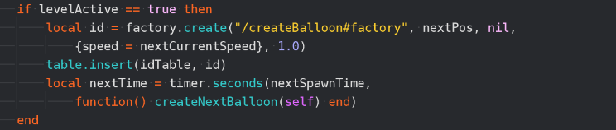

This means that a new balloon is spawned at different intervals. I will calculate the population of foxes and rabbits and spawn an appropriate amount of game objects at a regular interval of time. I will therefore use the update function and a variable representing time passed to do this instead of the timer function.

In this example the id of each instance of the prototype is stored into a table. I will also do this to keep track of the game objects that have been spawned.

This sets the position for the balloon to be spawned. I will use a similar process but will set the y value to a random number within the screen as well.

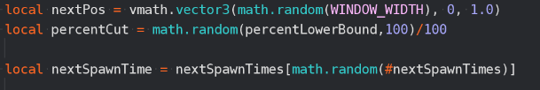

This sets the time until another balloon is spawned. I will not do this as my simulation will spawn game objects at regular intervals so I will use the update function and a variable to act as a timer.

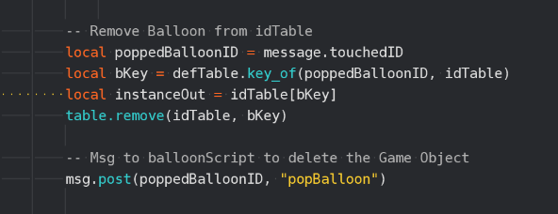

This removes the id of the game object that has been deleted. I will also do this to ensure that the table effectively keeps track of the game objects that have been spawned.

balloonScript

This deletes the game object. I will also use this when the size of the population is decreasing. However I will include the parameters to set specify the id of the game object to be deleted and I will set the second parameter recursive to true to ensure that all elements of the game object are deleted

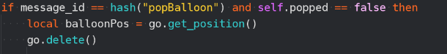

18/11/20 - Sprite creation

I first searched on the website OpenGameArt.org for the sprites for the fox and rabbit using the websites search engine to quickly find the relevant sprites that were simple to fit with my simulation’s style which can both be seen in the below images.

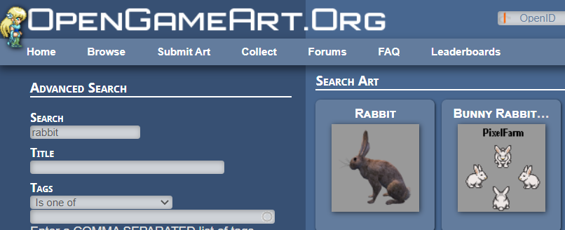

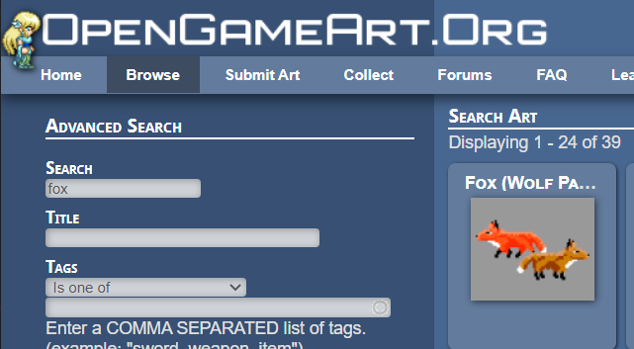

I then used Microsoft paint to resize both of these sprites and add the background otherwise there would be a white box around each sprite.

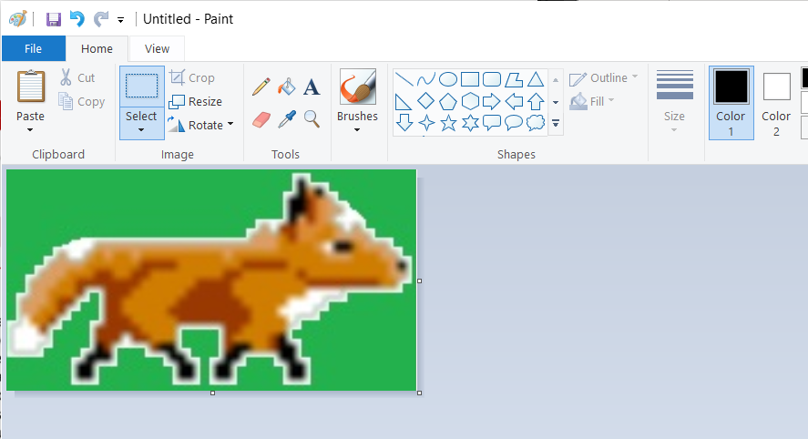

For a number of other sprites such as the background and any boxes I created these scripts in Microsoft paint, this was especially useful as it allows me to ensure they were exactly the correct size.

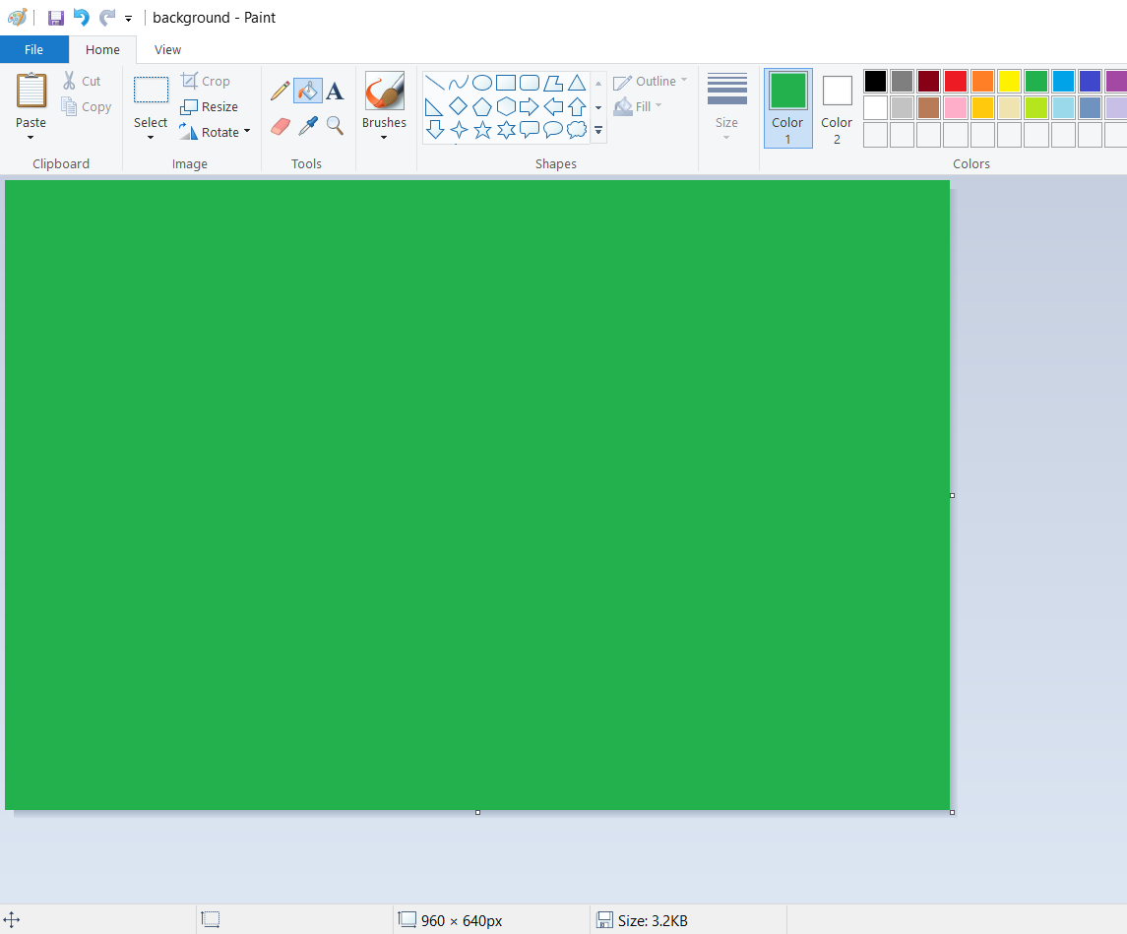

Here Microsoft paint has a function that allows you to edit the size of the image

Other sprites such as the display for the menu I created in Microsoft word as this made combining multiple elements including text far easier and because of the simplicity of my sprites. I used the highlighted features to create the necessary shapes and imported the necessary sprites.

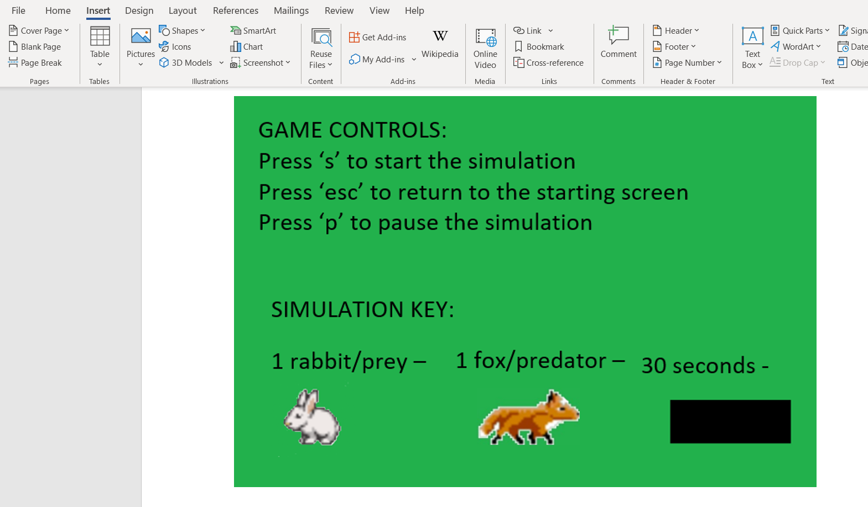

I then saved these scripts to a file so they would be easy to find when they were to be included into my simulation.

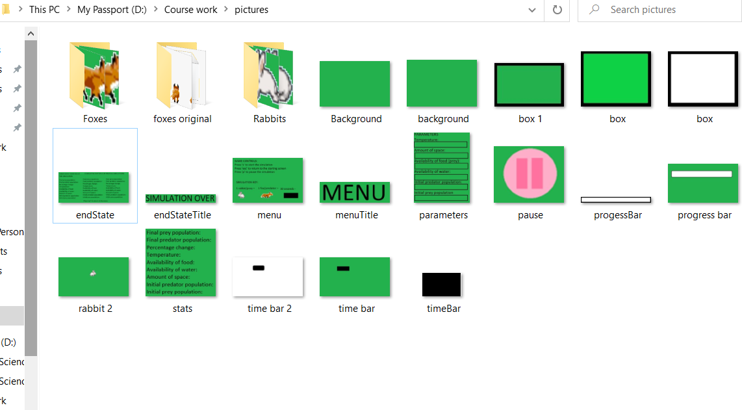

I then saved these to a file within my project so they could be accessed by the game engine.

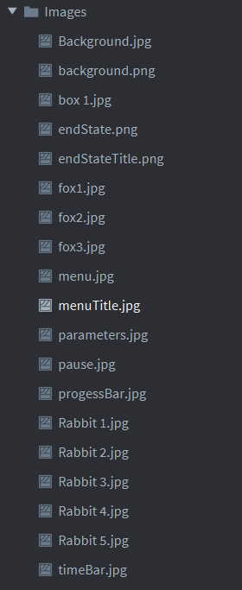

I then created an atlas and loaded these images into this atlas with the rabbit images and fox images forming animation groups which have been set to have playback as loop forward and 3 frames per second as this will allow the sprites to be animated smoothly and the rest are added as individual images with no animation and now these images could be used as sprites in the simulation.

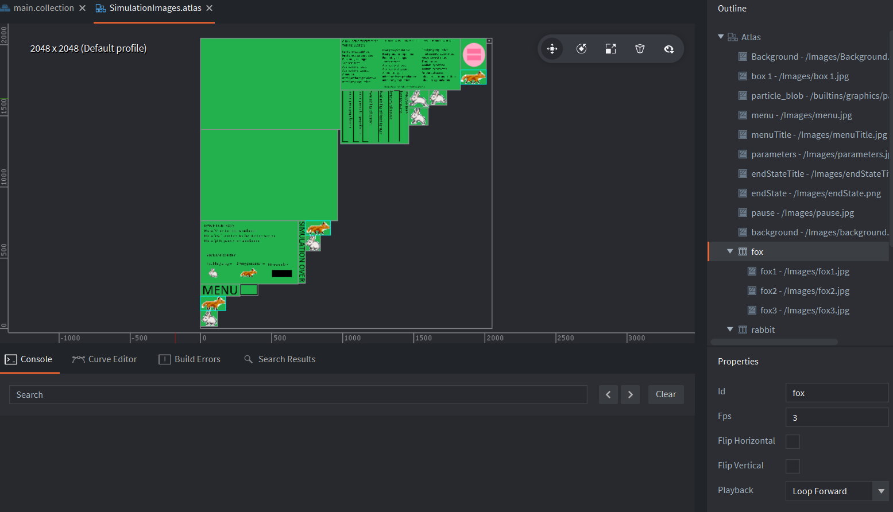

22/11/20 – Structure of the simulation

I began by creating the structure of the simulation, in order to do this, I created the necessary collections, the main collection, the menu collection, the simulation collection and the end collection. The main collection acts as a controller meaning that it has no sprites and remains loaded for the entirety of the simulation, it is the collection that will load and unload collections and will allow information to be passed between the collections as they will never be loaded at the same time. Furthermore, the input binding was also set to allow the user to navigate between these simulation states with the main collection’s controller script processing these inputs.

This shows the collections representing each simulation state.

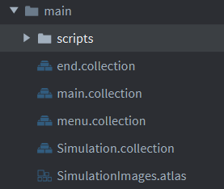

The input bindings as shown below will allow the user to navigate the simulation with the controller collection receiving the following action_ids and behaving appropriately from this.

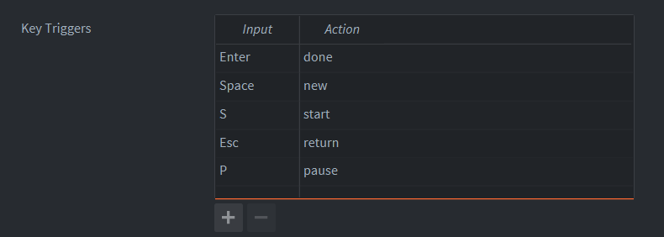

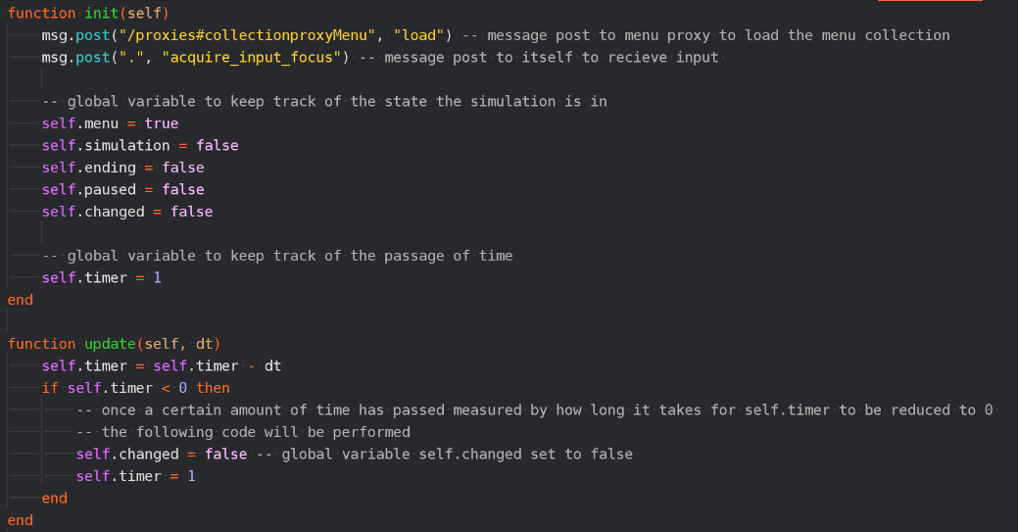Below is the controller script which takes the input from the user and ensures the simulation is in the correct state:

Message post to the menu proxy ensures that the menu is immediately loaded when the simulation begins.

Message post to the same script that ensures that the script recognizes inputs.

This ensures that once a key is pressed the intended action is only performed once as when a key is pressed the appropriate action is carried out once and self.changed is set to true to prevent this input from being processed more than once per key press. After a set period of time self.changed is set to false as in theory the user will have ended that key press and then input can be processed again.

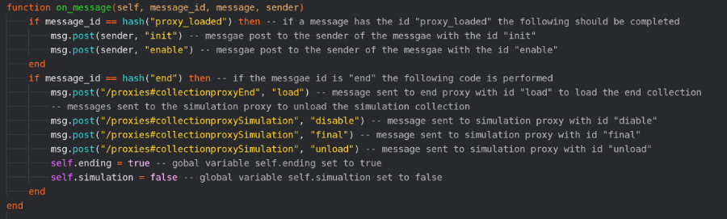

Once a proxy has loaded a collection it sends a message back to the script with id “proxy_loaded” and then the collection needs to be enabled and have the init functions of the scripts run.

When the spawning script from the simulation collection sends the controller script a message that the end of the simulation has been reached the end collection is loaded and the simulation collection unloaded

Global variable self.ending is true and self.simulation is false to represent the simulation’s state.

If ‘s’ key is pressed and the simulation is in its menu state, the simulation state changes to running (simulation collection) and the global variables are changed to reflect this. Self.menu has to be true as the simulation state can only be accessed from the menu and self.changed has to be false to prevent the simulation state from being loaded multiple times.

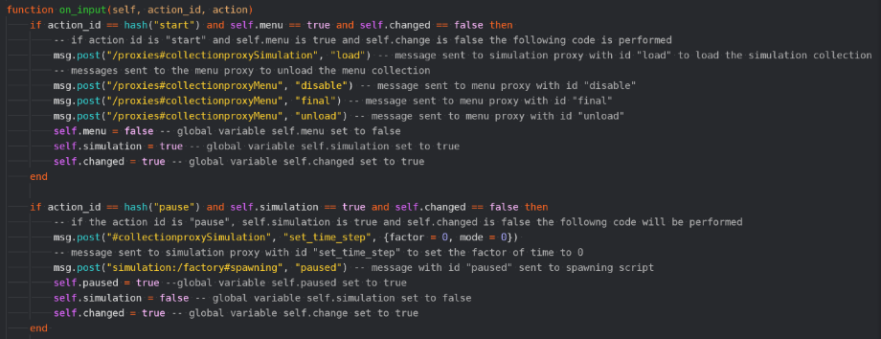

If the ‘p’ key is pressed and the simulation is in its simulation state and it will stop and then begin again when the ‘p’ key is pressed again

Message sent to spawning script which causes this script to display the pause symbol and then message sent for the spawning script to hide the pause symbol.

By setting the factor of time to 0 this means that update functions stop and therefore by setting the factor of time to 1 they continue again at the same speed

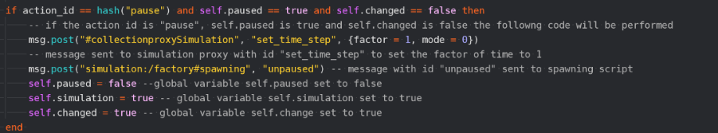

It is vital self.changed equal to false is a part of this condition and the one in the previous screenshot as it can be seen another condition is that self.paused is true which is set true in the code following the previous use of selection. Therefore because they are triggered by the same key press without this self.changed variable the simulation would alternate between paused and unpaused whilst the user was performing the key press and therefore would not pause for the desired amount of time

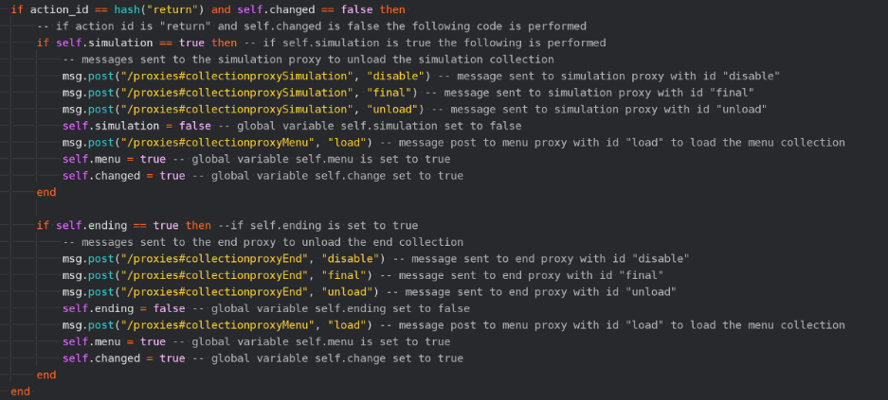

If ‘m’ key is pressed then if in simulation or end state then the simulation state will change to the menu state

Below is part of the spawning script that will later control the running script but now displays the paused symbol and controls ending the simulation:

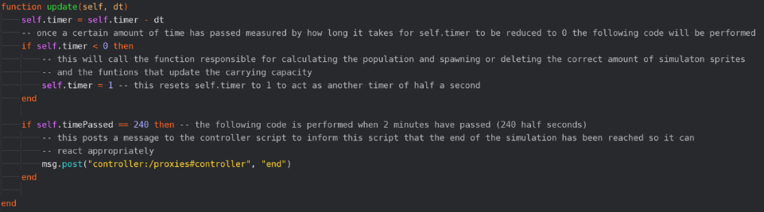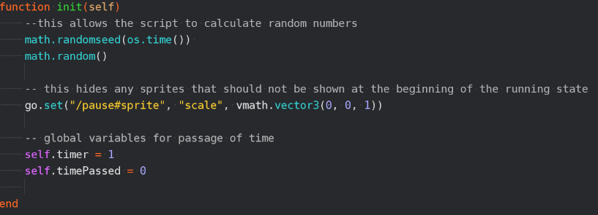

The pause symbol is initial set to a scale of 0 so it cannot be seen.

This works as a timer as after each dt unit of time has passed the value of dt is subtracted from self.timer until self.timer is 0 at which point code for the simulation is called and self.timer is set to 1 to begin this process again thereby acting as a counter.

After 2 minutes have passed a message is sent to the controller script with the id “end” and this leads to the controller script unloading the simulation state and the end state being loaded.

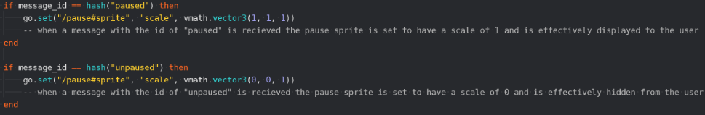

Receives message when simulation paused and the pause symbol is set to scale 1 and then receives a message when upaused and the symbol’s scale is set to 0.

Below is a series of tests in ensure the simulation is moving between states correctly and each test is followed by an image demonstrating that the actual outcome was in fact achieved:

|  |  |  |  |  |
| --- | --- | --- | --- | --- |
| What is being tested? | Input | Justification | Expected Outcome | Actual Outcome |
| Does the simulation state change from menu to running | s | This allows the user to begin the simulation | Green screen | Green screen |

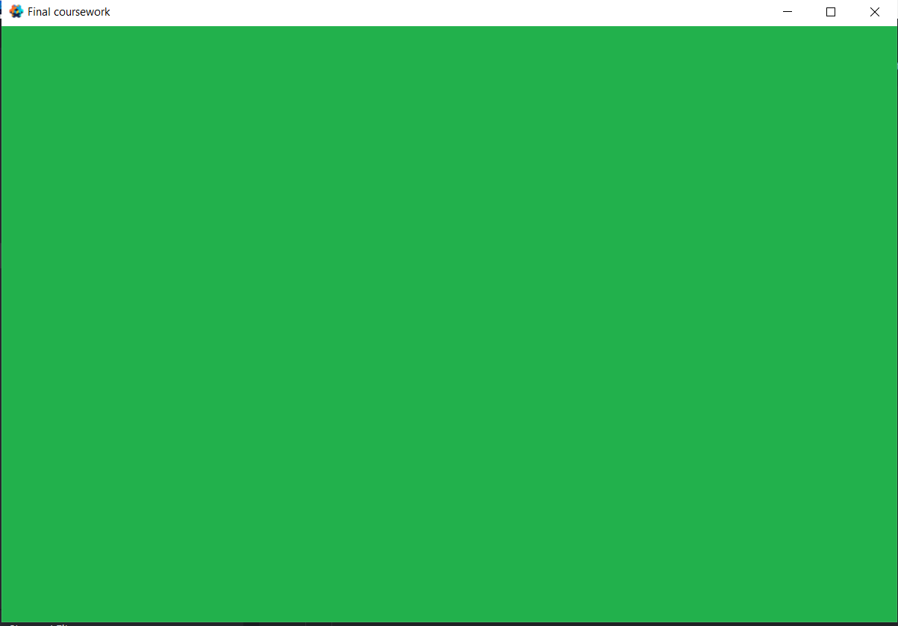

|  |  |  |  |  |
| --- | --- | --- | --- | --- |
| What is being tested? | Input | Justification | Expected Outcome | Actual Outcome |
| Does the simulation state change from running to pause | p | This allows the user to pause the simulation | Green screen with pause symbol | Green screen with pause symbol |

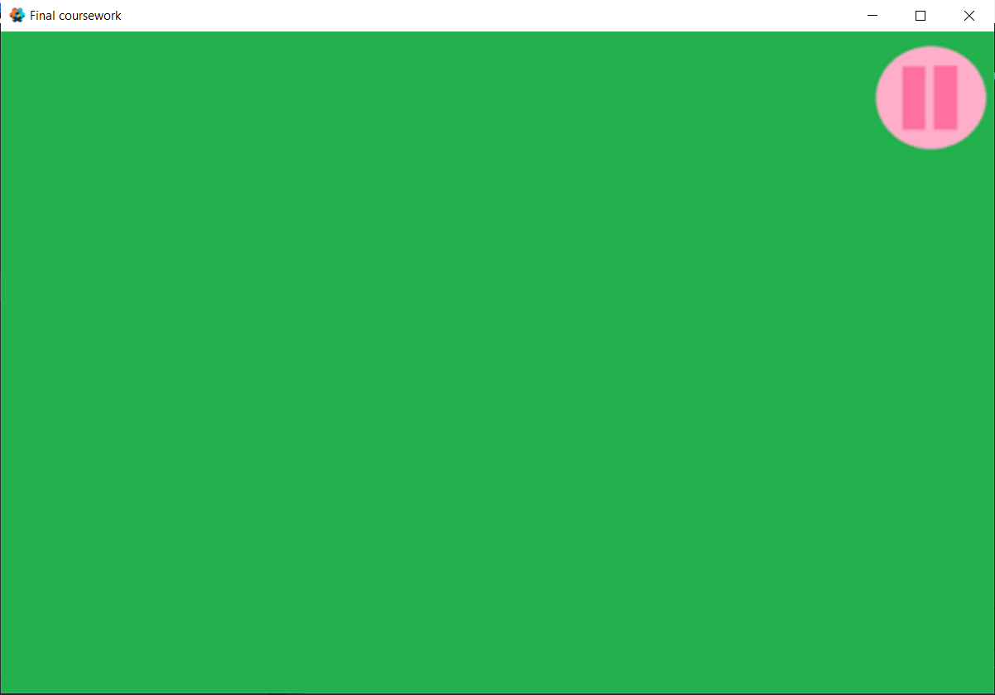

|  |  |  |  |  |
| --- | --- | --- | --- | --- |
| What is being tested? | Input | Justification | Expected Outcome | Actual Outcome |
| Does the simulation state change from pause to running | p | This allows the user to unpause the simulation | Green screen | Green screen |

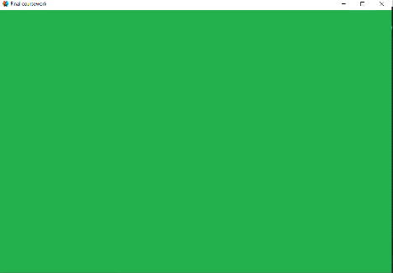

|  |  |  |  |  |
| --- | --- | --- | --- | --- |
| What is being tested? | Input | Justification | Expected Outcome | Actual Outcome |
| Does the simulation state change from pause to end | N/A | This ends the simulation after a set period of time | Green screen with title simulation over | Green screen with title simulation over |

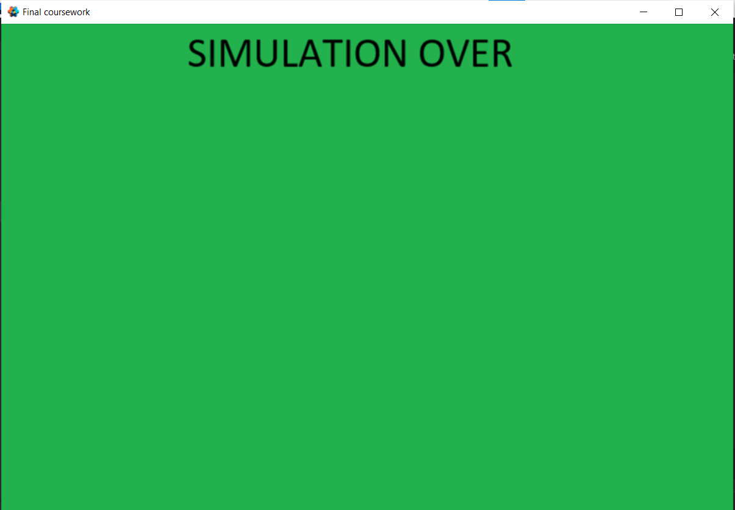

|  |  |  |  |  |
| --- | --- | --- | --- | --- |
| What is being tested? | Input | Justification | Expected Outcome | Actual Outcome |
| Does the simulation state change from simulation to menu | ‘m’ | This allows the user to stop the simulation | Green screen with title menu | Green screen with title menu |

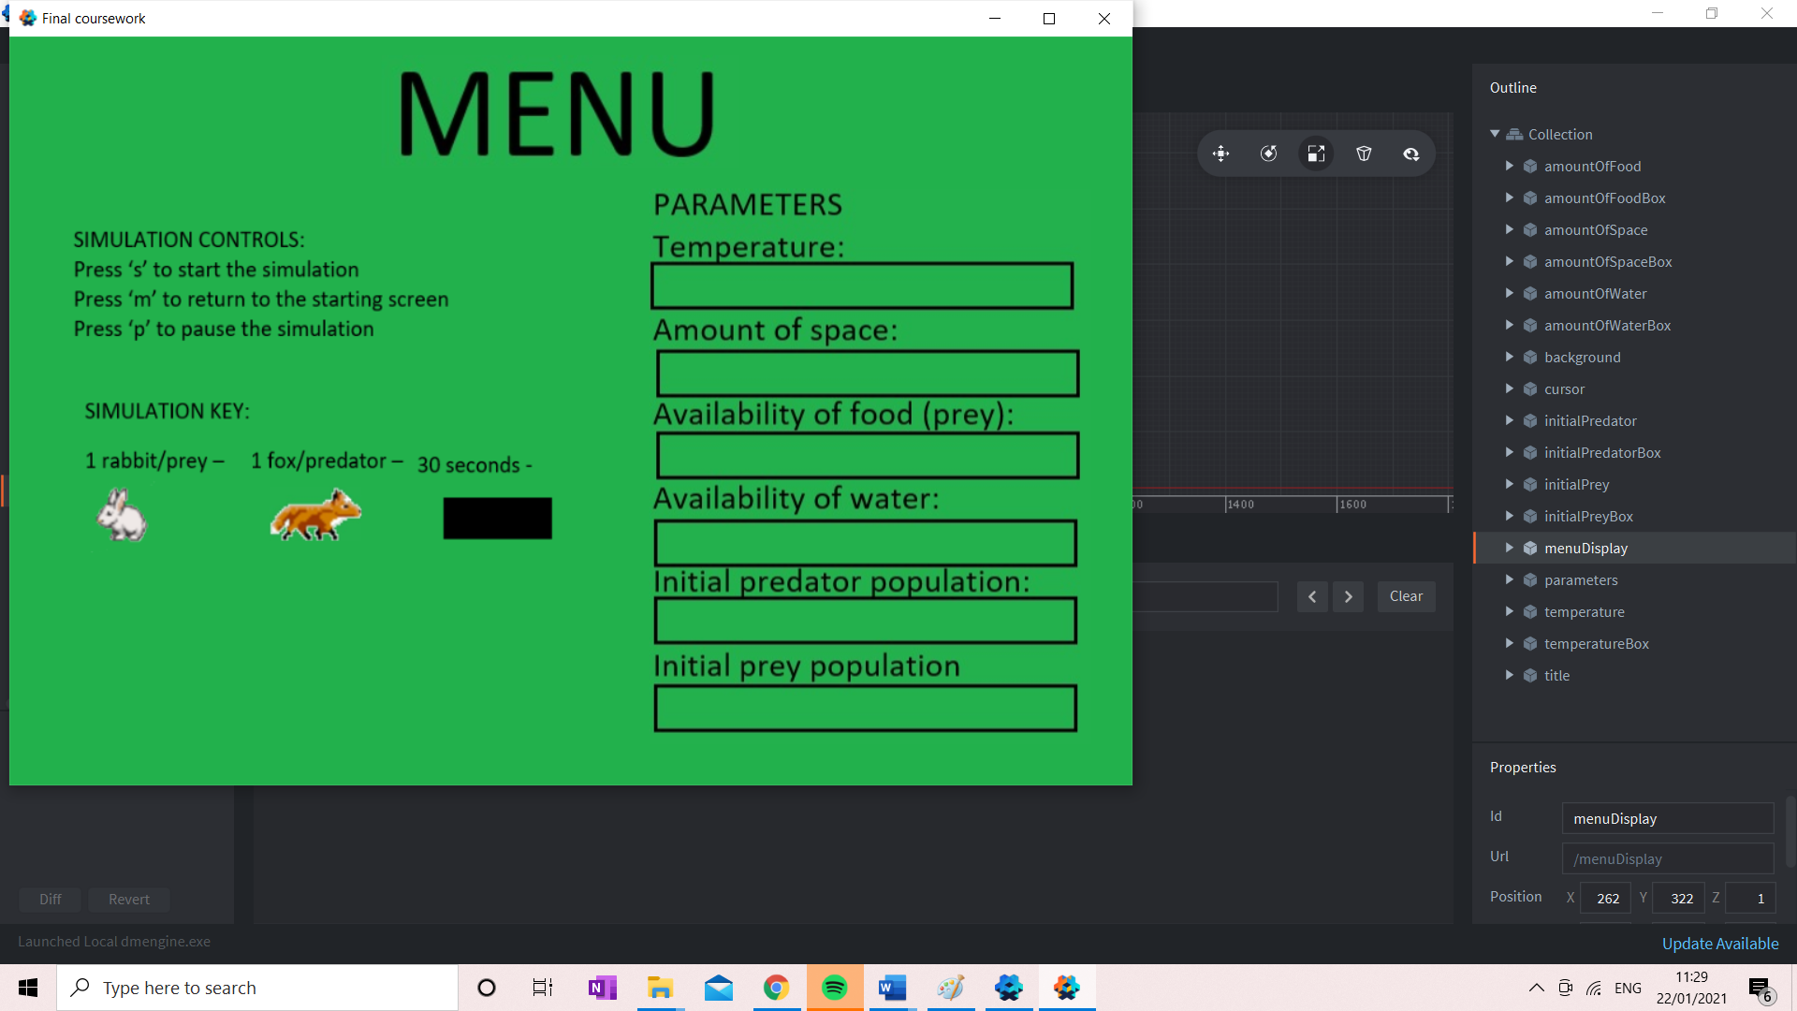

|  |  |  |  |  |
| --- | --- | --- | --- | --- |
| What is being tested? | Input | Justification | Expected Outcome | Actual Outcome |
| Does the simulation state change from end state to menu | ‘m’  (‘esc’ in defold closes the window) | This allows the user to stop the simulation | Green screen with title menu | Green screen with title menu |



Testing input data

Below I am testing inputting valid and invalid data into the different states to ensure the desired input has the desired effect and invalid input does not affect the simulation.

Menu state

Go to running state.

|  |  |  |
| --- | --- | --- |
| Test data | Type | Actual |
| “s” | Valid | Valid |
| “!” | Invalid | Invalid |
| “9” | Invalid | Invalid |

Running state

Return to menu

|  |  |  |
| --- | --- | --- |
| Test data | Type | Actual |
| “esc” | Valid | Exits window |
| “!” | Invalid | Invalid |
| “9” | Invalid | Invalid |

|  |  |  |
| --- | --- | --- |
| ‘m’ | Valid | Valid |

Pause

|  |  |  |
| --- | --- | --- |
| Test data | Type | Actual |
| “p” | Valid | Valid |
| “!” | Invalid | Invalid |
| “9” | Invalid | Invalid |

Paused state.

Un-pause

|  |  |  |
| --- | --- | --- |
| Test data | Type | Actual |
| “p” | Valid | Valid |
| “!” | Invalid | Invalid |
| “9” | Invalid | Invalid |

Ending state

Return to menu.

|  |  |  |
| --- | --- | --- |
| Test data | Type | Actual |
| “esc” | Valid | Exits window |
| “!” | Invalid | Invalid |
| “9” | Invalid | Invalid |

|  |  |  |
| --- | --- | --- |
| ‘m’ | Valid | Valid |

The following flowcharts represent how the user moves between simulation states.

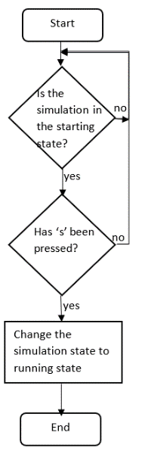

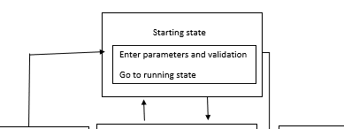

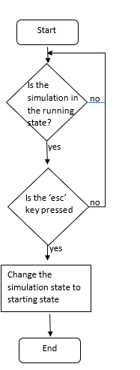

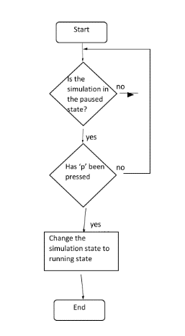

The ‘esc’ key in defold closes the window therefore this is instead triggered by an ‘m’ key press

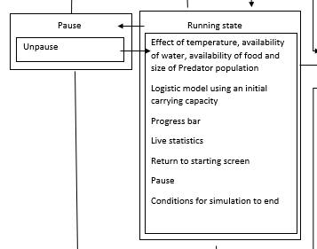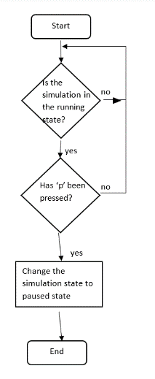



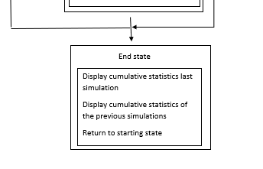

I had forgot to include the flowcharts the end simulation however the condition that end the simulation after a certain amount of time has been included:

However, the flowcharts that represent the conditions of either population being 0 will be included with the rest of the running state





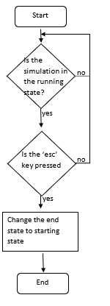

Interview 02/12/20

These are the requirements that have been looked at in this stage of development.

|  |  |  |
| --- | --- | --- |
| No. | Requirement | Justification |
| 4 | Press the ‘s’ key to enter the running state from the menu state | Allow the user to access the running state when they choose |
| 7 | Have a simple background of one colour | To not distract from the simulation |
| 9 | Press the ‘p’ key to enter the paused simulation state from the running state | This will be convenient to the user as they can for example stop the simulation and discuss what is happening in that moment |
| 10 | Press the ‘p’ key to re-enter the re-enter the running state | This will allow the user to resume the running state |
| 11 | Use the ‘esc’ key to return to the menu state from the running state or the end state | This will allow the user to end the simulation at any point they wish |
| 21 | Have the simulation end and enter the ending state after a certain amount of time (2 minutes) | This will prevent the simulation from going on for too long |
| 25 | Have a symbol to represent that the simulation is in the pause state | To ensure the user knows what state of the simulation they are in |

Me: I have completed the above requirements however due to the ‘esc’ key closing the window the simulation is running in in defold requirement 11 was not fully met and I instead made key ‘m’ have the same purpose. Otherwise, the ‘s’ key does make the simulation move from the menu to the running state; the ‘p’ key does when the simulation is in the running state pause the simulation and a symbol appears and then unpause it when the simulation is in running state; the background for each state is a simple and only one colour and the simulation changes to be in the end state after 2 minutes. Therefore, apart from the change of the ‘esc’ key to the ‘m’ key which I felt was the most appropriate key as to causes a change to the menu state, I feel the requirements above have been met.

Natalie Faughy: I am happy that the structure of the simulation does in fact function and the change of keys seems appropriate and will not have no real effect on the overall simulation. I would now like the next prototype to include a working menu created to the requirements.

Next step: After this interview I have decided that I will now create the menu which will display the simulation key and simulation controls as well as allowing the user to use the mouse and keyboard to enter parameters that will be used in the running state.

08/12/20 – Menu state

I first need to load and position the sprites into the menu state, create the collision objects for the cursor to be used to click on the boxes of the parameters and then have game objects for the labels and scripts attached to the parameter boxes.

For each parameter for the simulation the script is attached to the game object

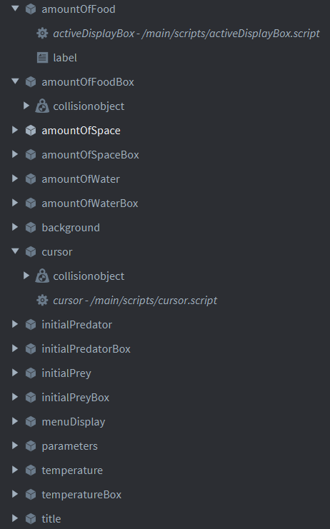

The cursor also has a script attached which monitors the position of the cursor and any collisions with the cursor and boxes.

Each parameter and the cursor have a collision object. Each box has its group set to its name and mask to the cursor whereas the group of the cursor is ‘cursor’ and its mask each of the boxes. This means that only the boxes can collide with the cursor.

Each parameter also has a label which will then display the user input back to the user.

Below is the cursor script which posts a message when the user has clicked on one of the fields to enter a value into:

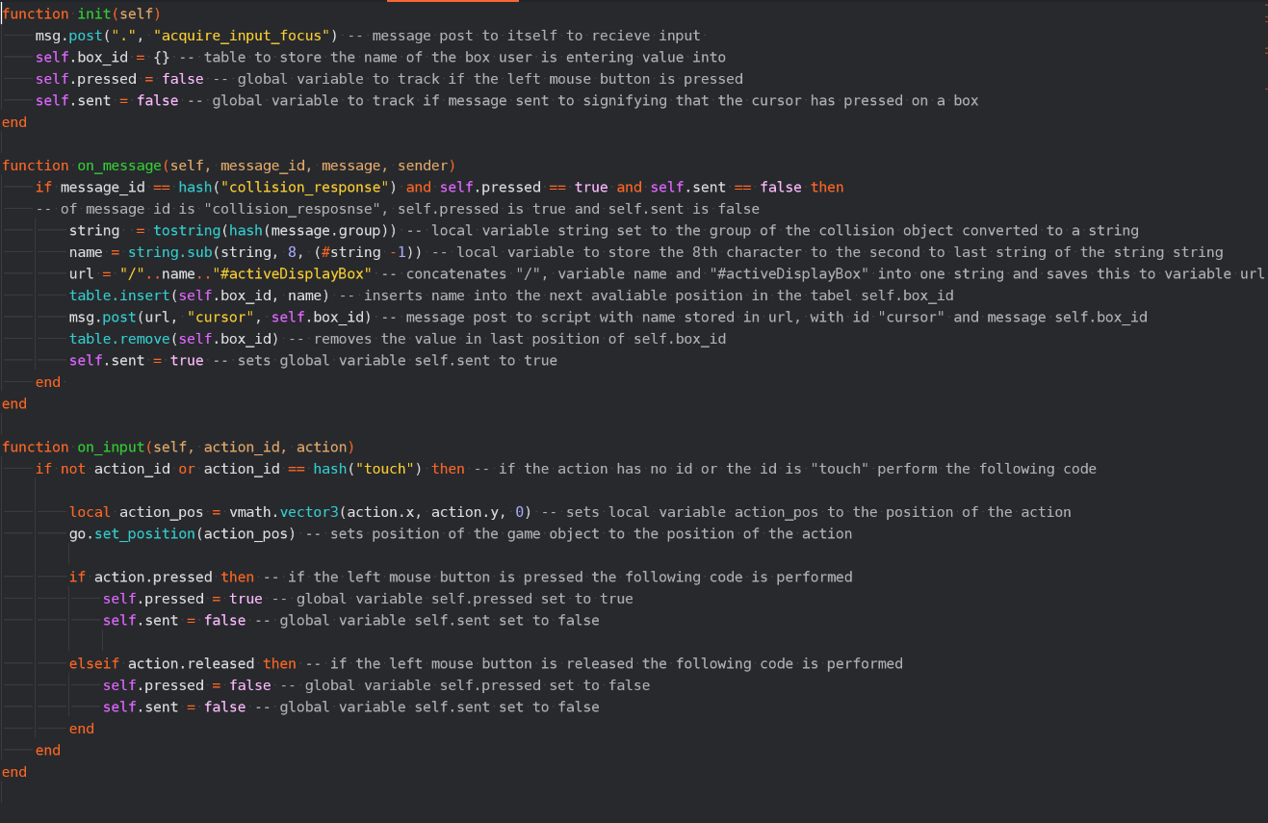

This retrieves the position of the mouse and sets the game object of the cursor to this position which therefore sets the position of the collision object for the cursor to this position.

This converts the message group of the collision to a string and takes the part of the string that is the name of the box and concatenates this with “/” and “activeDisplayBox” to form the script of the box the user has clicked on to then send a message to this script signifying the user has clicked on it. It then sets the global variable self.sent to true so the message is not sent multiple times.

This sends a message to the appropriate box saying the user has clicked on this box when the mouse key is pressed, and the cursor is colliding with that box and the message has not yet been sent

This sets self.pressed to true when the user presses the mouse and false when it the user releases the mouse and self.sent to false as for that key press the message has not been sent.

This is the activeDisplayBox script which receives input and displays it to the user:

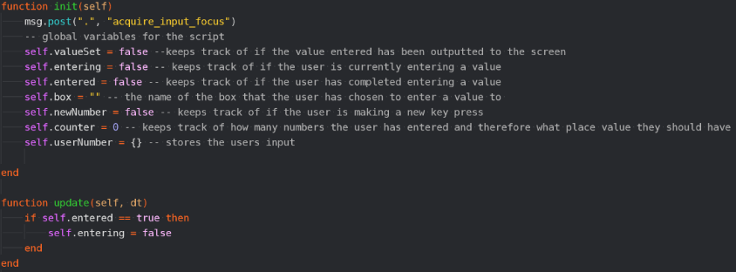

Message to itself to receive input.

Global variables that monitor what part of the process of entering a value the user is in and to store the user input and what box this should be outputted to.

As soon as self.entered is true self.entering will become false meaning that the program will stop interpreting input as further addition to the user input.

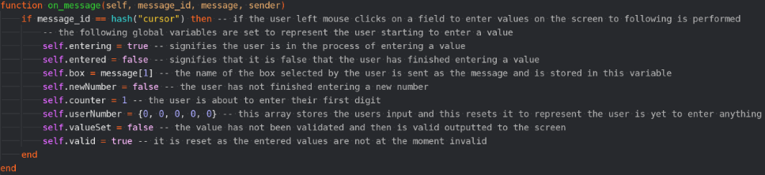

When the user presses on one of the boxes the script will receive a message from the cursor script above and the global variables are reset to represent that the user is entering values, but no value has been entered yet and the self.box variable to the box sent from the cursor.

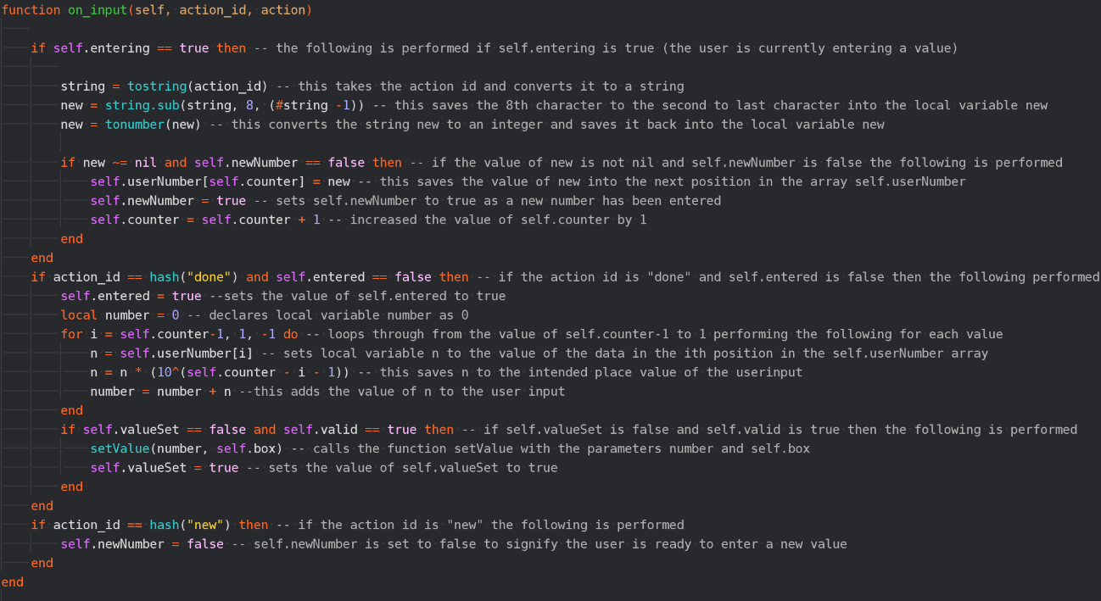

The self.counter is increased by 1 before enter is pressed so it will be one more than the number of numbers entered therefore this loops from one less than the self.counter to 1. It then multiples the position in the userNumber array by 10^ self.counter – 1 – i as this represents the place value of the number as intended by the user. These values are then added together to produce the number entered by the user.

This saves the user input into the next position in the userNumber array.

This calls the function setValue to validate and display the user input if it has not already been called.

When the user has pressed the ‘enter’ key and self.entered is false meaning this block of code has not been carried out before the user input is constructed into the intended number. This number is validated and if valid displayed to the screen.

It is necessary to have new~= nil as there are constant action ids however when the user has entered a value this will not be nil and therefore be processed and its false that a new number has been entered

This takes the user input and converts it to a string to take a sub string that is just the number entered and converts it to a number so it can then be used computation.

When the user presses the space key the variable self.newNumber is set to false signifying that the user has not yet entered the number.

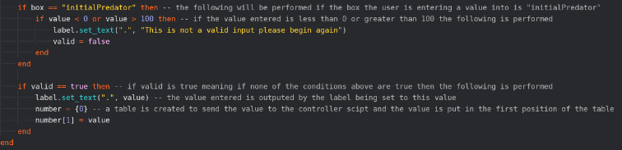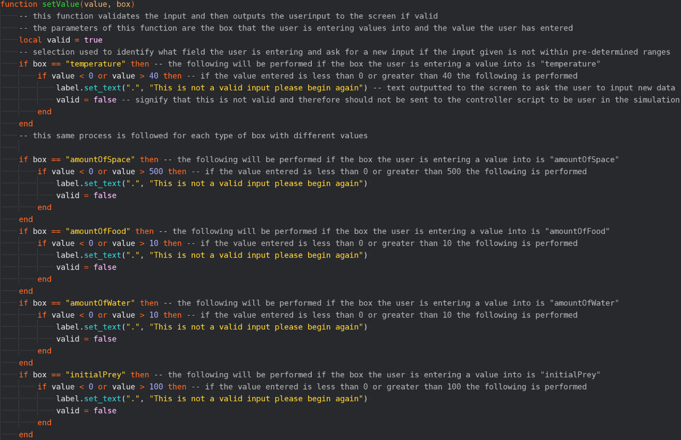

This ensures that the user input is within an appropriate range for the parameter that is being entered. It does so through selection to find the box that the user is entering information into and then if it is within a set range. If it is not, then a message asking the user to begin again is outputted.

If the input is valid then the value is outputted to the appropriate label

Below is a series of tests in ensure the menu state is performing correctly and each test is followed by an image demonstrating that the actual outcome was in fact achieved:

|  |  |  |  |  |
| --- | --- | --- | --- | --- |
| What is being tested? | Input | Justification | Expected Outcome | Actual Outcome |
| Is the simulation key, simulation controls, space for entering parameters and title outputted? | N/A | This allows the user to understand the simulation | Green background with the menu title, simulation key, space for parameters and simulation controls displayed | Green background with the menu title, simulation key, space for parameters and simulation controls displayed |



|  |  |  |  |  |
| --- | --- | --- | --- | --- |
| What is being tested? | Input | Justification | Expected Outcome | Actual Outcome |
| Is the value entered outputted after pressing the enter key into the field pressed on? | Key press over temperature field  22, enter | This allows the user to keep track of the entered value | 22 in box below temperature text | 22 in box below temperature text |

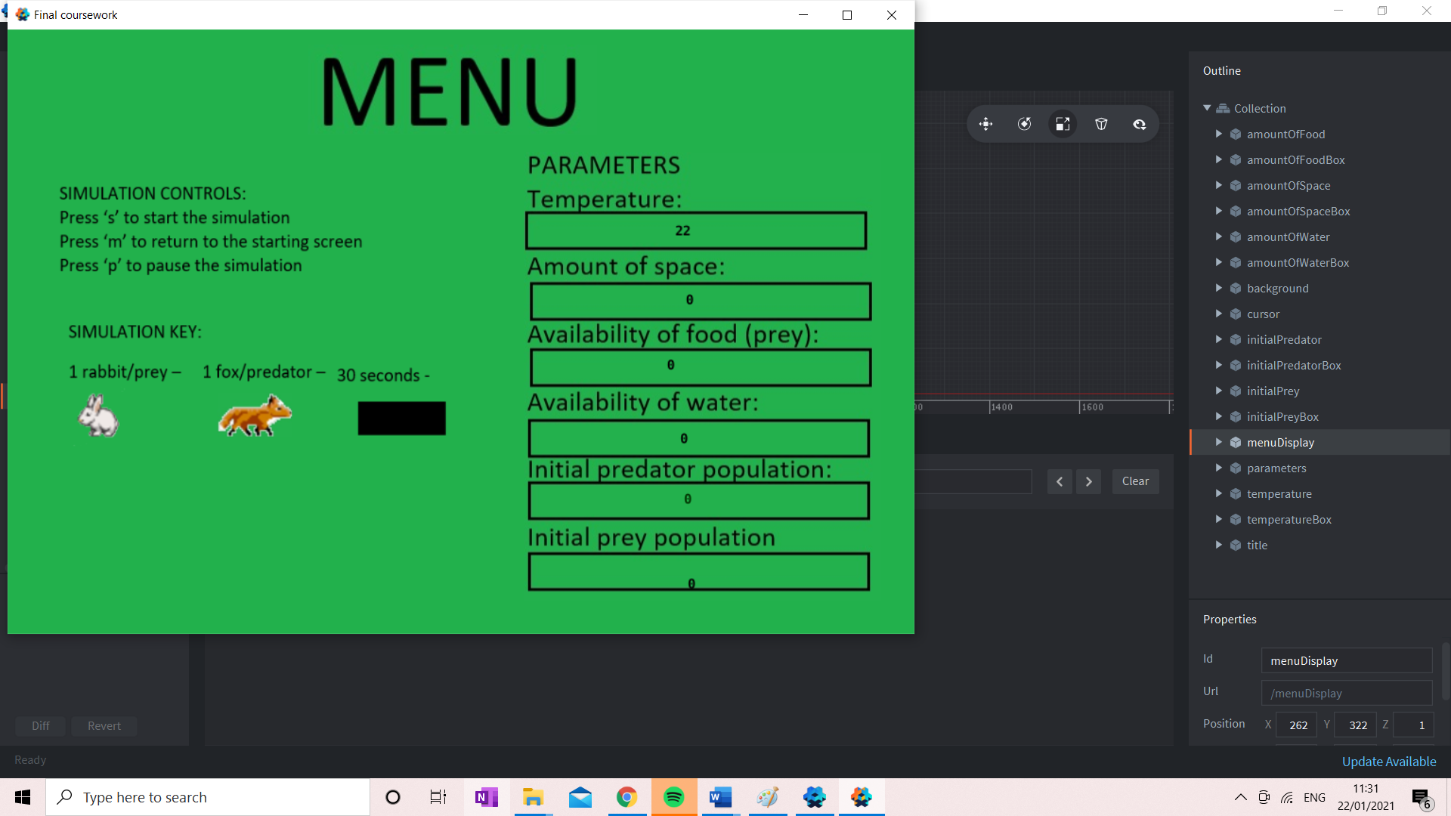

Each label in which the user enters information acts as a protoclass meaning that they each inherit the same script meaning that by testing the temperature label this ensures that each label works.

Enter parameters and validation.

Below I am testing inputting valid and invalid data into the running state to ensure the desired input has the desired effect and invalid input does not affect the simulation.

Temperature

|  |  |  |
| --- | --- | --- |
| Test data | Type | Actual |
| 0 | Borderline (valid) | Valid |
| 40 | Borderline (valid) | Valid |
| 25 | valid | Valid |
| “y” | Invalid | Invalid |
| -7 | Invalid | Valid |

Initial Prey Population

|  |  |  |
| --- | --- | --- |
| Test data | Type | Actual |
| 0 | Borderline (valid) | Valid |
| 100 | Borderline (valid) | Valid |
| 25 | valid | Valid |
| “y” | Invalid | Invalid |
| -7 | Invalid | Valid |

Initial Predator Population

|  |  |  |
| --- | --- | --- |
| Test data | Type | Actual |
| 0 | Borderline (valid) | Valid |
| 100 | Borderline (valid) | Valid |
| 25 | valid | Valid |
| “y” | Invalid | Invalid |
| -7 | Invalid | Valid |

Availability of Food

|  |  |  |
| --- | --- | --- |
| Test data | Type | Actual |
| 0 | Borderline (valid) | Valid |
| 10 | Borderline (valid) | Valid |
| 2 | valid | Valid |
| “y” | Invalid | Invalid |
| -7 | Invalid | Valid |

Availability of Water

|  |  |  |
| --- | --- | --- |
| Test data | Type | Actual |
| 0 | Borderline (valid) | Valid |
| 10 | Borderline (valid) | Valid |
| 2 | valid | Valid |
| “y” | Invalid | Invalid |
| -7 | Invalid | Valid |

Availability of Space

|  |  |  |
| --- | --- | --- |
| Test data | Type | Actual |
| 0 | Borderline (valid) | Valid |
| 10000 | Borderline (valid) | Valid |
| 2000 | valid | Valid |
| “y” | Invalid | Invalid |
| -7 | Invalid | Valid |

It is clear from this testing that this simulation cannot properly process the entry of negative numbers. This can be rectified by adding the ‘-‘key into the input bindings and then outputting that it is not a valid input if the user does in fact attempt to enter a negative number.

I created an input binding for the ‘- ‘key and added the following code to the activeDisplayBox script:

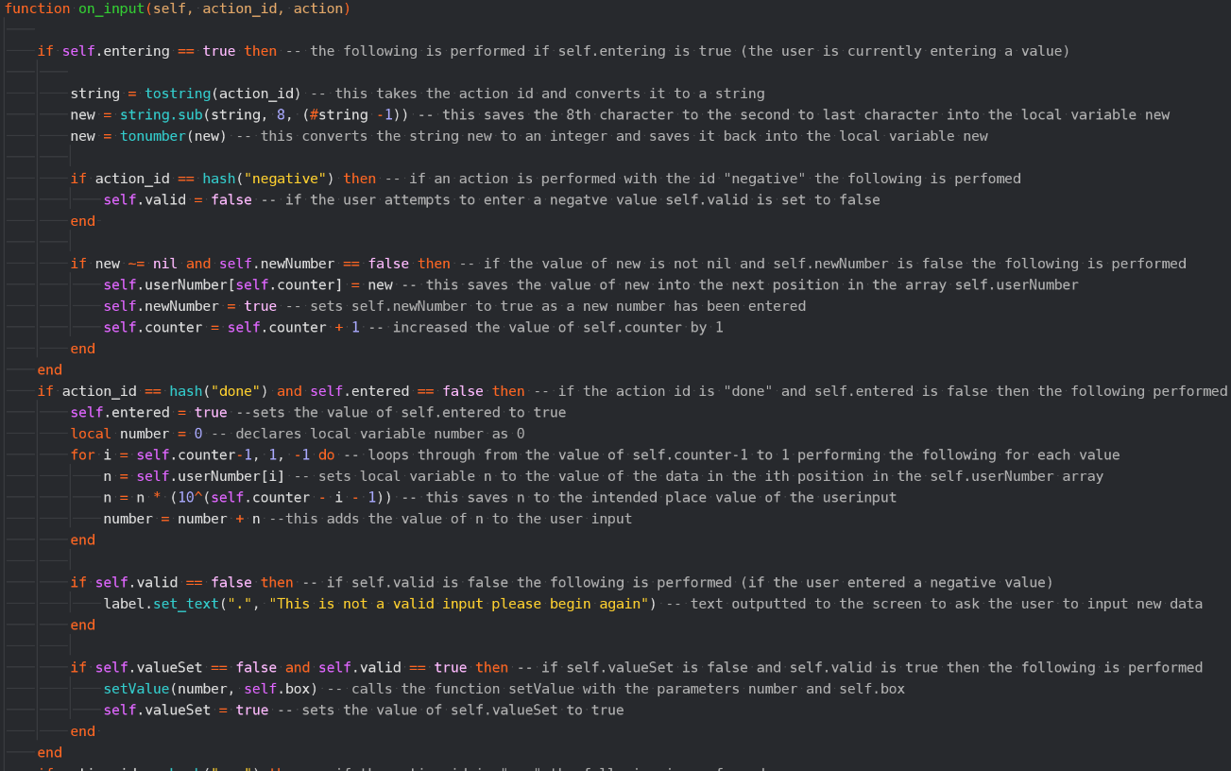

This outputs that the input is valid if the ‘-‘ key has been pressed after the user has entered a value.

This sets self.valid to false if the ‘-‘ key is pressed.

|  |  |  |  |  |
| --- | --- | --- | --- | --- |
| What is being tested? | Input | Justification | Expected Outcome | Actual Outcome |
| Is the “This is not a valid input please begin again” message outputted when a negative value is inputted? | Key press over temperature field  -7, enter | This ensures that the user cannot enter negative values as this would not work in the simulation | “This is not a valid input please begin again” message below temperature text | “This is not a valid input please begin again” message below temperature text |

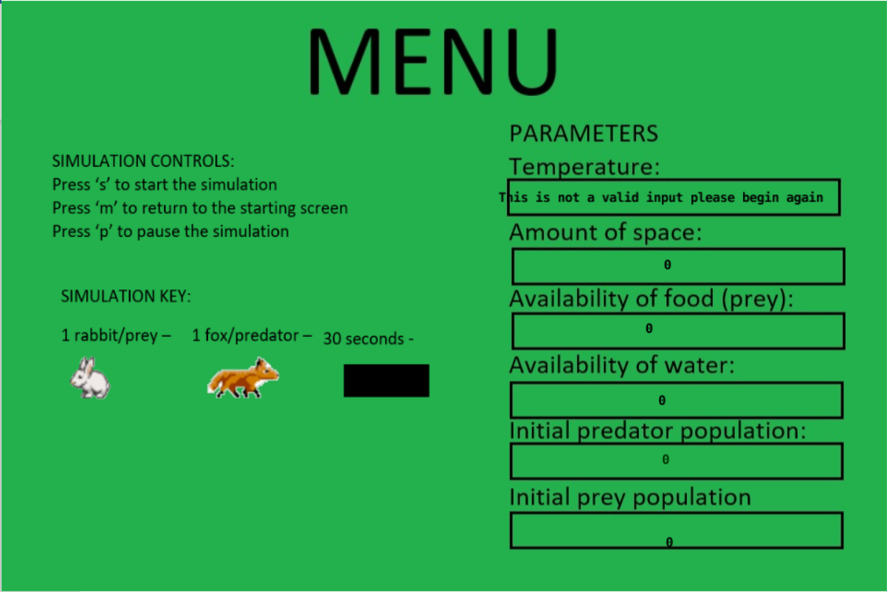

The following are the flowcharts that have been further included in this prototype:

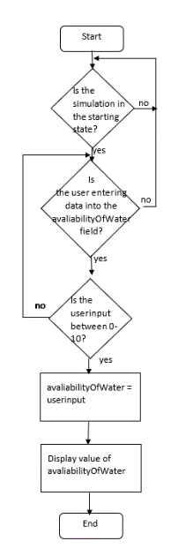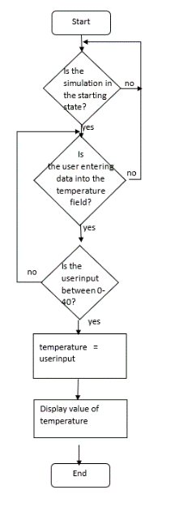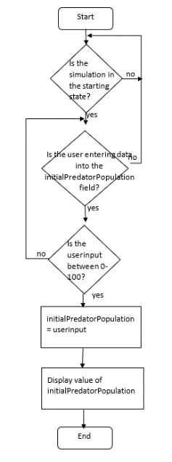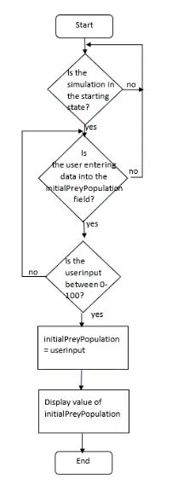

In these flowcharts some complexity has been ignored for example the use of the cursor to choose a field to enter and displaying the visuals for this state

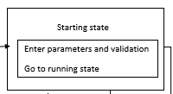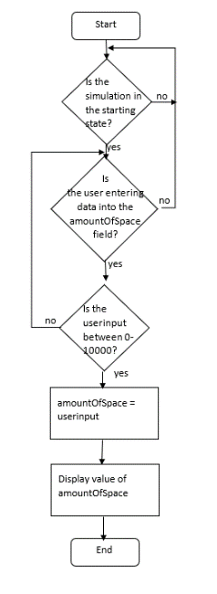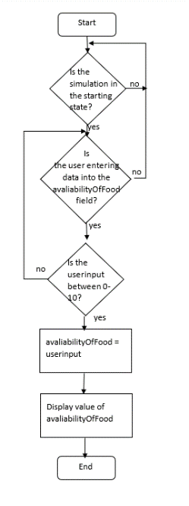

This part of the flowchart is not yet entirely achieved however in a later prototype when the running state is completed the parameters will be saved into variables and passed to the running state

I have later changed the maximum value for the amount of space to 500 as this means there can be a maximum amount of 1000 sprites instead of 20 000 which would be far too crowded for the screen

Below is the section of the class diagram completed in this section:

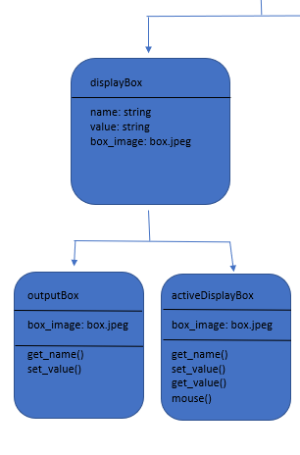

These values and the image are dictated in the collection and are individual to each box

This was not necessary as the name is of an output box is set in the game object meaning it can be easily addressed

Built in label.set_text() function

oninput() function in activeDisplayBox

setValue function in activeDisplayBox

Cursor script and collision objects

Cursor script

Each of the active display boxes which is those that can be changed by the user so the once for the parameters on the menu state

Interview 13/12/20

The following requirements have been looked at in this development stage:

|  |  |  |
| --- | --- | --- |
| No. | Requirement | Justification |
| 1 | Start menu | In order to explain what the simulation they are about to watch is, show a simulation key and prompt the user to enter data |
| 2 | Use the mouse the navigate the start screen | This is the easiest way for the user to decide what data they want to enter on the start page |
| 3 | Label that can be edited by the user to allow data entry for the availability of food for the prey, initial populations, temperature, availability of water, space | This will make the simulation more useful as different factors and their effect on the simulation can be investigated |
| 19 | The data entry from the user will be validated to endure it is within the given limits.  Initial populations 0-100  Temperature 0-40  Availability of food (prey) 0-10  Availability of water 0-10  Amount of Space 0-10000 | This will ensure that the data values that are processed by the model are not too large and therefore the outcomes are not too large as otherwise that would be confusing to look out and too demanding on the user |

Me: I have met the first two of these requirements in their entirety the start menu does in fact include the simulation key, a title and labels and boxes to enter the parameters. Furthermore, the mouse can be used to navigate the start screen for the user to be able to decide what they would like to enter. The 19th requirement is almost entirely met however I changed the maximum value for the amount of space to 500 as otherwise it would be possible for there to be far too many sprites on the screen and for the simulation to remain clear. The 3rd requirement is met in a sense the user can enter values and these are outputted through the labels in each box however in order for values to be entered the user is requirement to press the space bar between each value that is pressed. This is because this was what I felt it was the best solution to avoid having the value being processed multiple times whilst still allowing the same number being entered consecutively in cases such as ‘22’ for example that I could complete within the time limits.

Natalie Faughy: I agree that requirement 1 and 2 have successfully been met, additionally I agree that the changes made to requirement 19 are sensible and am happy with this requirement being completed. Although the solution to requirement 3 is not ideal I accept that this is the best solution that you could have completed within the time limits. Now that the structure of the simulation and the menu is completed, I would now like you to start on the running state, so this begins to look more like a simulation.

Next Step: I will now begin completing the running state of the simulation, in order to do this, I will pass the parameters to the spawning script; create the code to calculate the carrying capacity; code for spawning the prey and predators; code for outputting the live statistics; code for the animal’s movement and then displaying a progress bar.

15/12/20 – Running state.

The following code is from activeDisplayBox which passes the parameters to the controller script that is in the main collection:

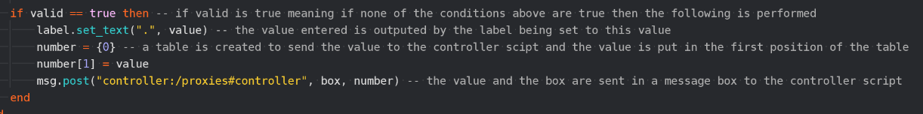

Message post to send parameter to controller script each time a user enters a new value.

The controller script then accepts the message from the menu collection and then sends these on to the simulation collection:

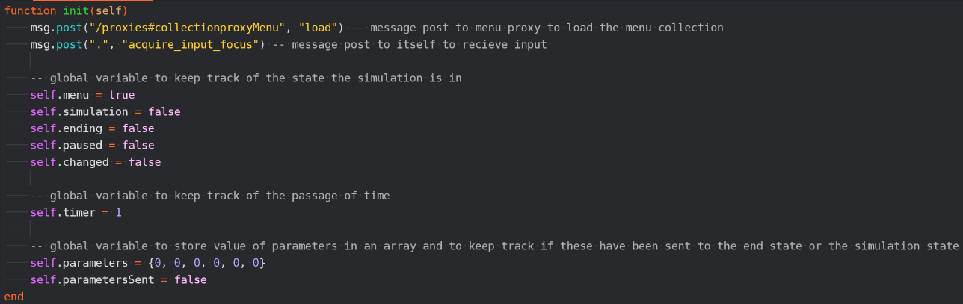

These global variables store the parameters when passed to the controller script and monitors if the parameters have been passed or not.

Controller script accepts the parameters and saves them into an array with each position representing a different factor for the simulation which is then messaged to the spawning script. The message id represents what factor the value is and the message is the value itself and therefore the id dictates the position the message is saved in then the message is the value saved into the array.

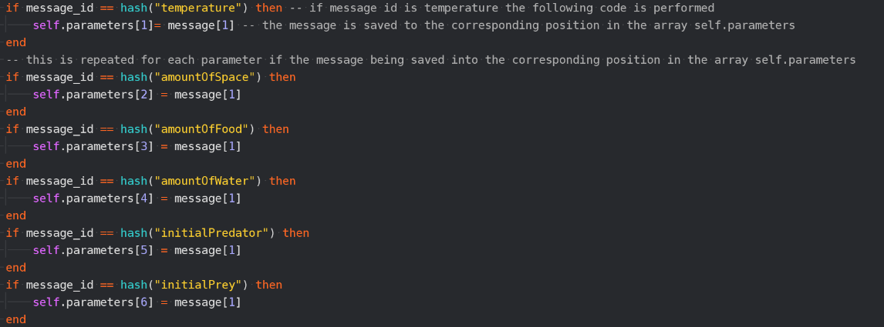

This then sends the parameters that are saved to the table self.parameters to the spawning script in the simulation collection.

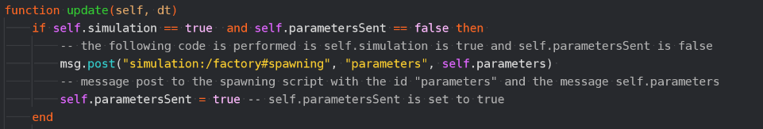

Global variable self.parametersSent set to true which prevents the selection statement from following the code being performed so the parameters are not sent multiple times.

The spawning script which is part of the simulation collection then accepts the parameters and saves these into global variables:

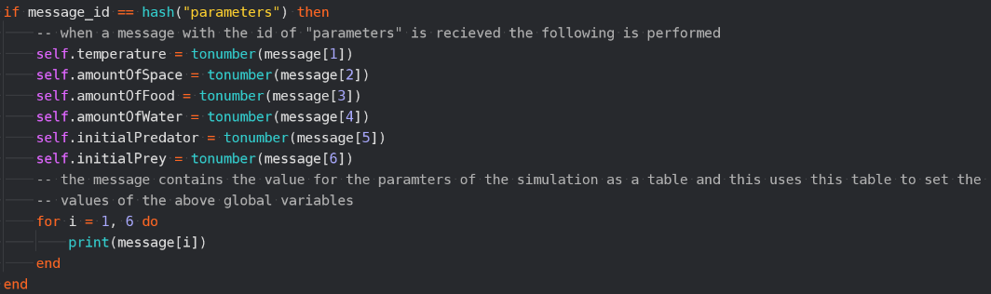

This will temporarily be in the code to test that the parameters have been sent to the simulation state.

This then saves the parameters into global variable to then be used in the simulation calculations. It converts these values to numbers so they can be used in calculations.

|  |  |  |  |  |
| --- | --- | --- | --- | --- |
| What is being tested? | Input | Justification | Expected Outcome | Actual Outcome |
| Has the parameters been sent to the simulation state correctly | Temperature: 22  amountOfSpace: 100  amountOfFood: 10  amountOfWater: 10  initialPredator: 3  initialPrey: 10 | This ensures that the correct input is used in the simulation | 22  100  10  10  3  10 | 22  100  10  10  3  10 |

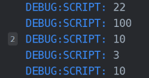

Now I will write the code to calculate the carrying capacities, below is part of the spawning script:

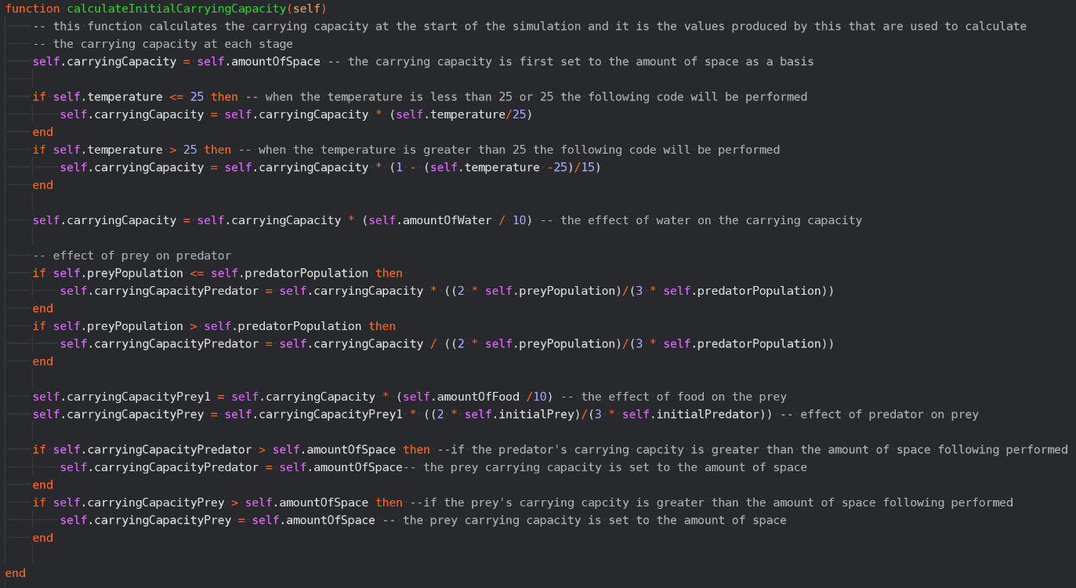

Carrying capacity divided by (2xprey population)/(3xpredator population) as this creates a relationship between the two populations when the prey population is larger and multiplies by this same fraction when prey population is smaller. The prey carrying capacity is multiplied by the same fraction.

The amount of water is given a value 0-10 and this divided by 10 is multiplied by the carrying capacity. Same with the amount of food for the prey’s carrying capacity.

The use of selection here allows 25 to act as the perfect temperature with the carrying capacity becoming smaller the further away from 25 it is resulting in smaller populations of animals.

This ensures that the carrying capacity does not become larger than the value for the amount of space so there are never more than the maximum number of sprites on the screen.

Below the function for calculating the initial carrying capacity is called after the parameters are sent:

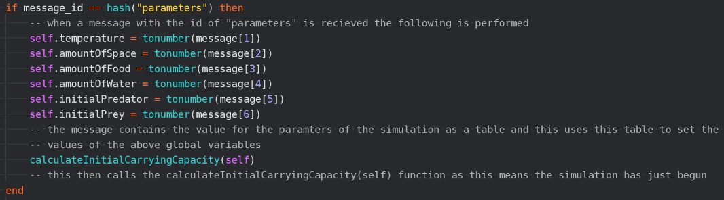

|  |  |  |  |  |
| --- | --- | --- | --- | --- |
| What is being tested? | Input | Justification | Expected Outcome | Actual Outcome |
| Is the carrying capacity being calculated correctly | Temperature: 22  amountOfSpace: 100  amountOfFood: 10  amountOfWater: 10  initialPredator: 3  initialPrey: 10 | This ensures that the simulation is accurate | 100  39.6 | 100  39.6 |

Spawning of prey and predator

I first attempted this stage by creating game objects and using factories to create instances of these game objects and this can be seen in the below code which is from the spawning script:

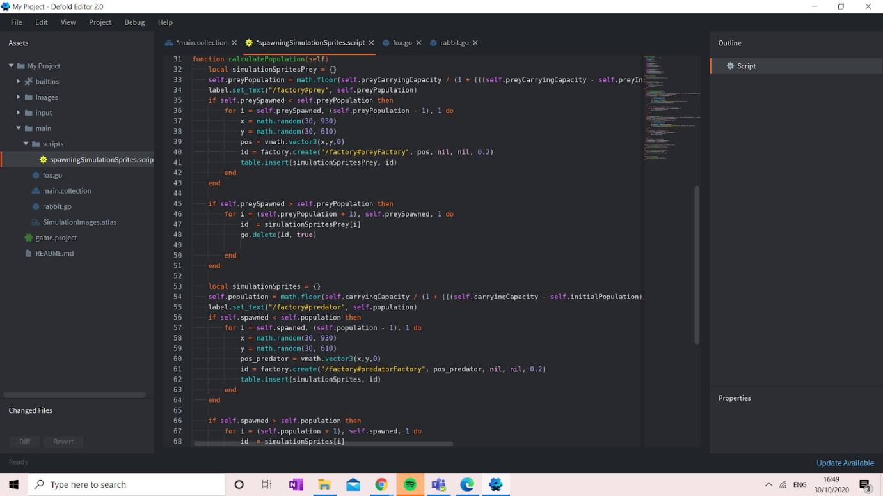

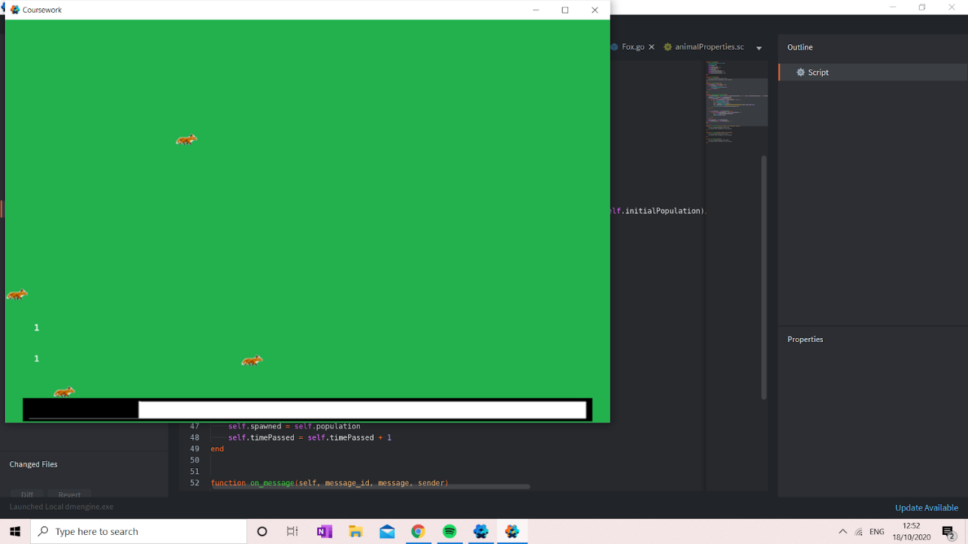However as shown in the result from this script below it was very quickly apparent that this was not functioning in the intended way:

There are in fact four foxes instead of one fox and one rabbit.

I temporarily included script to output the size of the populations and this here represents that there should be one fox and one rabbit..

I therefore changed my approach in a number of ways starting with creating collections for the rabbits and foxes as not only did this help with functionality it also allows for further extension if wanted later in the simulation as other game objects can be easily spawned with the rabbits and foxes within these collections. I also went on to move the declaration of the variable for the array of the ids to be a global variable meaning that it would not be overwritten each time the function is called. However much of the logic seems to be sound in the above code therefore I only needed to alter the pre-exisiting code and this can be seen below.

I will now create collections for the foxes and rabbits:

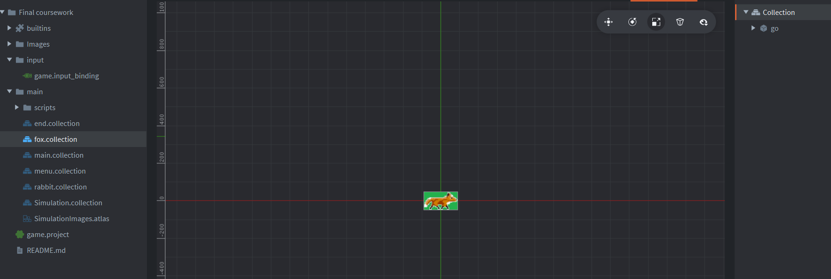

The fox and rabbit collections each have the corresponding animation group attacked under a game object.

Fox and rabbit collections that will be created and deleted from the spawning script.

First in order to do this I have to create collection factories for the foxes and rabbits and attach the spawning script to this game object.

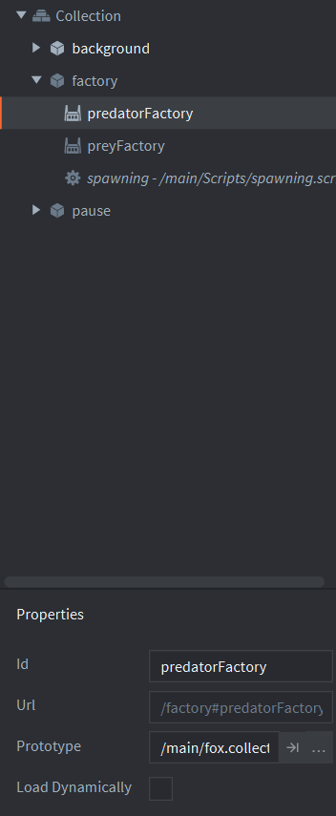

The prototype for each are the corresponding collection and this dictates what is loaded by the factory.

Factories to create instances of each collection.

Below is the code from the spawning script that creates instances of the above collections according to the calculated populations:

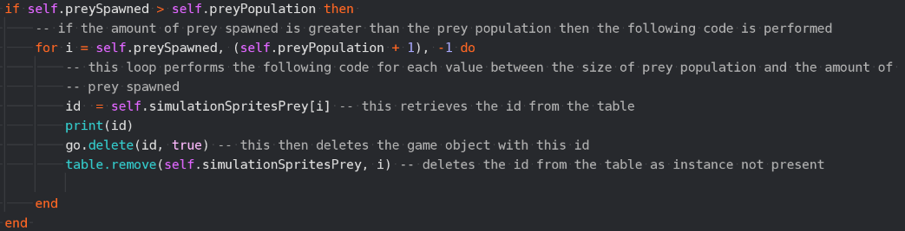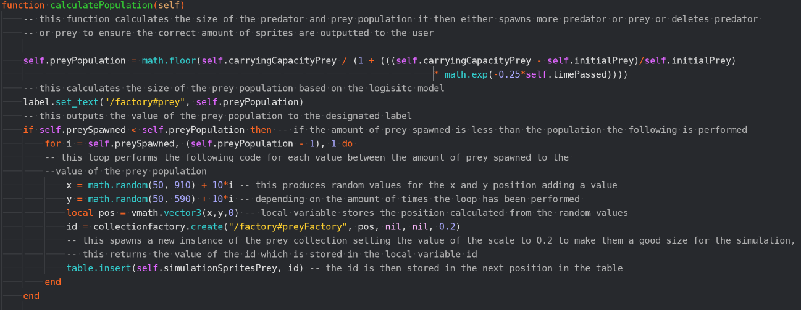

Saving the ids into a table means that they can be addressed and accessed later on easily as otherwise it would be easy for the ids to be lost

The 10*i is included as otherwise there were issues with sprites spawning in the same position because they are being spawned at the same time and random number generation uses OS time as a part of its calculation.

If more sprites are spawned than the size of the population in a similar way this loop will delete the sprites

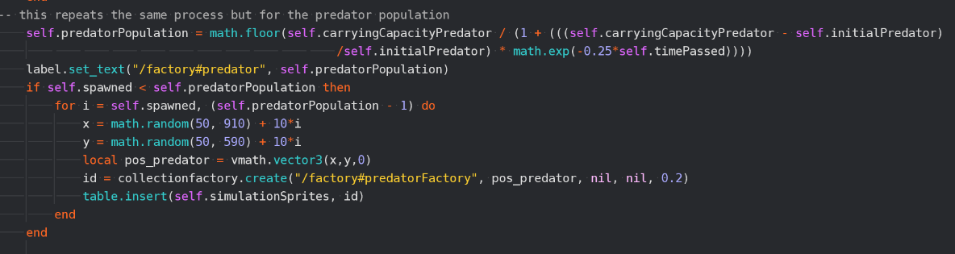

This repeats the same process as the prey for the predator.

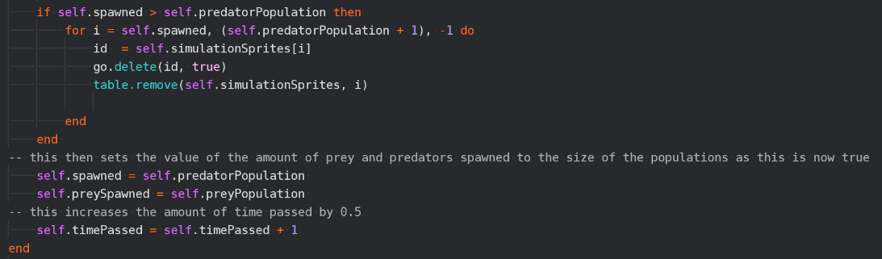

This updates the global variables to represent the changes made.

|  |  |  |  |  |
| --- | --- | --- | --- | --- |
| What is being tested? | Input | Justification | Expected Outcome | Actual Outcome |
| Is the population being calculated correctly and are the correct number of sprites being outputted as a result of this? | Temperature: 22  amountOfSpace: 100  amountOfFood: 10  amountOfWater: 10  initialPredator: 3  initialPrey: 10 | This ensures that the simulation is accurate | Rabbits: 10  Foxes: 3  Rabbits: 14  Foxes: 4  Rabbits: 17  Foxes: 7 | Rabbits: 10  Foxes: 3  Rabbits: 14  Foxes: 4  Rabbits: 17  Foxes: 7 |

The below screenshots demonstrate the fact that in the first instance 10 rabbits and 3 foxes are outputted followed by 14 rabbits and 4 foxes in the second screen shot and then 17 rabbits and 7 foxes in the third:

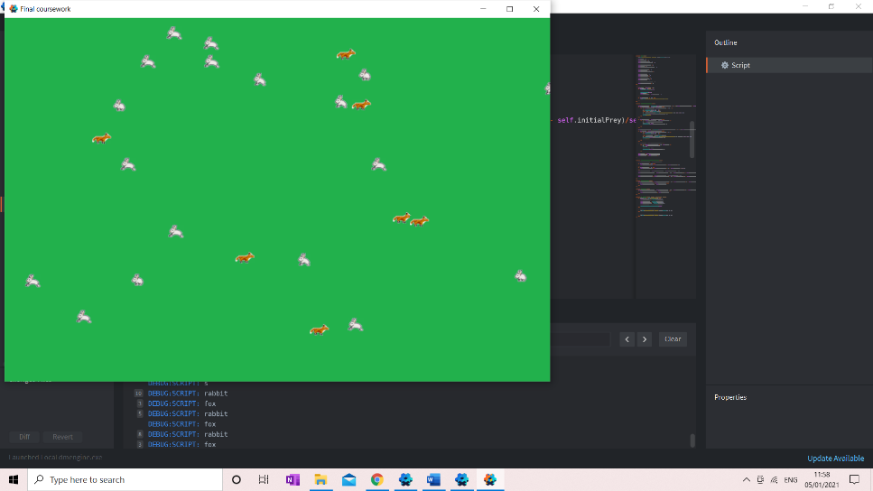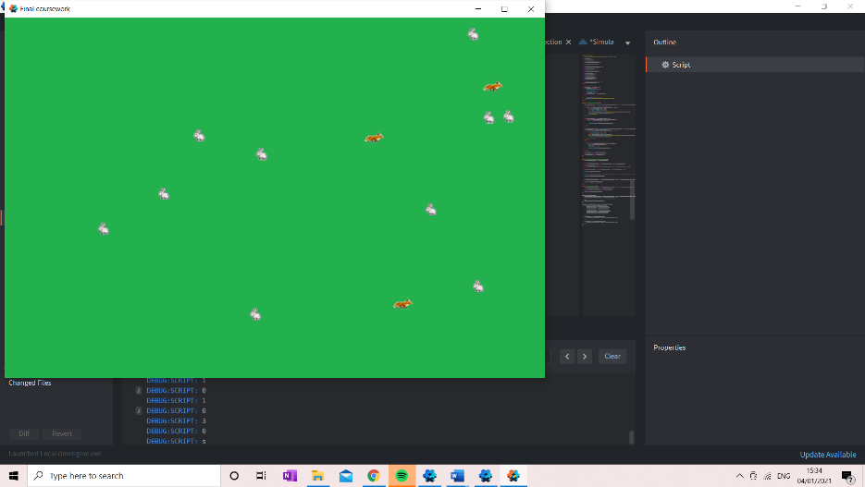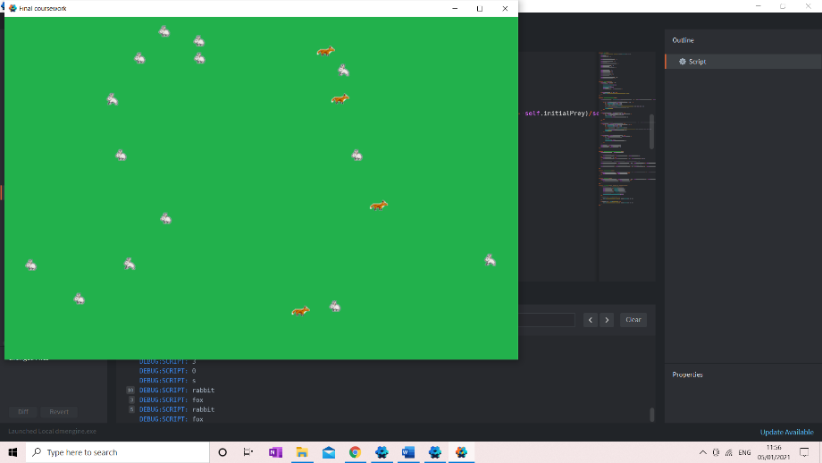

2

1

3

I will now include the code to output the live statistics:

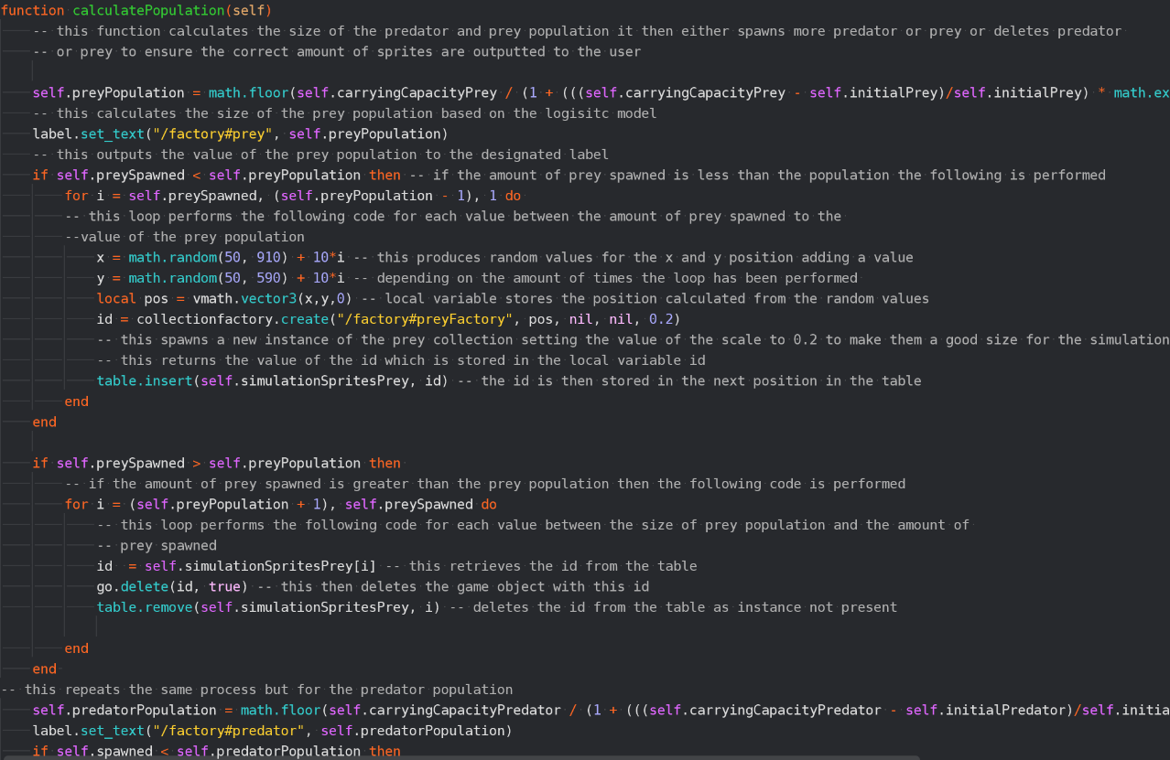

This function sets the text of the label to the population.

|  |  |  |  |  |
| --- | --- | --- | --- | --- |
| What is being tested? | Input | Justification | Expected Outcome | Actual Outcome |
| Is the correct value being outputted to the label | Temperature: 22  amountOfSpace: 100  amountOfFood: 10  amountOfWater: 10  initialPredator: 3  initialPrey: 10 | This ensures that the labels are accurate | Same amount of prey and predator as written to labels | Same amount of prey and predator as written to labels |

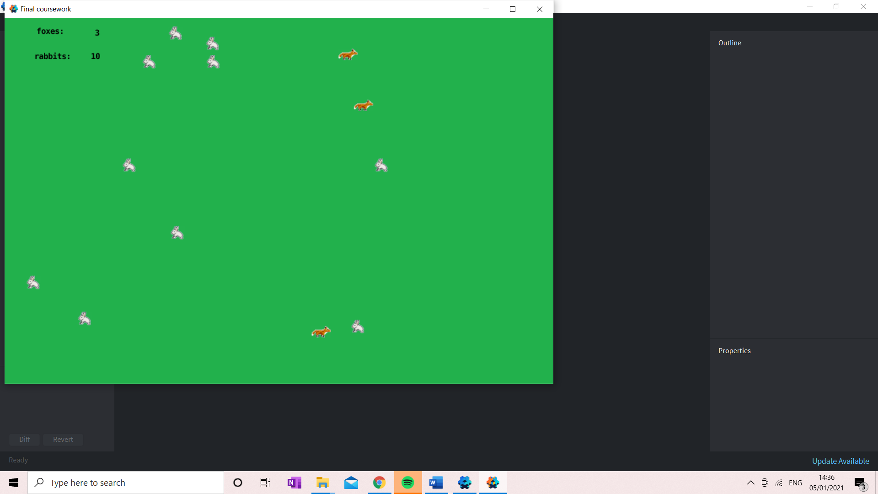

3 foxes and 10 rabbits are outputted as said in the actual outcome.

I will now create a new script that will allow for the movement of the animals and this will be attached to the fox and rabbit collection:

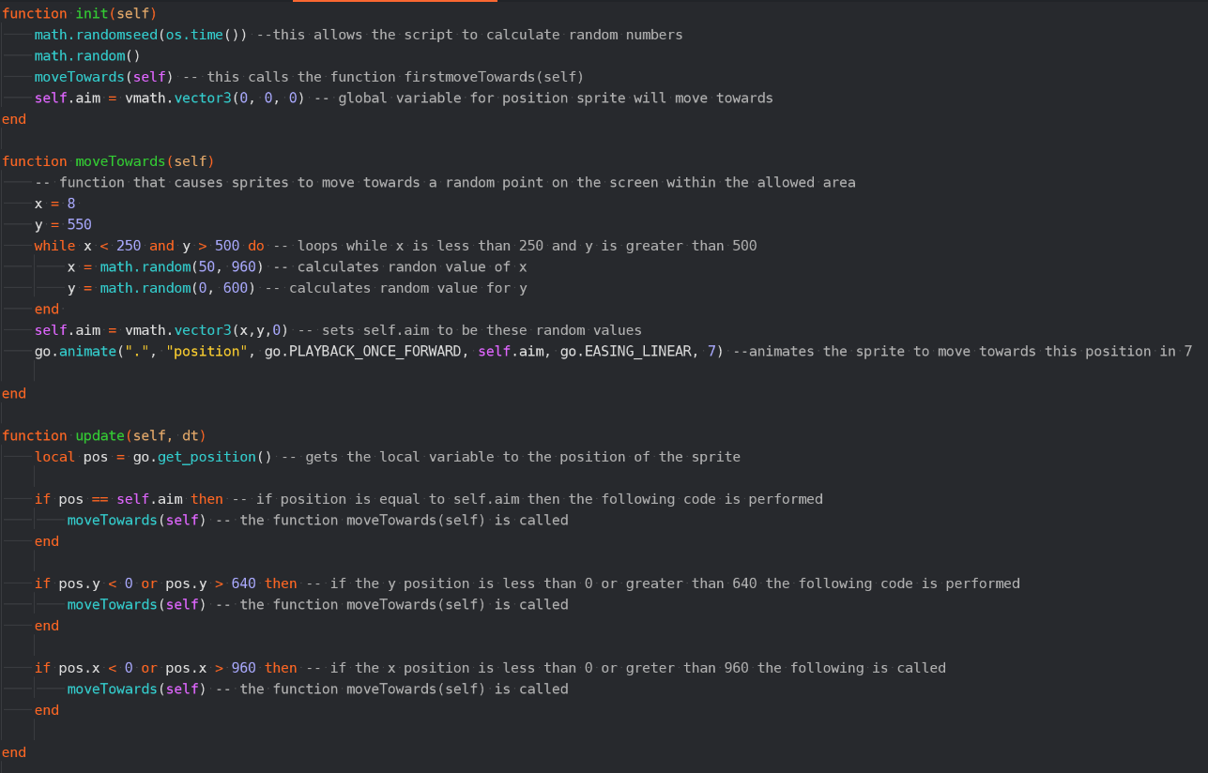

|  |  |  |  |  |
| --- | --- | --- | --- | --- |
| What is being tested? | Input | Justification | Expected Outcome | Actual Outcome |
| Are the rabbits and foxes moving on the screen? | Temperature: 22  amountOfSpace: 100  amountOfFood: 10  amountOfWater: 10  initialPredator: 3  initialPrey: 10 | This makes the simulation more engaging | For the rabbits and foxes to move to different aims | Animals spawned at the same time all move towards the same point |

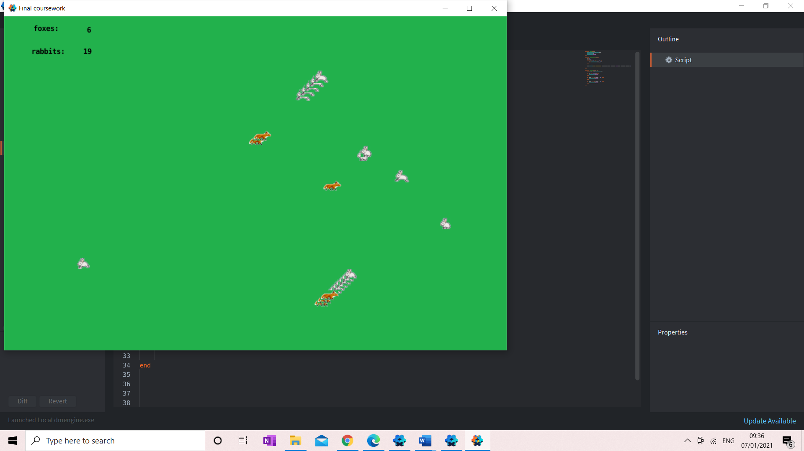

These sprites are all moving towards one point.

It is clear from this I needed to change the code so I added a function for the animals to move towards the first goal as it seems as once they have moved to one point they then move towards individual different points. Below is the code with this function included:

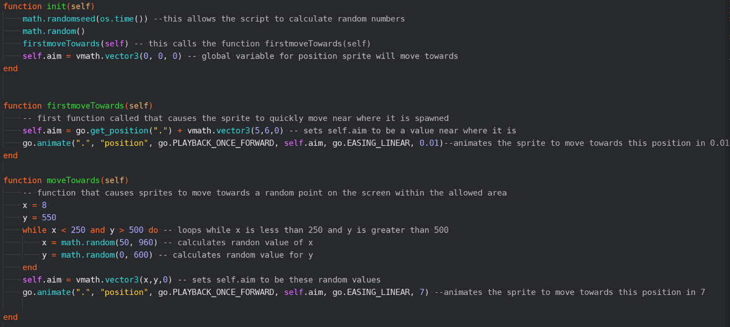

This animates the sprites to move towards this position randomly generated in 7 units of time.

This loops as long as the x value is less than 250 and the y value is greater than 500 and it generates a new random number for x and y, and this ensures that the animals don’t got over the labels for the live statistics.

This ensures that the while loop is called at least once.

This causes the sprites to move towards a point very close to where the sprite spawns in a very short amount of time meaning it will not be noticeable to the user but will prevent the previous issue that the sprites were moving towards the same position.

This calls the function for the first movement.

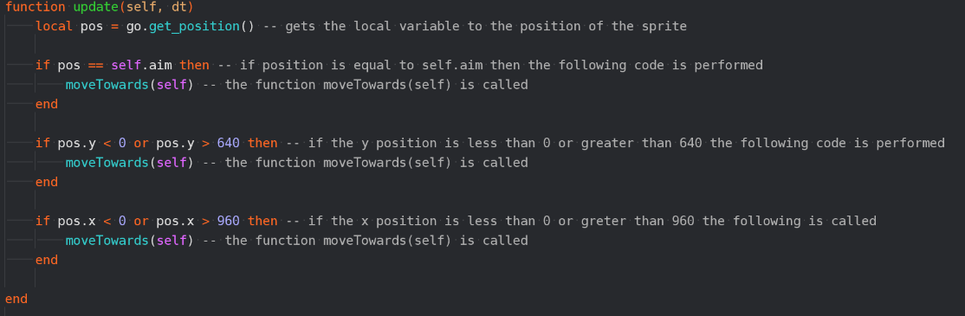

This use of selection means that if the sprite has reached its aim or if the sprite has left the screen the function moveTowards is called again for the sprite to move towards a new position.

|  |  |  |  |  |
| --- | --- | --- | --- | --- |
| What is being tested? | Input | Justification | Expected Outcome | Actual Outcome |
| Are the rabbits and foxes moving on the screen? | Temperature: 22  amountOfSpace: 100  amountOfFood: 10  amountOfWater: 10  initialPredator: 3  initialPrey: 10 | This makes the simulation more engaging | For the rabbits and foxes to move to different aims | For the rabbits and foxes to move to different aims |

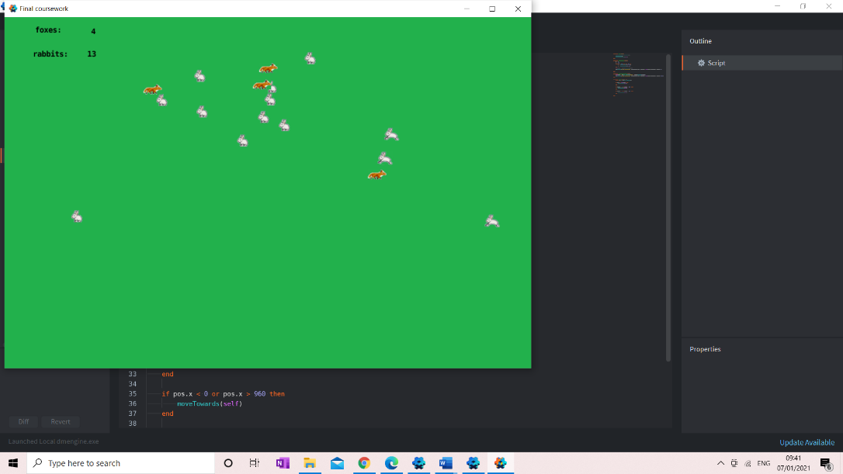In this image it can be seen that the foxes and rabbits are each moving towards different points

Displaying the progress bar

In order to do this, I will create game objects for the progress bar and then for the fourth time bar sprites and will then include the necessary code for the progress and time bars:

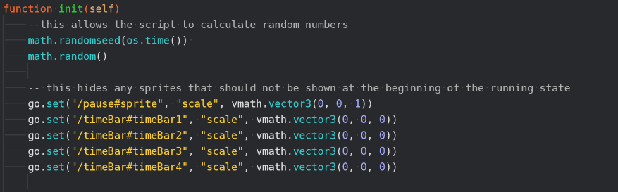

This means the user cannot see the time bars at the beginning of the simulation.

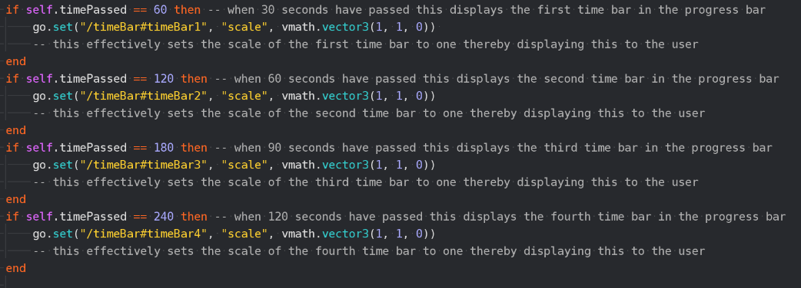

This means that another time bar can be seen at regular intervals throughout the simulation.

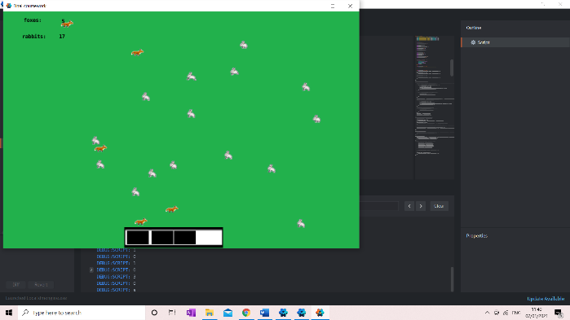

|  |  |  |  |  |
| --- | --- | --- | --- | --- |
| What is being tested? | Input | Justification | Expected Outcome | Actual Outcome |
| Are the time bars displayed at appropriate time intervals | Temperature: 22  amountOfSpace: 100  amountOfFood: 10  amountOfWater: 10  initialPredator: 3  initialPrey: 10 | This allows the user to know how far through the simulation the user is | For another time bar to be displayed after 30 seconds | Another time bar is displayed after 30 seconds however this means that the 4th bar is not displayed |

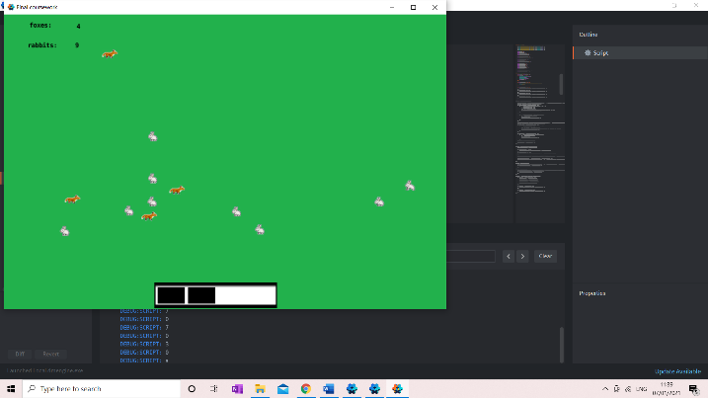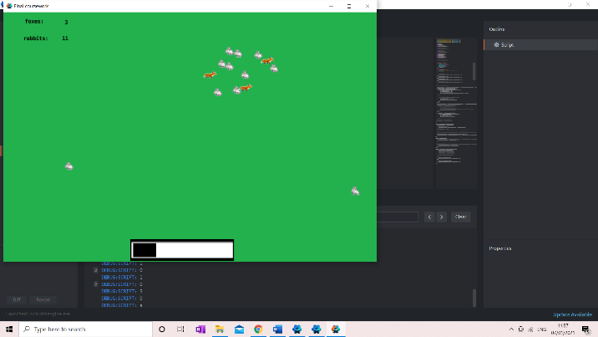

I therefore changed the times so another bar is displayed after 24 seconds:

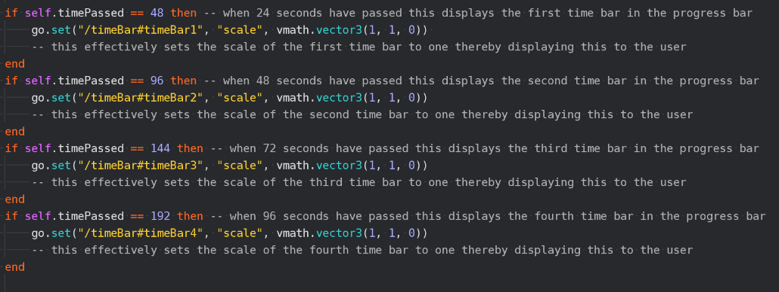

|  |  |  |  |  |
| --- | --- | --- | --- | --- |
| What is being tested? | Input | Justification | Expected Outcome | Actual Outcome |
| Are the time bars displayed at appropriate time intervals | Temperature: 22  amountOfSpace: 100  amountOfFood: 10  amountOfWater: 10  initialPredator: 3  initialPrey: 10 | This allows the user to know how far through the simulation the user is | For another time bar to be displayed after 24 seconds | Another time bar is displayed after 24 seconds |

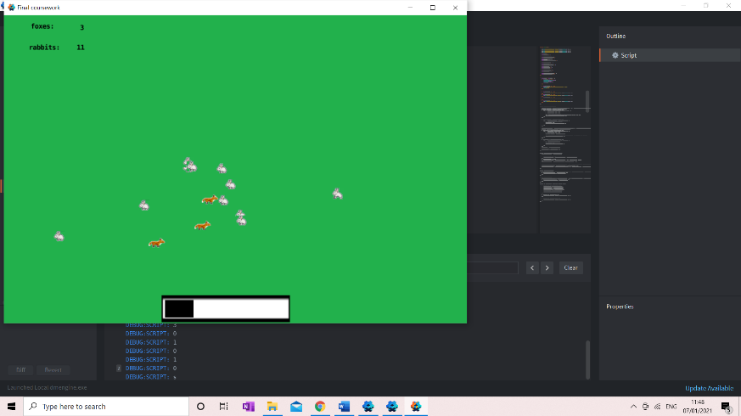

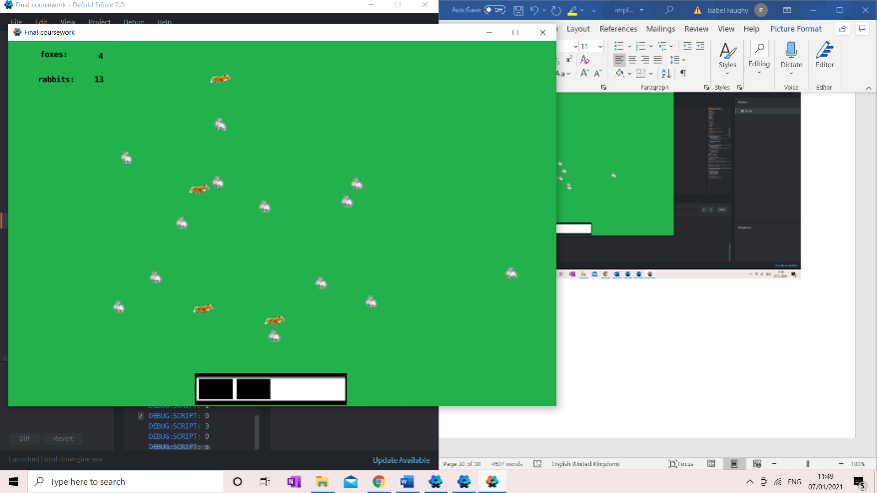

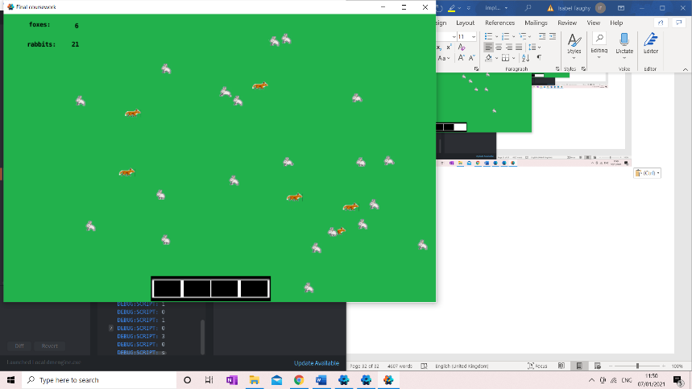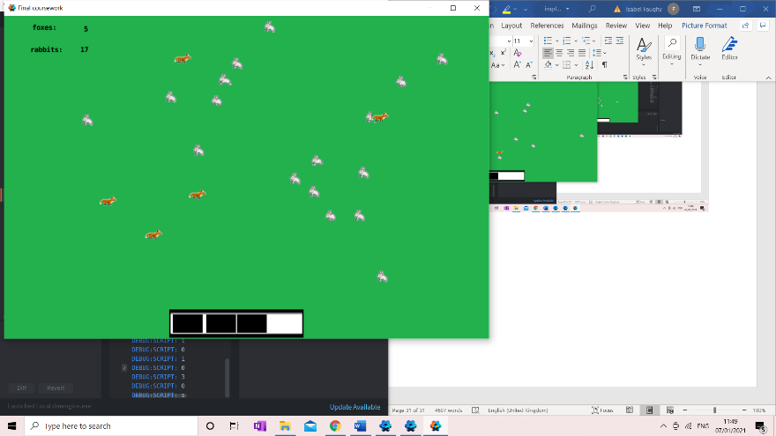

The following flowcharts were included in this prototype:

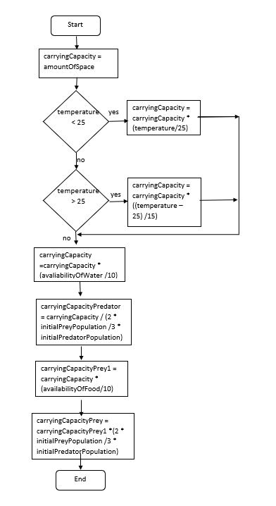

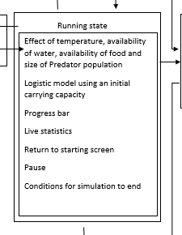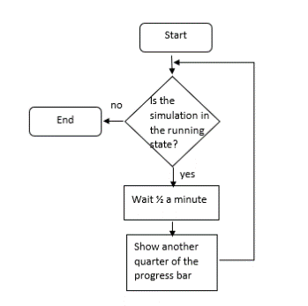

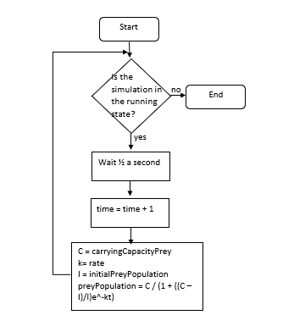

This was changed to display a timeBar every 24 seconds to mean that all four were displayed



Below is the section of the class diagram completed in this prototype:

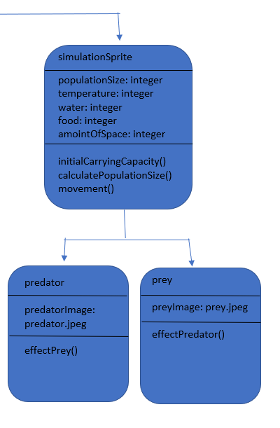

Variables declared in spawning script

functions in spawning script

animalProperties script which is a part of the fox and rabbit collections meaning inherited by each instance of the class

Image defined in sprite in fox collection

Image defined in sprite in rabbit collection

Inherited function in spawning script

Inherited function in spawning script

04/01/21 Interview

The following requirements have been addressed in this prototype:

|  |  |  |
| --- | --- | --- |
| 5 | Use a logistic model to accurately represent the predator/prey dynamics and therefore have them spawn or delete accordingly | This is essential to the simulation being a useful education tool |
| 6 | Have the predator/prey animated in the same way on a path | This will create a visual representation of the populations |
| 8 | Have population size boxes for the size of the predator and prey populations outputted live as the simulation goes on at the top left of the screen | To give the user a clear and concise idea of what is happening in the simulation |
| 12 | The prey will have the sprite of a rabbit | This will be clearly the prey as they are a very recognisable animal |
| 13 | The prey will have the sprite of a fox | This will be clearly the predator as they are a very recognisable animal |
| 14 | All sprites and backgrounds will be simple and clear | This will mean that it is clear what they are representing but will not distract from the educational value of the simulation |
| 15 | The parameters the temperature and availability of water will affect the carrying capacity of the populations in the same way | This will allow the user to investigate the effect of different parameters. |
| 16 | The carrying capacity will be initially calculated from the amount of space and then it will be altered appropriately by the appropriate parameters | This will allow the user to investigate the effect of different parameters |
| 17 | The carrying capacity of the prey will be affected by the size of the population of predator | This will allow for the two different population sizes to affect each other therefore allowing population dynamics to be portrayed |
| 18 | The availability of food for the predator will be dictated by the population size of prey which will then in turn affect the carrying capacity of the predator | This will allow for the two different population sizes to affect each other therefore allowing population dynamics to be portrayed |
| 20 | Have a progress bar to represent the passing of time | This will give the user a concept of how far through the simulation the user is |

Me: I feel I have met the vast majority of these requirements. I have used the logistic population model to calculate the population of the prey and predator at different times and have spawned and deleted prey and predators’ sprites accordingly meeting requirement 5 and these population sizes are outputted to labels in the top left of the screen meeting requirement 8. Additionally, these sprites are foxes and rabbit meeting requirement 12 and 13 and the rest of the sprites are simple and clear meeting requirement 14. The carrying capacity is initially made equal to the amount of space and cannot exceed this meeting requirement 16, temperature and availability of water effect the carrying capacity in the same way meeting requirement 15, the carrying capacity of the prey is affected by the predator population and the carrying capacity of the predator is affected by the prey therefore meeting requirement 17 and 18. I have also included a progress bar to represent the passing of time meeting requirement 20. However, I have not entirely met requirement 6 as although the predator and prey are animated in the same way they do not move at a constant speed as given the time limitations I felt the solution I have provided was more appropriate as it was quick to code and is effective although each sprite does move at different speeds whilst on the screen.

Natalie Faughy: I am happy with the progress that has been made and feel that it is resembling a simulation now which is a very positive development. I am pleased with the way the population and carrying capacities are being calculated and that the sprites are being spawned and deleted effectively. Additionally, the progress bar and live statistics are very helpful to the user and I am happy that these requirements have been met. I feel that the movement of the simulation sprites will not be too much of the problem as it does not distract away from the meaning of the simulation and therefore, I am happy for you to continue without any changes to this. I would now like you to start working on a solution for the end state.

Next step: I will now begin coding for the end state. I will do this by setting up the conditions for the end state to be loaded so when either population is equal to zero; I will send the parameters and information about the simulation to the end state; I will then include the necessary sprites for the end state and then code for the information about the simulation to be displayed.

08/01/20 The end state

In order to include the conditions for the end state I will use selection to send a message to the proxy to end the simulation if the prey or predator population is equal to 0. Below is code from the spawning script that includes this:

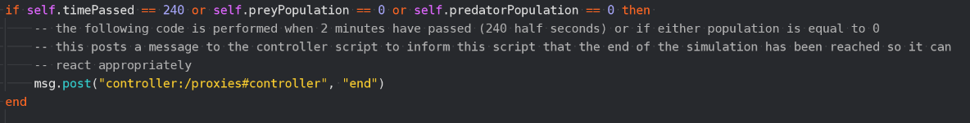

This ends the simulation if either population is equal to zero.

|  |  |  |  |  |
| --- | --- | --- | --- | --- |
| What is being tested? | Input | Justification | Expected Outcome | Actual Outcome |
| Does the simulation change to the end state after a population becomes 0 | Temperature: 1  amountOfSpace: 1  AmountOfFood: 1  amountOfWater: 1  initialPredator: 1  initialPrey: 10 | This will prevent the simulation from continuing unnecessarily | For the end state to begin when the population reaches 0 | The end state to begin when the population reaches 0 |

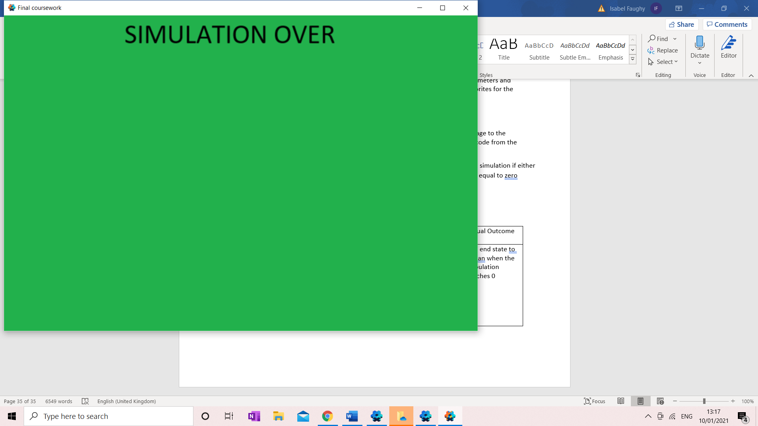

I will now send the parameters and information to the end state – the below code is from the spawning script:

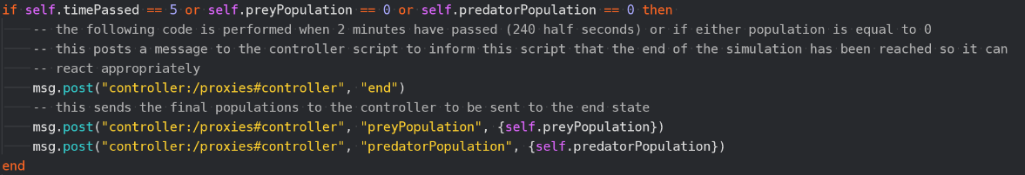

This sends a message post to the controller with the values of the final population.

Below is the code from the controller script:

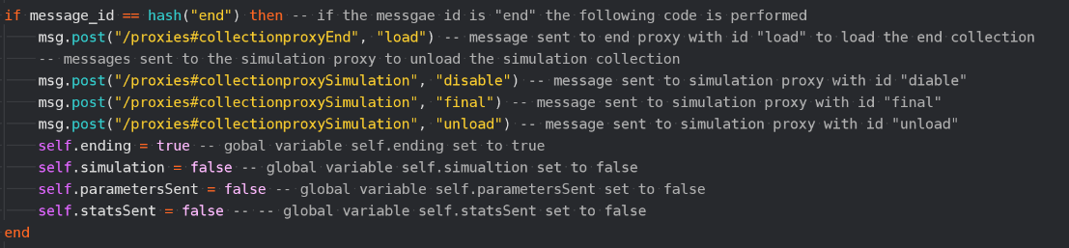

If the simulation is in the ending state and the parameters have not been sent yet, then the parameters are sent to the end state script and the variable self.parametersSent is set to true to prevent the parameters from being sent multiple times.

These global variables are set to false to signify that the simulation has now changed to the end state, but the parameters and stats have not yet been sent.

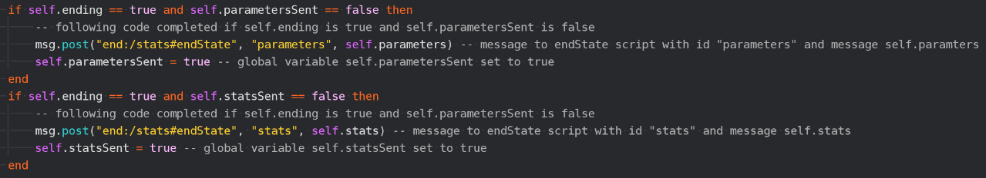

If the simulation is in the ending state and the stats have not been sent yet, then the stats are sent to end state script and the variable self.statsSent is set to true to prevent the stats from being sent multiple times.

Below is the code from the endState script:

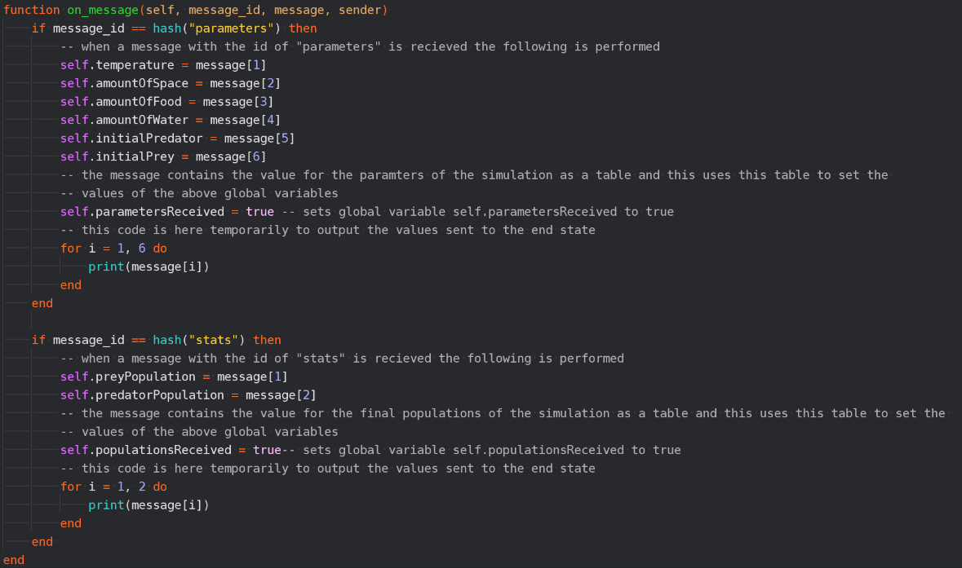

This code is temporarily here to print the populations to ensure they are being sent properly.

Set the variable self.populationsReceived to true to signify the populations have been received.

Sets the variable self.parametersReceived to true to signify the parameters have been received.

When the message with the id “stats” is sent then the value of the stats sent in the message is saved into global variables

This code is temporarily here to print the parameters to ensure they are being sent properly.

When the message with the id “parameters” is sent then the value of the parameters sent in the message is saved into global variables

|  |  |  |  |  |
| --- | --- | --- | --- | --- |
| What is being tested? | Input | Justification | Expected Outcome | Actual Outcome |
| Are the parameters and simulation stats sent to the end state | Temperature: 22  amountOfSpace: 100  AmountOfFood: 10  amountOfWater: 10  initialPredator: 3  initialPrey: 10 | The values outputted at the end state are accurate | 22  100  10  10  3  10  25  7  Outputted to debug script | 22  100  10  10  3  10  25  7 |

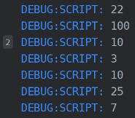

I created the necessary labels and included the images for the end state:

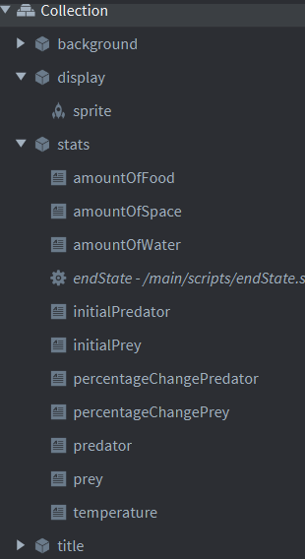

This includes the titles for each label.

The labels for the information to be outputted to and the script which will be responsible for outputting information to this script.

I will now include the sprites for the end state and the code to display the statistics for the previous simulation – the following code is from the endState script:

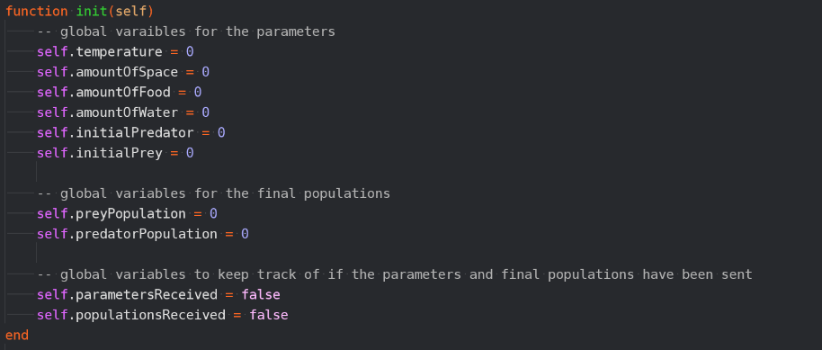

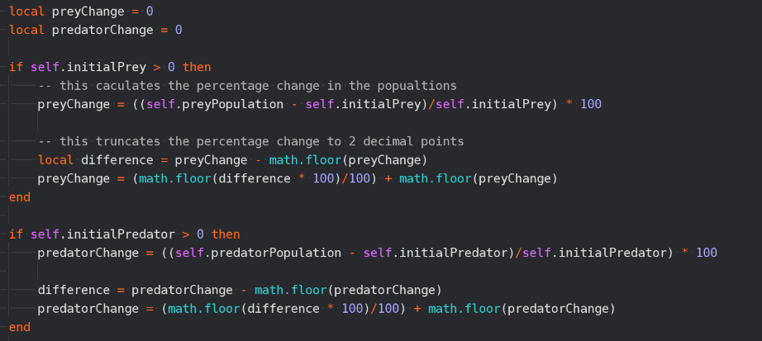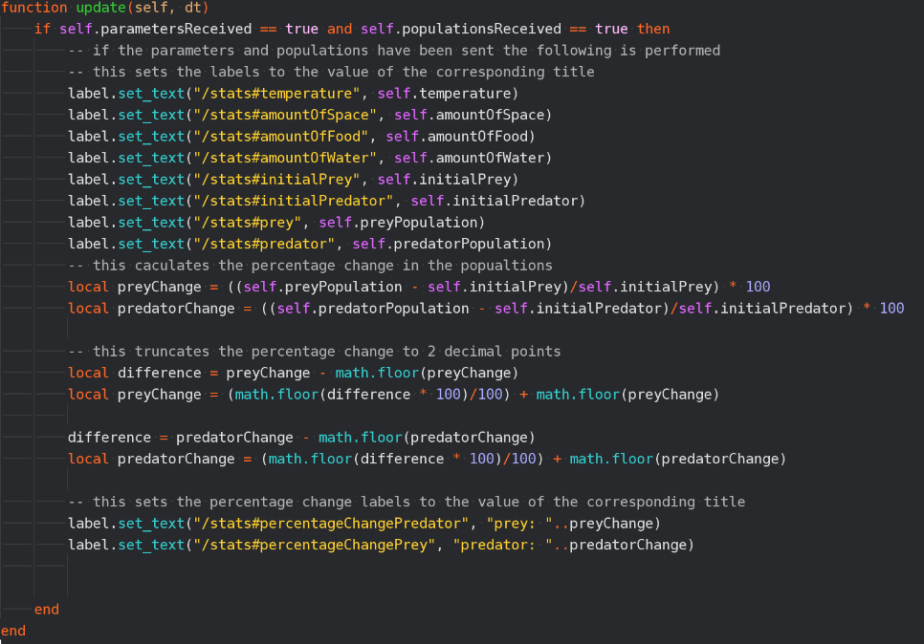

This calculates the percentage change of the predator and prey populations if the initial population is over 0 to avoid nil values.

This repeats the same process to find the percentage change for the predator.

This truncates the percentage changes to two decimal places by taking the difference between the percentage change and the integer part of this and multiplying this by 100 and flooring this to take only the integer part and then dividing this by 100 and adding this to the integer part of the percentage change to truncate the percentage change to two decimal points.

This outputs the values of the parameters and the final populations to the appropriate labels

When both the stats and the parameters have been received the values are displayed



This outputs the percentage changes to the appropriate labels.

|  |  |  |  |  |
| --- | --- | --- | --- | --- |
| What is being tested? | Input | Justification | Expected Outcome | Actual Outcome |
| Are the parameters and simulation stats being displayed to the screen | Temperature: 22  amountOfSpace: 100  AmountOfFood: 10  amountOfWater: 10  initialPredator: 3  initialPrey: 10 | The values outputted to the end state | 25  7  133.33  150  22  10  10  100  3  10 | 25  7  133.33  150  22  10  10  100  3  10 |

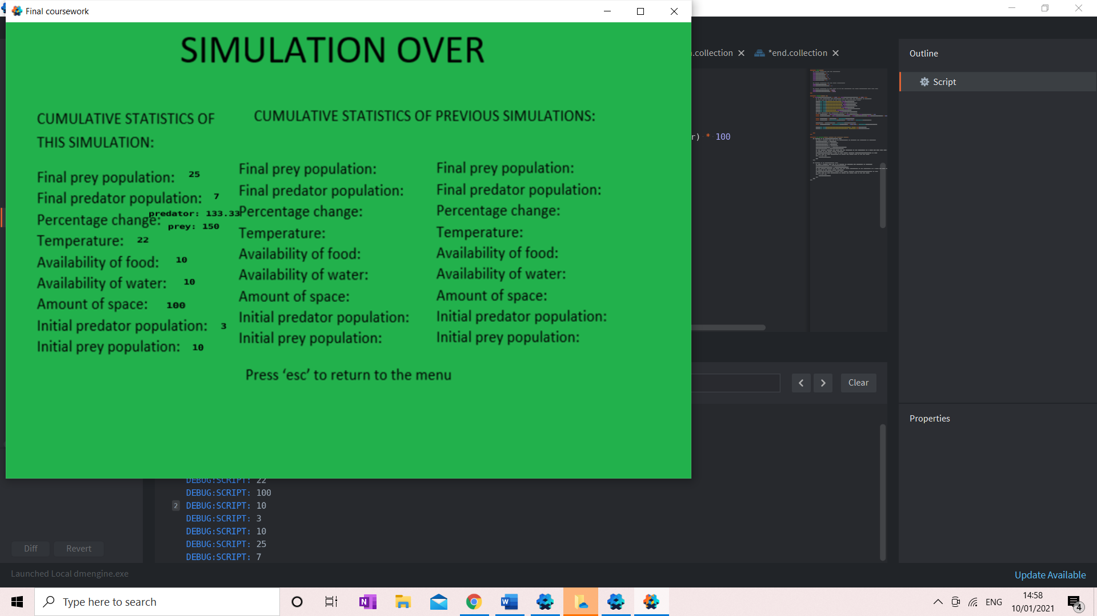

Below are the flowcharts included in this prototype:

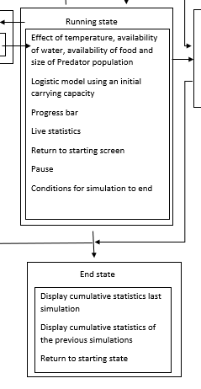

This takes away some of the complexity such as passing the parameters and stats to the end state.

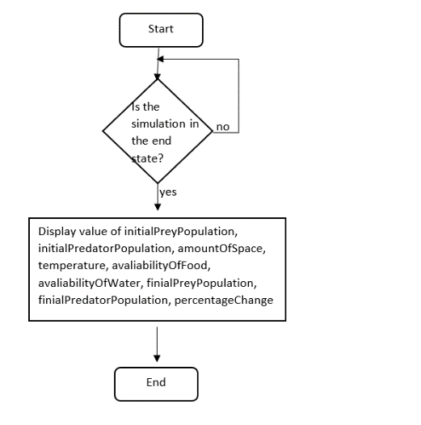

10/01/21 Interview

Below are the requirements that have been met in this prototype:

|  |  |  |
| --- | --- | --- |
| 22 | Have the simulation end if a population becomes extinct | This will prevent the simulation from not being engaging as one of the populations has died. |
| 23 | Have the end state display the cumulative stats including the final size of both populations and both of their percentage changes. As well as a prompt for the user to press ‘esc’ to return to the menu | This will allow the user to have a good idea of what had taken place in the simulation |

Me: I have met requirement 22 in its entirety as when the predator or prey population reaches zero the simulation changes to the end state. However, I have not met requirement 23 in its entirety, the cumulative stats including the final size of both populations and their percentage change are outputted but I have not outputted a prompt for the user to press ‘esc’ to return to the menu which would now be ‘m’ because of necessary changes made in a previous prototype. I can quite easily include this prompt and will look to do so in the next prototype.

Natalie Faughy: Yes, I agree that requirement 22 has been met and requirement 23 has almost been met. I would now like you to include the last part of requirement 23 and look to include saving the information about the simulation to file and then outputting this to the screen in the end state.

Next step: I now need to include the prompt in the end state and then need to complete the code for saving to file. I will do this by creating the necessary file, writing the information to this file in the controller script and then outputting this information in the end state.

13/01/21 Save to file.

I first identified an issue in that once the simulation has been run and ‘m’ has been pressed to return to the menu then the simulation cannot be successfully run again as can be seen below as when I reached the end of a simulation and pressed ‘m’ to return to the menu and then pressed ‘s’ to move to the running state this was the result:

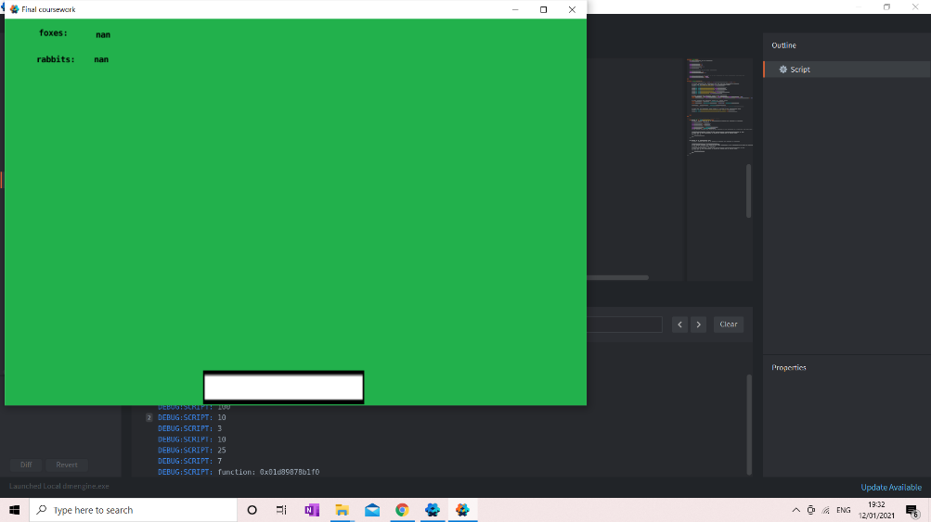

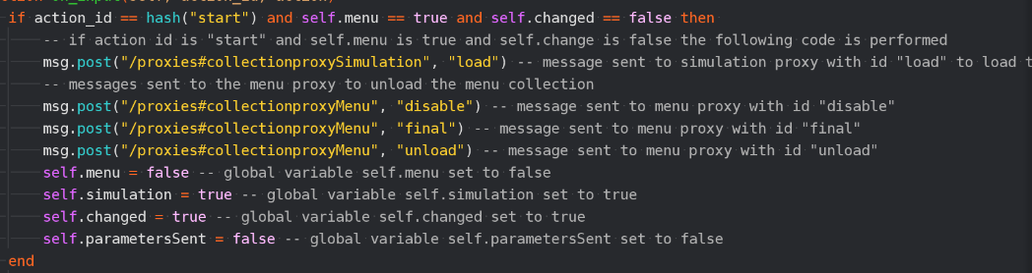In order to resolve this the following code had to be changed in the controller script:

The following code had to be included to ensure that the parameters were sent each time.

|  |  |  |  |  |
| --- | --- | --- | --- | --- |
| What is being tested? | Input | Justification | Expected Outcome | Actual Outcome |
| Can the simulation be run multiple times | Simulation ran multiple times. | To allow the user to run the simulation multiple times | Simulation successfully ran multiple times | Simulation successfully ran multiple times |

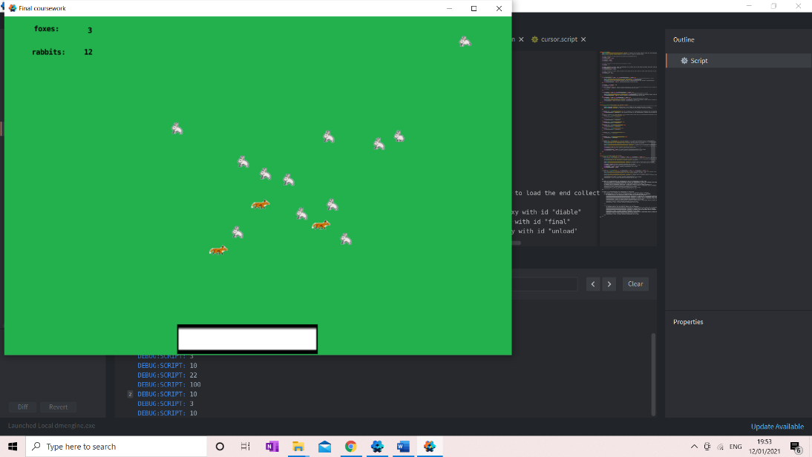

When I reached the end of a simulation and pressed ‘m’ to return to menu and then pressed ‘s’ to move to the running state this was the result showing that the simulation can now be successfully ran multiple times.

I then included the additional labels for outputting the additional values from the previous simulations:

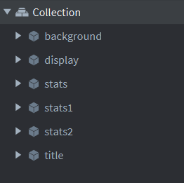

Below is the code from the endState script for saving and loading previous simulation statistics from file

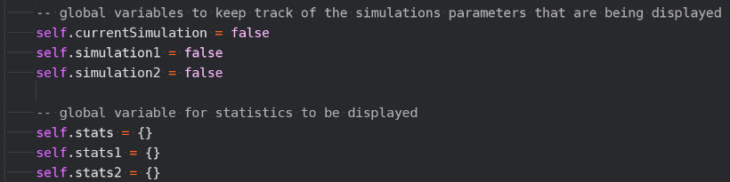

The following global variables have been included to keep track of what information is being outputted and to store this information.

This section of the endState script is the same however I changed it so that the parameters and final populations are saved into a variable called self.stats as this should make code later easier to code.

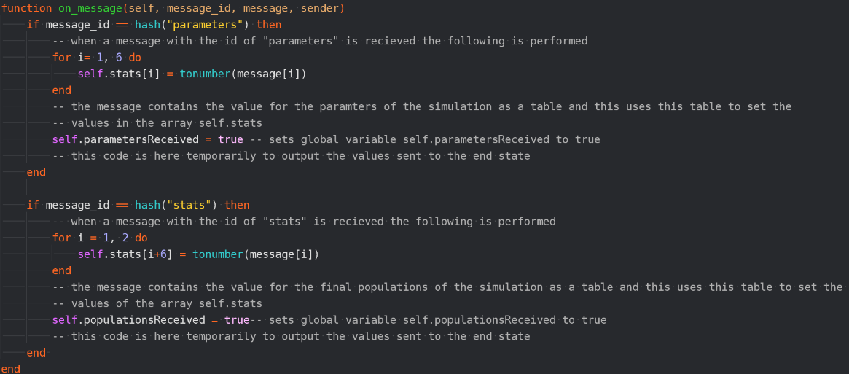

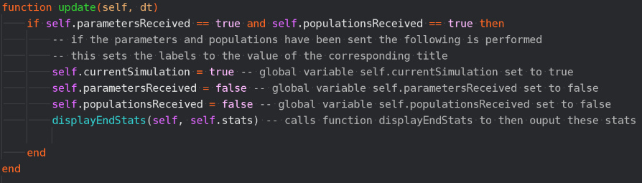

This section of the endState script is the similar however this now updates the global variables to represent that statistics are being outputted and also calls a function displayEndStats to then output these values.

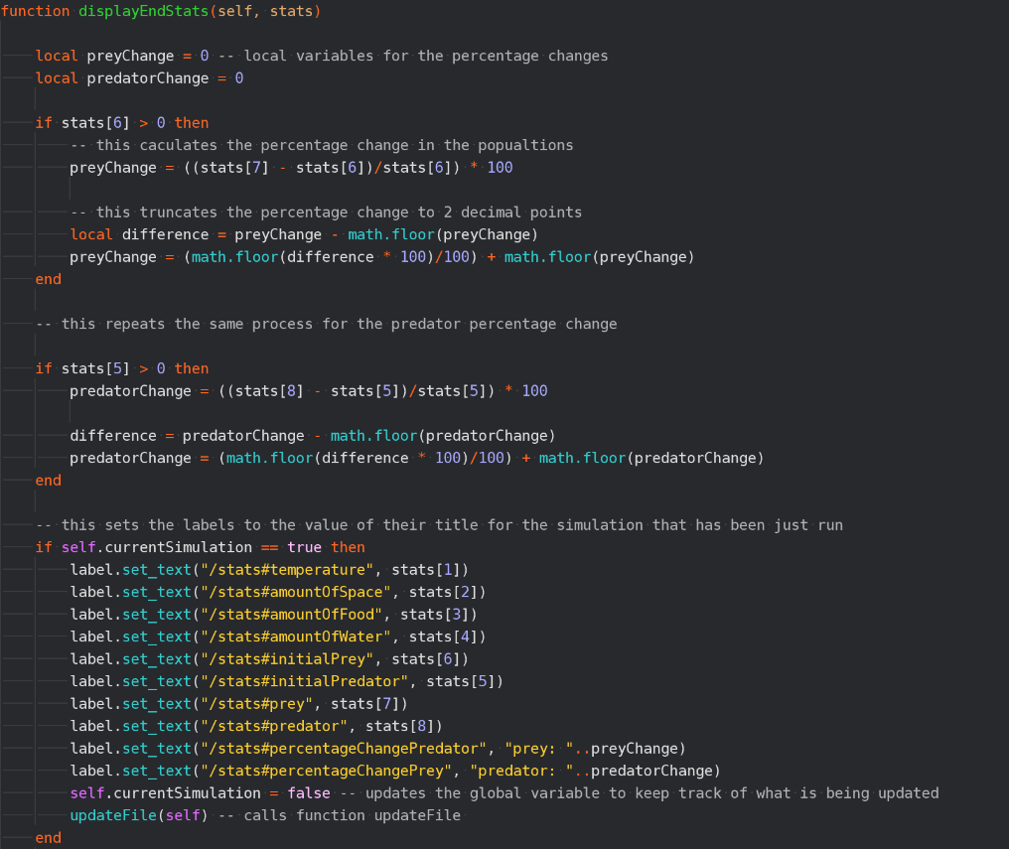

This will output the values for the simulation that has just happened if that is what is currently being processed, it then updates the global variables to represent that the current simulation statistics are no longer being outputted and calls the function updateFile() which includes the values of the simulation that has just passed into the file

This calculates the percentage change in a similar just using values from the table stats.

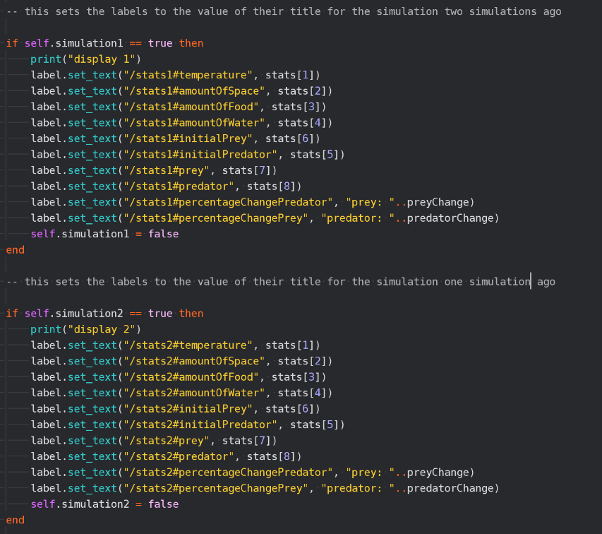

This follows a similar process for the previous two simulations.

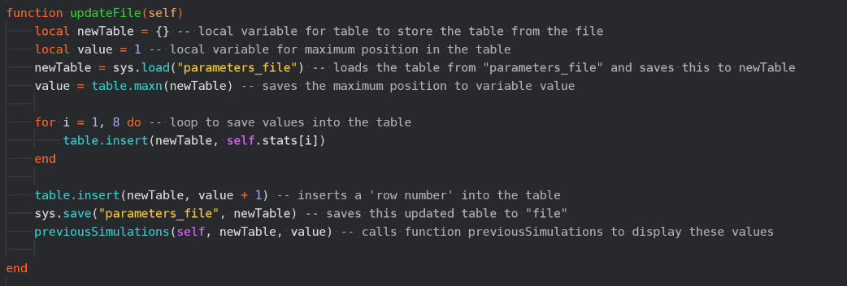

The updateFile function loads the table from file and saves it to the variable newTable and saves the maximum position to the variable value. It then inserts the statistics from the last simulation and the ‘row number’ for the next simulation. It then saves the updated table back to the file and calls the function previousSimulations.

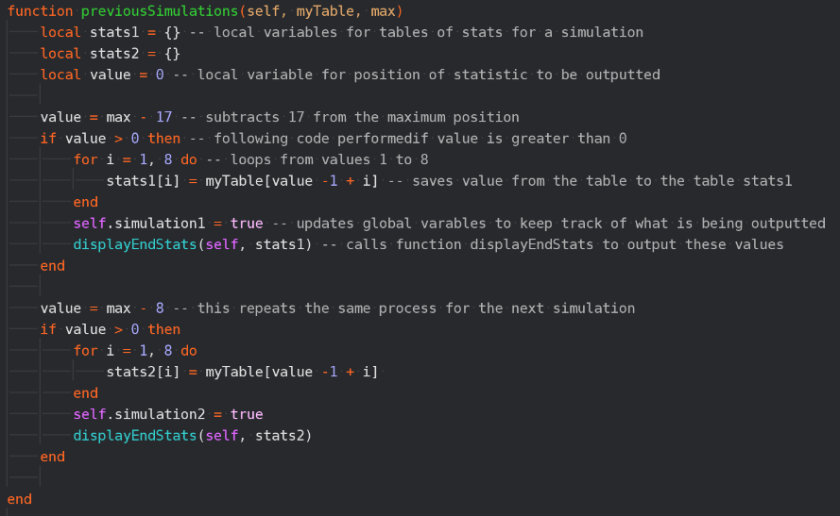

This function saves the values of the past two simulaitons if two simulations have been run. It does this by taking the value of the greatest position and subtracting values and if these are over 0 meaning there are enough items saved to the table for there to be two previous simulations. It then loops through to save the values from the table to another table which is then passed to the displayEndStats function which then displays these values to the screen.

However, a limitation of this is that the following code has to be included in the controller script if the simulation is run when the table is empty:

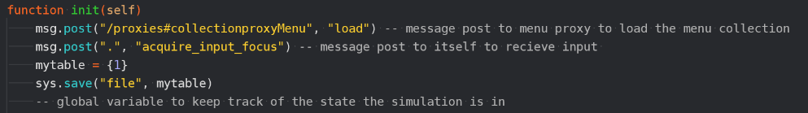

This code has to be included as later in the program the table is loaded and if there is not some form of table there already this will not work.

|  |  |  |  |  |
| --- | --- | --- | --- | --- |
| What is being tested? | Input | Justification | Expected Outcome | Actual Outcome |
| Are previous simulations correctly outputted during the end state | N/A | To allow the user to compare simulations | For three simulation statistics to be outputted | For three simulation statistics to be outputted |

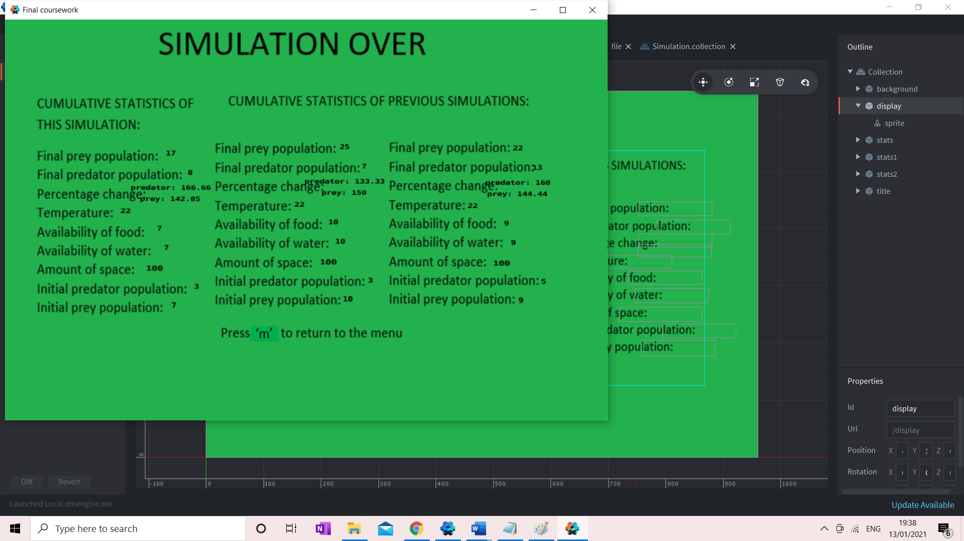

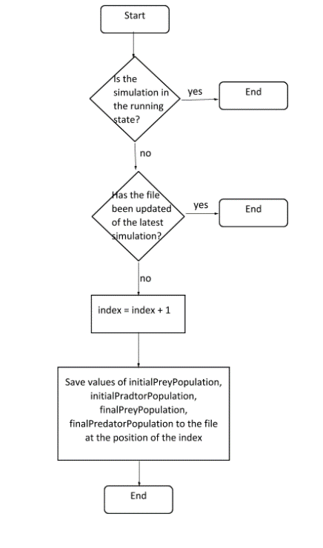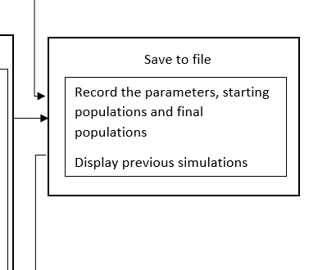Below shows the flowcharts included in this prototype:

This is also no longer entirely accurate as the saving to file is done in the end state to allow for the final populations to be saved

Although the parameters and population sizes are set to 0 this is done by the controller script and the activeDisplayBox script and the sprites from the running state are deleted when the running state is unloaded by the controller script meaning this part of the flowchart is no longer accurate

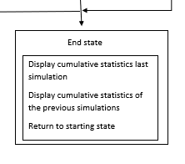

15/01/21 – Interview

These are the requirements that were included in this prototype:

|  |  |  |
| --- | --- | --- |
| 24 | Have the simulation write to file the initial and final populations, the parameters and the percentage change | This will allow the user to compare multiple results and could process data from multiple simulations in different ways more easily |

Me: I have met requirement 24 the initial and final populations and the parameters are saved to the file, although I did not include the percentage change this is calculated from the initial and final populations. These can then be loaded and displayed to the screen during the end screen.

Natalie Faughy: Yes, I agree that requirement 24 has been met and the fact percentage change is not saved will have no real effect on the simulation. I am happy now that the development stage can end as given the time restraints, I feel the simulation has come to a good place.

Testing for evaluation

Navigation

This section will test the navigation through the simulation.

|  |  |  |  |  |  |
| --- | --- | --- | --- | --- | --- |
| No. | Test | Input | Expected outcome | Actual outcome | Video reference |
| 2 | Press the ‘p’ key to enter the paused simulation state from the running state | Valid: “p” | Valid: the running state is paused | As expected | Video 1.1 |
|  |  | Invalid: “h” | Invalid: The running state will continue without any disruption | As expected | Video 1.2 |
|  |  | Invalid: “6” | Invalid: The running state will continue without any disruption | As expected | Video 1.3 |
|  |  | Invalid: “!” | Invalid: The running state will continue without any disruption | As expected | Video 1.4 |
| 3 | Press the ‘p’ key to unpause the simulation and re-enter the running state | Valid: “p” | Valid: the running state is returned to  Invalid: The simulation will continue to be paused | As expected | Video 2.1 |
|  |  | Invalid: “h” | Invalid: The simulation will continue to be paused | As expected | Video 2.2 |
|  |  | Invalid: “6” | Invalid: The simulation will continue to be paused | As expected | Video 2.3 |
|  |  | Invalid: “!” | Invalid: The simulation will continue to be paused | As expected | Video 2.4 |
| 12 | Press the ‘s’ key to enter the running state from the menu state | Valid: “s” | Valid: becomes the running state from the menu | As expected | Video 3.1 |
|  |  | Invalid: “h” | Invalid: the simulation will remain in the menu | As expected | Video 3.2 |
|  |  | Invalid: “6” | Invalid: the simulation will remain in the menu | As expected | Video 3.3 |
|  |  | Invalid: “!” | Invalid: the simulation will remain in the menu | As expected | Video 3.4 |
| 23 | Have the simulation end and enter the ending state after a certain amount of time (2 minutes) | N/A | If two minutes had passed the simulation should change to the end state | As expected | Video 4 |
| 26 | Use the ‘esc’ key to return to the starting state from the running state | Valid: “m”  (no longer “esc” because of changes made in development) | Valid: the simulation moves to the menu | As expected | Video 5.1 |
|  |  | Invalid: “h” | Invalid: the simulation stays in the running state | As expected | Video 5.2 |
|  |  | Invalid: “6” | Invalid: the simulation stays in the running state | As expected | Video 5.3 |
|  |  | Invalid: “!” | Invalid: the simulation stays in the running state | As expected | Video 5.4 |
| 28 | Use the ‘esc’ key to return to the menu from the end state | Valid: “m”  (no longer “esc” because of changes made in development) | Valid: the simulation moves to the menu | As expected | Video 6.1 |
|  |  | Invalid: “h” | Invalid: the simulation stays in the end state | As expected | Video 6.2 |
|  |  | Invalid: “6” | Invalid: the simulation stays in the end state | As expected | Video 6.3 |
|  |  | Invalid: “!” | Invalid: the simulation stays in the end state | As expected | Video 6.4 |

Menu State

This section is testing the menu and the entering of values for the parameters in this state.

|  |  |  |  |  |  |
| --- | --- | --- | --- | --- | --- |
| No. | Tests | Input | Expected outcome | Actual outcome | Video  Reference |
| 4 | Menu displayed with a title, simulation key, user control instructions and text box to enter parameters | N/A | Valid: The user will have instructions about simulation controls and what images of the simulation represent and a text box to enter parameters | As expected | N/A  (can be seen in later videos) |
| 5 | The user can enter the temperature parameter however it must be validated and be within 0-40 | Valid: 34 | Valid: 34 will be stored as the value for the variable temperature | As expected | Video 7.1 |
|  |  | Borderline: 40 | Valid: 40 will be stored as the value for the variable temperature | As expected | Video 7.1 |
|  |  | Borderline: 0 | Valid: 0 will be stored as the value for the variable temperature | As expected | Video 7.1 |
|  |  | Invalid: “r” | Invalid: the program will output that this is an invalid input and the user will be able to input a new value and this will not be saved to the variable temperature | The program does not process anything for letters or symbols being entered apart from those used in navigation to this has no effect on the simulation meaning that the user can still continue to enter a number but is not alerted that this is invalid input | Video 7.2 |
|  |  | Invalid: 76 | Invalid: the program will output that this is an invalid input, and the user will be able to input a new value and this will not be saved to the variable temperature | As expected | Video 7.3 |
|  |  | Invalid: “!” | Invalid: the program will output that this is an invalid input, and the user will be able to input a new value and this will not be saved to the variable temperature | The program does not process anything for letters or symbols being entered apart from those used in navigation to this has no effect on the simulation meaning that the user can still continue to enter a number but is not alerted that this is invalid input | Video 7.4 |
|  |  | Invalid: 3.4 | Invalid: the program will output that this is an invalid input, and the user will be able to input a new value and this will not be saved to the variable temperature | Because this program does not process anything when a symbol is entered this is interpreted as 3 | Video 7.5 |
| 6 | The user can enter the initial prey population parameter however it must be validated and be within 0-100 | Valid: 34 | Valid: 34 will be stored as the value for the variable initial prey population | As expected | Video 8.1 |
|  |  | Borderline: 100 | Valid: 100 will be stored as the value for the variable initial prey population | As expected | Video 8.1 |
|  |  | Borderline: 0 | Valid: 0 will be stored as the value for the variable initial prey population | This means that when the population is calculated a nil value is produced because it means that the formula divides by 0 this means that “nan” is outputted as the population sizes and no sprites are outputted | Video 8.1 |
|  |  | Invalid: “r” | Invalid: the program will output that this is an invalid input, and the user will be able to input a new value and it will not be saved to the initialPrey variable | The program does not process anything for letters or symbols being entered apart from those used in navigation to this has no effect on the simulation meaning that the user can still continue to enter a number but is not alerted that this is invalid input | Video 8.2 |
|  |  | Invalid: 124 | Invalid: the program will output that this is an invalid input, and the user will be able to input a new value and it will not be saved to the initialPrey variable | As expected | Video 8.3 |
|  |  | Invalid: “!” | Invalid: the program will output that this is an invalid input, and the user will be able to input a new value and it will not be saved to the initialPrey variable | The program does not process anything for letters or symbols being entered apart from those used in navigation to this has no effect on the simulation meaning that the user can still continue to enter a number but is not alerted that this is invalid input | Video 8.4 |
|  |  | Invalid: 3.4 | Invalid: the program will output that this is an invalid input, and the user will be able to input a new value and it will not be saved to the initialPrey variable | Because this program does not process anything when a symbol is entered this is interpreted as 3 | Video 8.5 |
| 7 | The user can enter the initial predator population parameter however it must be validated and be within 0-100 | Valid: 34 | Valid: 34 will be stored as the value for the variable initial predator population | As expected, | Video 9.1 |
|  |  | Borderline: 100 | Valid: 100 will be stored as the value for the variable initial predator population | As expected | Video 9.1 |
|  |  | Borderline: 0 | Valid: 0 will be stored as the value for the variable initial predator population | This means that when the population is calculated a nil value is produced because it means that the formula divides by 0 this means that “nan” is outputted as the population sizes and no sprites are outputted | Video 9.1 |
|  |  | Invalid: “r” | Invalid: the program will output that this is an invalid input, and the user will be able to input a new value and it will not be saved to the initialPredator variable | The program does not process anything for letters or symbols being entered apart from those used in navigation to this has no effect on the simulation meaning that the user can still continue to enter a number but is not alerted that this is invalid input | Video 9.2 |
|  |  | Invalid: 124 | Invalid: the program will output that this is an invalid input, and the user will be able to input a new value and it will not be saved to the initialPredator variable | As expected | Video 9.3 |
|  |  | Invalid: “!” | Invalid: the program will output that this is an invalid input, and the user will be able to input a new value and it will not be saved to the initialPredator variable | The program does not process anything for letters or symbols being entered apart from those used in navigation to this has no effect on the simulation meaning that the user can still continue to enter a number but is not alerted that this is invalid input | Video 9.4 |
|  |  | Invalid: “3.4” | Invalid: the program will output that this is an invalid input, and the user will be able to input a new value and it will not be saved to the initialPredator variable | Because this program does not process anything when a symbol is entered this is interpreted as 3 | Video 9.5 |
| 8 | The user can enter the availability of food parameter however it must be validated and be within 0-10 | Valid: 3 | Valid: 3 will be stored as the value for the variable availability of food | As expected | Video 10.1 |
|  |  | Borderline: 10 | Valid: 10 will be stored as the value for the variable availability of food | As expected | Video 10.1 |
|  |  | Borderline: 0 | Valid: 0 will be stored as the value for the variable availability of food | As expected | Video 10.1 |
|  |  | Invalid: “r” | Invalid: the program will output that this is an invalid input, and the user will be able to input a new value and it will not be saved to the amountOfFood variable | The program does not process anything for letters or symbols being entered apart from those used in navigation to this has no effect on the simulation meaning that the user can still continue to enter a number but is not alerted that this is invalid input | Video 10.2 |
|  |  | Invalid: 76 | Invalid: the program will output that this is an invalid input, and the user will be able to input a new value and it will not be saved to the amountOfFood variable | As expected | Video 10.3 |
|  |  | Invalid: “!” | Invalid: the program will output that this is an invalid input, and the user will be able to input a new value and it will not be saved to the amountOfFood variable | The program does not process anything for letters or symbols being entered apart from those used in navigation to this has no effect on the simulation meaning that the user can still continue to enter a number but is not alerted that this is invalid input | Video 10.4 |
|  |  | Invalid: 3.4 | Invalid: the program will output that this is an invalid input, and the user will be able to input a new value and it will not be saved to the amountOfFood variable | Because this program does not process anything when a symbol is entered this is interpreted as 3 | Video 10.5 |
| 9 | The user can enter the availability of water parameter however it must be validated and be within 0-10 | Valid: 3 | Valid: 3 will be stored as the value for the variable availability of water | As expected | Video 11.1 |
|  |  | Borderline: 10 | Valid: 10 will be stored as the value for the variable availability of water | As expected | Video 11.1 |
|  |  | Borderline: 0 | Valid: 0 will be stored as the value for the variable availability of water | As expected | Video 11.1 |
|  |  | Invalid: “r” | Invalid: the program will output that this is an invalid input, and the user will be able to input a new value | The program does not process anything for letters or symbols being entered apart from those used in navigation to this has no effect on the simulation meaning that the user can still continue to enter a number but is not alerted that this is invalid input | Video 11.2 |
|  |  | Invalid: 76 | Invalid: the program will output that this is an invalid input, and the user will be able to input a new value | As expected, | Video 11.3 |
|  |  | Invalid: “!” | Invalid: the program will output that this is an invalid input, and the user will be able to input a new value | The program does not process anything for letters or symbols being entered apart from those used in navigation to this has no effect on the simulation meaning that the user can still continue to enter a number but is not alerted that this is invalid input | Video 11.4 |
|  |  | Invalid: 3.4 | Invalid: the program will output that this is an invalid input, and the user will be able to input a new value | Because this program does not process anything when a symbol is entered this is interpreted as 3 | Video 11.5 |
| 10 | The user can enter the amount of space parameter however it must be validated and be within 0-500 (this has changed during the development stage) | Valid: 34 | Valid: 34 will be stored as the value for the variable amount of space | As expected | Video 12.1 |
|  |  | Borderline: 500 | Valid: 500 will be stored as the value for the variable amount of space | As expected | Video 12.1 |
|  |  | Borderline: 0 | Valid: 0 will be stored as the value for the variable amount of space | As expected | Video 12.1 |
|  |  | Invalid: “r” | Invalid: the program will output that this is an invalid input, and the user will be able to input a new value | The program does not process anything for letters or symbols being entered apart from those used in navigation to this has no effect on the simulation meaning that the user can still continue to enter a number but is not alerted that this is invalid input | Video 12.2 |
|  |  | Invalid: 1000 | Invalid: the program will output that this is an invalid input, and the user will be able to input a new value | As expected | Video 12.3 |
|  |  | Invalid: “!” | Invalid: the program will output that this is an invalid input, and the user will be able to input a new value | The program does not process anything for letters or symbols being entered apart from those used in navigation to this has no effect on the simulation meaning that the user can still continue to enter a number but is not alerted that this is invalid input | Video 12.4 |
|  |  | Invalid: 3.4 | Invalid: the program will output that this is an invalid input, and the user will be able to input a new value | Because this program does not process anything when a symbol is entered this is interpreted as 3 | Video 12.5 |

Running state

|  |  |  |  |  |  |
| --- | --- | --- | --- | --- | --- |
| No | Test | Input | Expected Outcome | Actual Outcome | Video Reference |
| 11 | All sprites and backgrounds will be simple and clear | N/A | Valid: All sprites and backgrounds will be simple and clear without pixilation or objects being out of scale | As expected | N/A |
| 13 | The carrying capacity will be initially calculated from the amount of space | N/A | Valid: carryingCapacity is initially equal to the amountOfSpace  Invalid: carryingCapacity is not initially equal to the amountOfSpace | As expected | N/A |
| 14 | The parameters the temperature and availability of water will affect the carrying capacity of the populations in the same way | N/A | Valid: the temperature and availability of water will affect the carrying capacity of the populations in the same way  Invalid: the temperature and availability of water do not affect the carrying capacity of the populations in the same way | As expected | N/A |
| 15 | The carrying capacity of the prey will be affected by the availabilityOfFood | N/A | Valid: The carrying capacity of the prey will be affected by the availabilityOfFood  Invalid: The carrying capacity of the prey will not be affected appropriately by the availabilityOfFood | As expected | N/A |
| 16 | The availability of food for the predator will be dictated by the population size of prey which will then in turn affect the carrying capacity of the predator and this will be updated each time the population is calculated | N/A | Valid: population size of the prey will affect the carrying capacity of the predator  Invalid: population size of the prey will not appropriately affect the carrying capacity of the predator | As expected | N/A |
| 17 | The predator population will affect the prey population, and this will be updated each time the population is calculated | N/A | Valid: population size of the predator will affect the carrying capacity of the prey  Invalid: population size of the predator will not appropriately affect the carrying capacity of the prey | As expected | N/A |
| 18 | Use a logistical model to accurately calculate the predator population | N/A | Valid: the logistical model is used to accurately calculate the predator population  Invalid: the logistical model is not used to accurately calculate the predator population | As expected | N/A |
| 19 | Use a logistical model to accurately calculate the predator population | N/A | Valid: the logistical model is used to accurately calculate the prey population  Invalid: the logistical model is not used to accurately calculate the prey population | As expected | N/A |
| 20 | Have sprites of the appropriate population spawned if the calculated population is greater than the number of displayed sprites and deleted if less | N/A | Valid: Have the same number of sprites as the size of the two populations  Invalid: to not have the same number of sprites as the size of the two populations | As expected | Video 4 |
| 21 | Have a progress bar to represent the passing of time | N/A | Valid: Have another time bar be displayed every 24 seconds (changed from 30 seconds in development stage)  Invalid: Have another time bar be displayed at different time intervals or not displayed at all | As expected | Video 4 |
| 22 | Have population size boxes for the size of the predator and prey populations outputted live as the simulation goes on at the top left of the screen | N/A | Valid: Have the population sizes displayed  Invalid: no values are displayed for the populations or values other than the size of the populations are displayed or values are displayed that are not integers | As expected | Video 4 |

End state

|  |  |  |  |  |  |
| --- | --- | --- | --- | --- | --- |
| No. | Test | Input | Expected Result |  |  |
| 27 | Have the end state display the cumulative stats including the final size of both populations and both of their percentage changes. As well as a prompt for the user to press ‘esc’ to return to the menu | N/A | Valid: Have the end state display the cumulative stats including the final size of both populations and both of their percentage changes. As well as a prompt for the user to press ‘esc’ to return to menu.  Invalid: having anything displayed not mentioned above or not displaying something of the above | As expected apart from the fact the prompt is now to press ‘m’ to return to the starting state | N/A |
| 24 | Have the simulation end if a population becomes extinct | N/A | Valid: the simulation ends  Invalid: the simulation doesn’t end | As expected | Video 13 |

Save to file.

|  |  |  |  |  |  |
| --- | --- | --- | --- | --- | --- |
| No | Test | Input | Expected outcome | Actual Outcome | Video Reference |
| 1 | Save the parameters to an array | N/A | Valid: an array containing the values of the parameters as integer in a predetermined order  Invalid: a data structure other than an array containing any value that is not an integer | As expected | N/A |
| 25 | Save to file the array storing the final populations before the simulation moves to the end state | N/A | Valid: text file is appended to include the parameters and final populations of the simulation that has just run  Invalid: text file doesn’t include the parameters and final populations of the simulation that has or contains the incorrect values | This is done at the same time as the parameters in the end state but otherwise as expected | N/A |
| 29 | Have the simulation load from file the statistics from the two previous simulations if two simulations have been run | N/A | Valid: The statistics from two previous simulations will be displayed  Invalid: the statistics from the last two simulations are not displayed | As expected | Video 13 |

Usability features

I will now annotate a series of images to highlight the usability features followed by a statement from the stakeholder:

Menu:

Title so the user knows what part of the simulation they are in

The user can press the ‘s’ key to begin the simulation.

The user can use the mouse to click on these boxes and then the keyboard to enter information.

This explains to the user what the sprites used in the simulation mean.

This gives instructions to the user for navigation.

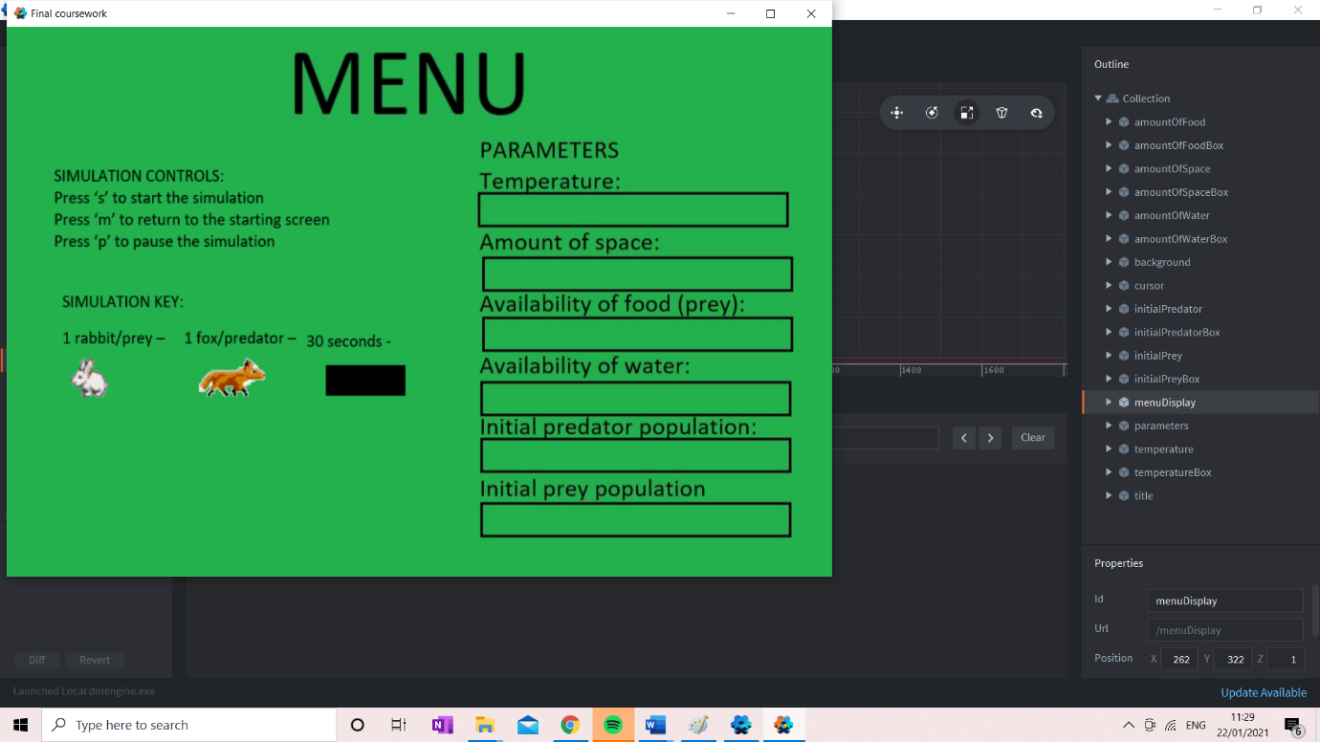

Me: as discussed, the simulation controls and the simulation key are displayed to the screen and there are boxes that the user can use the mouse to click and then the keyboard to enter information, they are to press the space bar in between each number entered and the enter key when they have finished entering their value. The user can also in this state press ‘s’ to begin the simulation.

Natalie Faughy: I agree that you have implemented what we had discussed however I do feel that because of the changes in the way data is entered in that the space bar was introduced I think they would need to be text explaining that this is required of the user however I think that otherwise it is clear how to navigate the simulation.

Running state:

Live statistics outputted each time the population is re-calculated to allow the user to easily follow the simulation.

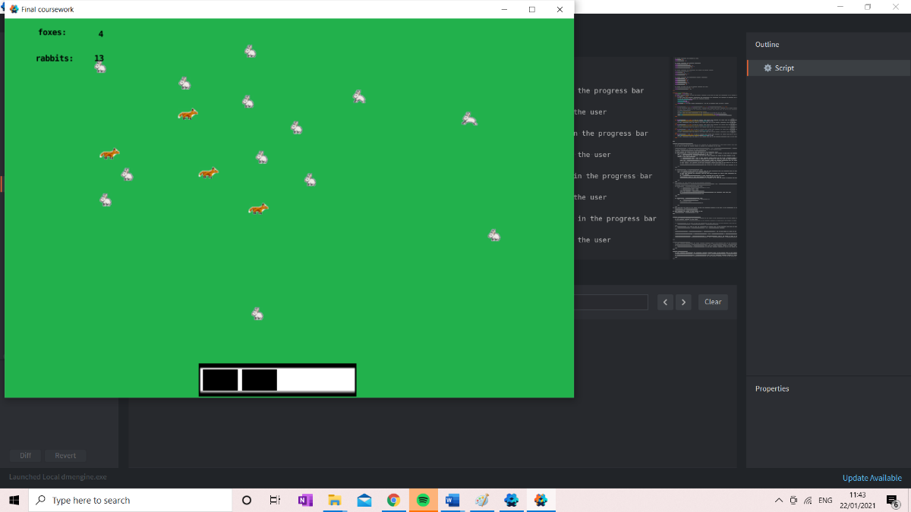

In the running state the user can press ‘p’ to pause the simulation and can press ‘m’ to return to the menu state

Progress bar allows the user to have an idea of how far through the simulation the user is

Simulation sprites for the rabbits and foxes are distinct and give the user a visual representation of the simulation.

Me: The live statistics, progress bar and simulation sprites allow the user to follow what is happening in the simulation – these have been implemented as discussed apart from the movement of the spites as they move to a target within a set amount of time meaning they do not move at the same speed or at a constant speed as because of the time restraints this was a more desirable solution. At this stage, the user can press ‘p’ to pause the simulation and ‘m’ to return to the menu state.

Natalie Faughy: Yes, I agree that the elements you have claimed to have implemented have in fact been implemented and although the movement of the simulation sprites is not as we had discussed I think it is still okay. I do however think perhaps it would be useful to have text reminding the user of the key presses they can use to navigate the simulation at this stage.

Paused

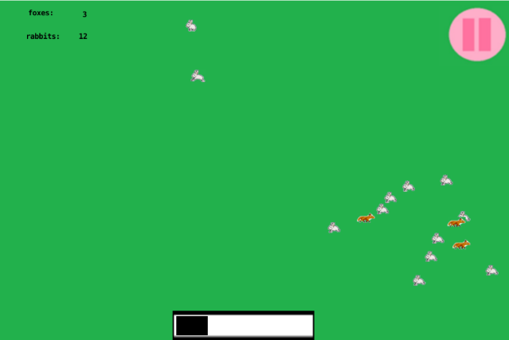

In this state the user can press ‘p’ to return to the running state

In the paused state this symbol is outputted so the user is aware the simulation is paused

Me: This state outputs a paused symbol as discussed, and the user can press ‘p’ to return to the running state as discussed

Natalie Faughy: This state is functioning as discussed however I do feel it would be helpful to the user to output text to remind the user they can press ‘p’ to return to the running state.

End state and save to file:

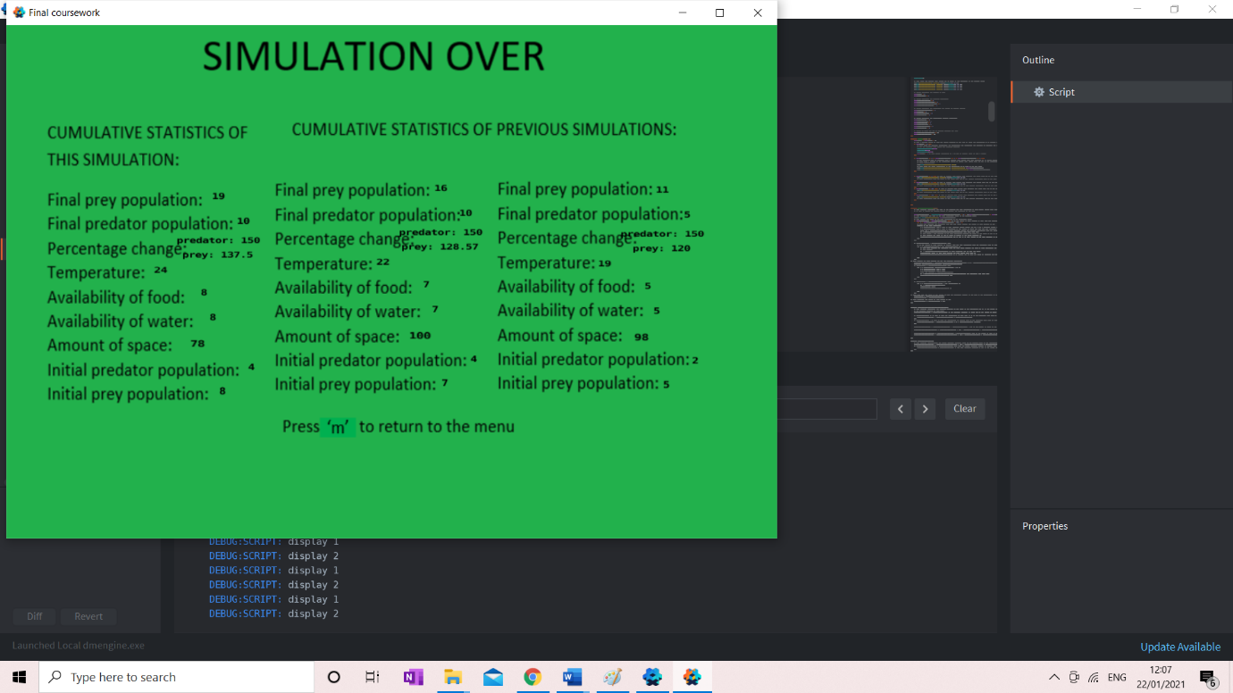

At this state the user can press ‘m’ to return to the menu and this prompt reminds the user of this

Statistics of two previous simulation outputted.

Statistics of the last simulation outputted.

Title so the user knows what part of the simulation they are in

Me: This state outputs the last simulations stats and the two previous simulations and prompts the user that they can press ‘m’ to return to menu as discussed

Natalie Faughy: Yes, I am happy with this state the information is outputted as discussed and a prompt is given to help the user navigate the simulation.

Controls:

Me: I tried to keep the controls as simple as I could and the majority have been implemented as discussed, the ‘s’ key ends the menu state and begins the running state, the ‘p’ key pauses and unpauses the running state, the user can select a parameter to enter on the menu using the mouse and the simulation ends after two minutes. However, in two areas I was unable to execute the controls as discussed: in order to return to the menu from the running state or from the end state the ‘m’ key press is to be used instead of the ‘esc’ key press and in order to enter values into the menu the space bar has to be pressed in between each value entered and the enter key after the user has finished entering their value. This does somewhat complicate the controls however due to the time restraints a better solution could not be found.

Natalie Faughy: I agree that the majority of the controls have been implemented as discussed. The change of key from ‘esc’ to ‘m’ is completely fine although the use of the enter key is also completely fine it does take away somewhat from the simulation that the space bar is used in between each user input however I understand this was a necessary compromise given the time restraints.

How well does my solution match the success criteria?

Below I will look at the requirements of the solution I set out for the solution and looking at how well I met the following success criteria. I will then discuss any changes made to the design in the development stage, and the reason behind these.

Navigation between states

|  |  |  |
| --- | --- | --- |
| No. | Requirement | Justification |
| 4 | Press the ‘s’ key to enter the running state from the menu state | Allow the user to access the running state when they choose |
| 9 | Press the ‘p’ key to enter the paused simulation state from the running state | This will be convenient to the user as they can for example stop the simulation and discuss what is happening in that moment |
| 10 | Press the ‘p’ key to re-enter the running state | This will allow the user to resume the running state |
| 11 | Use the ‘esc’ key to return to the menu state from the running state or the end state | This will allow the user to end the simulation at any point they wish |
| 21 | Have the simulation end and enter the ending state after a certain amount of time (2 minutes) | This will prevent the simulation from going on for too long |
| 22 | Have the simulation end if a population becomes extinct | This will prevent the simulation from not being engaging as one of the populations has died. |

I was able to implement all these requirements except from requirement 11 and partially requirement 21. When writing this part of the development I was less aware about all the functions of Defold, so I was unaware of how to prevent the ‘esc’ key from closing the window the simulation was in, so I instead made the ‘m’ key press serve the same purpose. However now I know that by going to preferences under file you can chose to have ‘esc’ not close the window the program is running in so I would now be able to implement this requirement fully. Although the change to use the ‘m’ key is not significantly different to the use of the ‘esc’ key and otherwise this requirement was met and testing for this can be found on pages 93-94

Requirements 4, 9, 10 were all very similar in the way they were implemented. A controller collection that had no sprites and was always loaded contained the controller script and the proxies for each other simulation state. Therefore, for requirement 4 when the user pressed the ‘s’ key the controller script messaged the menu proxy to unload the menu collection and messaged the simulation proxy to load the simulation collection. Requirements 9 and 10 followed the same process with their respected key press and the simulation states. The testing for this can be found on pages 91-94.

Requirement 21 was almost entirely met as after a given time the simulation state does become the end state however this given time will be close to 2 minutes however because of the nature of the solution it is unlikely this is exactly 2 minutes as it relies on counting the fixed units of time represented by the variable dt meaning that by subtracting from 1 after each fixed unit of time dt, 240 times is unlikely to be exactly 2 minutes.

Requirement 22 has been met as when either population reaches 0 the simulation ends. However, this is very soon after the simulation ends so this could be confusing to the user as the simulation ends fairly suddenly however the requirement has been met.

Menu

|  |  |  |
| --- | --- | --- |
| No. | Requirement | Justification |
| 1 | Start menu | In order to explain what the simulation they are about to watch is, show a simulation key and prompt the user to enter data |
| 2 | Use the mouse the navigate the start screen | This is the easiest way for the user to decide what data they want to enter on the start page |
| 3 | Label that can be edited by the user to allow data entry for the availability of food for the prey, initial populations, temperature, availability of water, space | This will make the simulation more useful as different factors and their effect on the simulation can be investigated |
| 19 | The data entry from the user will be validated to endure it is within the given limits.  Initial populations 0-100  Temperature 0-40  Availability of food (prey) 0-10  Availability of water 0-10  Amount of Space 0-10000 | This will ensure that the data values that are processed by the model are not too large and therefore the outcomes are not too large as otherwise that would be confusing to look out and too demanding on the user |

I was able to meet requirement 1 and 2 and partially meet requirements 3 and 19. Requirement 1 has been met displaying a title, a simulation key so the user knows what the images in the running state represent, and a prompt for the user to enter data in that there are titles and empty boxes however I should have included more of a prompt to explain how to enter data. The user is able to use the mouse in the menu state to select a box to then enter numbers into and the numbers entered is displayed to the correct box using this information meeting requirement 2.

Requirement 3 was partially met as although the user can enter values into a selected box however the user has to press the space bar each time. I did this because for each key press the engine was receiving the input message multiple times. However, for this approach to fully work there needed to have been a prompt on the screen informing the user that the space bar needed to be clicked between each value being entered. I considered using a timer to prevent the engine from processing input messages for a short amount of time in between each key press but I decided not to do this as it relied on the user always pressing the keys in the same way which is unlikely as for example if the user is pressing the same key twice to enter for example “33” they are likely to press these keys very quickly so I felt that the timer approach would not be appropriate. I now feel that with my increased knowledge of the engine and Lua I would now use action. pressed and action.released to be able to have the engine process on input message and therefore meaning that the space bar would not be necessary.

Requirement 19 was almost entirely met however I reduced the maximum about of space to 500 as whilst it was 10000 it would allow for too many sprites to be on the screen which would involve additional processing requirements and would look very confusing because there would be so much on the screen. The rest of the limits have been implemented as described in requirement 19.

Running State

|  |  |  |
| --- | --- | --- |
| 5 | Use a logistical model to accurately represent the predator/prey dynamics and therefore have them spawn or delete accordingly | This is essential to the simulation being a useful education tool |
| 6 | Have the predator/prey animated in the same way on a path | This will create a visual representation of the populations |
| 8 | Have population size boxes for the size of the predator and prey populations outputted live as the simulation goes on at the top left of the screen | To give the user a clear and concise idea of what is happening in the simulation |
| 12 | The prey will have the sprite of a rabbit | This will be clearly the prey as they are a very recognisable animal |
| 13 | The prey will have the sprite of a fox | This will be clearly the predator as they are a very recognisable animal |
| 15 | The parameters the temperature and availability of water will affect the carrying capacity of the populations in the same way | This will allow the user to investigate the effect of different parameters. |
| 16 | The carrying capacity will be initially calculated from the amount of space and then it will be altered appropriately by the appropriate parameters | This will allow the user to investigate the effect of different parameters |
| 17 | The carrying capacity of the prey will be affected by the size of the population of predator and the amount of food | This will allow for the two different population sizes to affect each other therefore allowing population dynamics to be portrayed |
| 18 | The availability of food for the predator will be dictated by the population size of prey. Meaning the population size of the prey will affect the population size of the predator. | This will allow for the two different population sizes to affect each other therefore allowing population dynamics to be portrayed |
| 20 | Have a progress bar to represent the passing of time | This will give the user a concept of how far through the simulation the user is |

Requirements 5, 8, 12, 13, 15, 16, 17, 18 and 20 have been met whilst requirement 6 has been partially met. Requirement 5 has been met with the formula for logistical model being used correctly to calculate the population size as regular intervals of time. Then a number of foxes or rabbits are spawned or deleted so the number of animals displayed is the same as the size of the populations. This is tested in the development stage on page 117.

Requirement 8 has been met with the population size being displayed to the screen in the top left corner. This is updated every half second, each time the population and sprites displayed is updated so this will accurately represent the population displayed. Requirements 12 and 13 have both been met with a sprite of the image of the fox and rabbit representing the predator and prey respectively and these are animated to appear as though they are running.

Requirement 15, 16, 17 and 18 have been met in the way that the carrying capacity has been calculated. Requirement 16 is met as the carrying capacity for each population is initially set to the amount of space, these carrying capacities are then multiplied by the temperature and availability of water divided by 10 meeting requirement 15. The predator carrying capacity is multiplied by two times the prey population divided by 3 times the predator population when the prey population is less than or equal to the predator population whereas if the prey population is greater than then predator population it is divided by two times the prey population divided by three times the predator population. This then means that the predator carrying capacity and therefore the predator population size is affected by the prey population size meeting requirement 18. Requirement 17 is met as the prey carrying capacity is multiplied by the amount of food divided by 10 and the prey carrying capacity is multiplied by the prey population times by two divided by the predator population times by three. This means that the amount of food and the predator population size effects the carrying capacity of the prey and therefore the prey population size meeting requirement 17. These requirements have been met meaning that the carrying capacity is calculated as dictated in the success criteria.

Requirement 20 has been met as another quarter of the progress bar is displayed every 24 seconds representing a fifth of the time passing which allows the user to have an idea of how far through the simulation the user is. This has been tested in the development stage in pages 112-13

Requirement 6 as not been entirely met as the simulation spites move towards a random point in a fixed amount of time meaning they move at different speeds do and they do not move in the same way on a path. Now I know a little more about Lua and Defold instead of choosing a random position for it to move towards I would get the position of the sprite and then have it move to a position of a set distance away but have the angle of motion be random, this would make the movement of the foxes and rabbits more uniform and mean they would move in the same way as they would have moved at the same speed.

Pause

|  |  |  |
| --- | --- | --- |
| 25 | Have a symbol to represent that the simulation is in the pause state | To ensure the user knows what state of the simulation they are in |

Requirement 25 has been met so that a symbol is displayed when the simulation is in the pause state.

End State

|  |  |  |
| --- | --- | --- |
| 23 | Have the end state display the cumulative stats including the final size of both populations both of their percentage changes, the initial values used for the three previous simulations. As well as a prompt for the user to press ‘esc’ to return to the menu state | This will allow the user to have a good idea of what had taken place in the simulation |
| 24 | Have the simulation write to file the initial and final populations, the parameters and the percentage change | This will allow the user to compare multiple results and could process data from multiple simulations in different ways more easily |

I have met requirement 23 and have mostly met requirement 24. Requirement 24 is almost entirely met with the values described in the success criteria being saved to a file. However, this requirement has not entirely been met as the percentage change was not saved as this can easily be calculated from the initial and final populations so I felt it would be an unnecessary use of memory to also write this to file. Also, if the user would like to delete the contents of the file this has to be done manually by opening the file and then the code that is in comments at the beginning of the controller script has to be included only the first time the simulation is run after the contents of the table is deleted. Requirement 23 is met with the statistics described being displayed in the end state and a prompt to press ‘m’ is displayed (not ‘esc’ as the key press used for returning to the menu state changed as previously discussed) and this is tested in the development stage on page 138

Overall Simulation

|  |  |  |
| --- | --- | --- |
| 7 | Have a simple background of one colour | To not distract from the simulation |
| 14 | All sprites will be simple and clear | This will mean that it is clear what they are representing but will not distract from the educational value of the simulation |

Both requirements 7 and 14 have been met with all backgrounds and sprites being simple and clear with the background being one simple colour.

Maintenance

Current and future maintenance

No features for maintenance have been implemented into this solution however this would be required if it were professional distributed in order to fix bugs or for adding more features and refining the simulation.

This is not a complete solution but if I were to complete the simulation a feature would be included most likely into the menu or end state. This would allow the user to report any issues they have found in the simulation which would then be addressed and patched. This would also allow the user to check for updates which would allow for these issues to be addressed and potentially for new features to be included and the simulation to be refined to ensure the simulation is always as accurate and useful as it can be.

Limitations and how they would be approached.

Below is a series of limitations and how they would be approached

|  |  |
| --- | --- |
| Requirement | Justification |
| Considering other parameters for example the weather or amount of sunlight | This would create a more realistic simulation which would more accurately represent real life |

To complete this I could include additional factors that would affect both populations equally such as the effect of hunting, weather or hunting. I could also include factors as This would require further input boxes in the menu, further calculations involving the carrying capacities and changes in the end state to include this additional information.

|  |  |
| --- | --- |
| Requirement | Justification |
| Include a third species to create a more complex ecosystem and have these three species interact | This would increase the scope of the program, making it more complex and further demonstrating the ideas of population dynamics |

This would potentially involve giving an option in the menu state to allow the user to decide between having two or three animals. This would then mean there would have to be two modes for the simulation one in which the two animals interact with each other and another where three animals interact which would require further coding similar to what has been coded for the two animals but in between each of the three animals.

|  |  |
| --- | --- |
| Requirement | Justification |
| To have the sprites move differently and more closely to the animals they are depicting | This would help the user differentiate between the two sprites |

To complete this additional requirement, I could create to separate scripts one for the movement of each animal. I could potentially vary the time it takes for the animal to move towards a position that is a set distance away from the animal as well as the distance the point is moving towards from the animal which could vary the way in which the animals would move.

|  |  |
| --- | --- |
| Requirement | Justification |
| To include different environments | This would allow students to appreciate the effect of different terrains |

This could allow the user to choose different terrains such as the desert or the tundra. This would set the conditions for the simulation for the user without them having to input these values and would allow investigation into the effect of different environments and what their different environments are like

|  |  |
| --- | --- |
| Requirement | Justification |
| Impressive visuals | This would make the simulation clearer and therefore it would be easier for the user to visualise the population dynamics |

In order to create more impressive features, I would use need to use additional photo editing software such as photoshop which could create more realistic and interesting graphics.

|  |  |
| --- | --- |
| Requirement | Justification |
| To allow the user to change the conditions of the simulation whilst the simulation is running | This will allow the students to see the effect of changing certain parameters more easily |

To allow the user to change the parameters during the simulation, a separate pop-up menu could be created and then once the user selects the changes, they want to make the carrying capacity would have to be re-calculated which can then be used going forward in the simulation.

|  |  |
| --- | --- |
| Requirement | Justification |
| Allow the user to run multiple simulations at once to quickly compare different species or initial conditions | This will allow the students to see the effect of changing certain parameters or species more easily |

This would mean that the menu would have to be changed to allow the user to chose different parameters for each simulation and then the running state would have to be changed to show multiple simulations. Different movement scripts and spawning scripts would be needed to have the separate parameters and to ensure the sprites stay in their area. The end state would then have to be somewhat changed to display the information for each simulation.